

Attendance on the Cloud

User Manual

Table of Contents
Sr. No | Title | Page No
1 | Create Account | 5
2 | Logging In | 10
3 | System Setting Wizard
4 | Admin Login
5 | Admin Dashboard
6 | Employee Dashboard
7 | Analytics Dashboard
8 | Company
 | 8.1.Transaction Year
 | 8.2.Company Master
 | 8.3 Branch Master
 | 8.7 Department Master
 | 8.5 Designation Master
 | 8.6 Employee Master
 | 8.7 Device Master
 | 8.8 Religion Master
9 | Shift Master
 | 9.1.Shift Group Master
 | 9.2.Shift Master
 | 9.3.Shift Allocation
10 | Leave Master
 | 10.1.Leave Type
 | 10.2.On Duty Leave
 | 10.3.Leave Sanction
 | 10.4.Leave Carry Forward
 | 10.5.Leave Carry Forward/Rollback
11 | Holiday Master
12 | User Management
 | 12.1.Role Master
 | 12.2.Rights Distribution
13 | Utilities
 | 13.1.Manual Punch
 | 13.2.Import Employees
 | 13.3.Restore Database
 | 13.7.Transaction Monitor
 | 13.5.Device Service
 | 13.6 Valid Employee
 | 13.6.Device Command
 | 13.7.Attendance
 | 13.8.Scheduler
 | 13.9. Custom Fields
 | 13.10 Custom Template
14 | ESS
 | 14.1.Approve Leave
 | 14.2.Approve Attendance
 | 14.3.Approve Webpunch
15 | Policy
 | 15.1.HR Policy
 | 15.2.HR Policy Allocation
16 | Alert
 | 16.1.Email SMTP Configuration
 | 16.2.Send Mail
17 | Account Setting
18 | Employee Login
 | 18.1 Web Punch
 | 18.2 Analytics Dashboard
 | 18.3 Leave Request
 | 18.7 Approve Leave
 | 18.5 Attendance
 | 18.6 Approve Attendance
 | 18.7 Holidays
 | 18.8 Approve Webpunch
19 | Developer Login
 | Developer Dashboard
20 | Device Management
 | 20.1 Device
 | 20.2 Transaction Data
21 | Download
 | Download Sample

Create Account
- To create new Account navigate to http://minopcloud.com/ and then click on Login OR Click on SIGNUP button to navigate to http://minopcloud.com/PayTime/LoginPage.
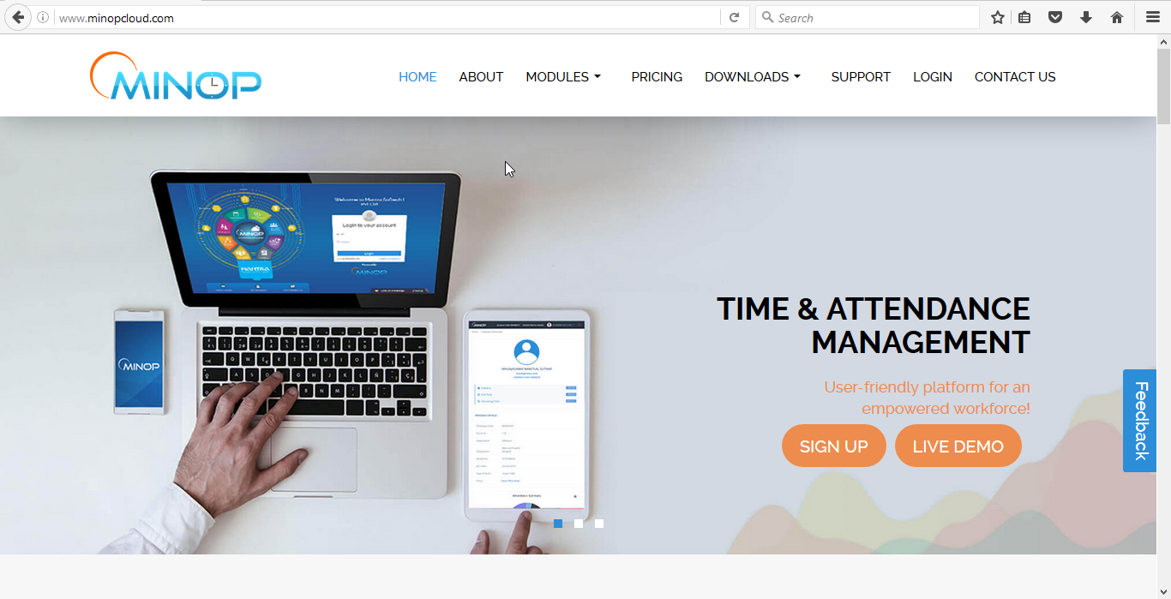
- Click on Create New account button and fill all details and then click on register button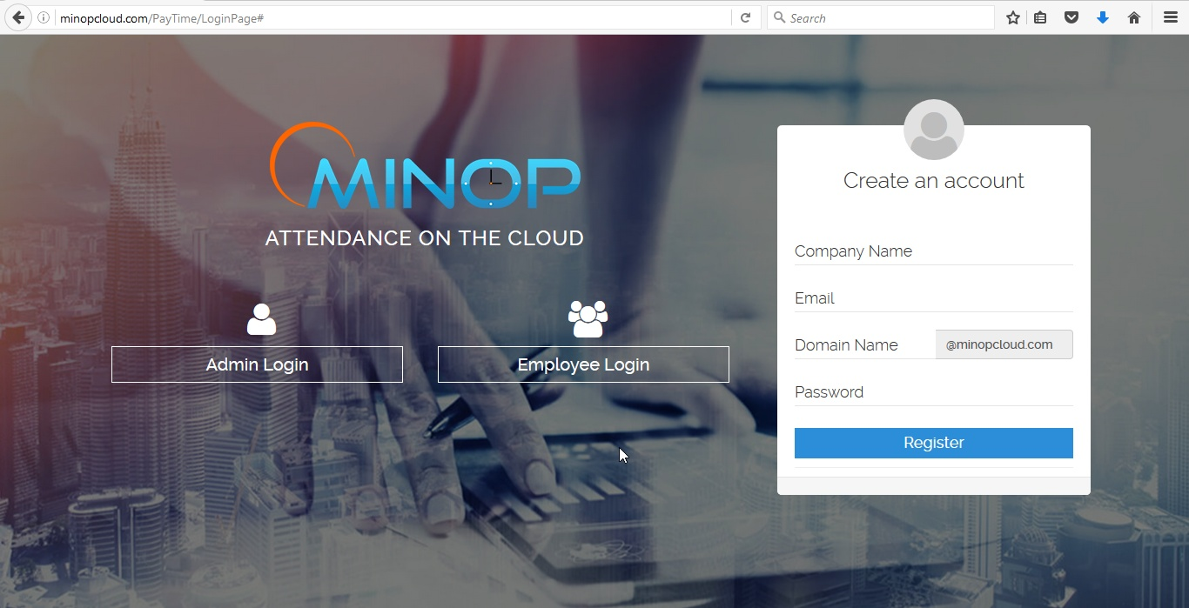
- Message will display that email is sent to your mail, Open that mail and click on the provided link to activate account.
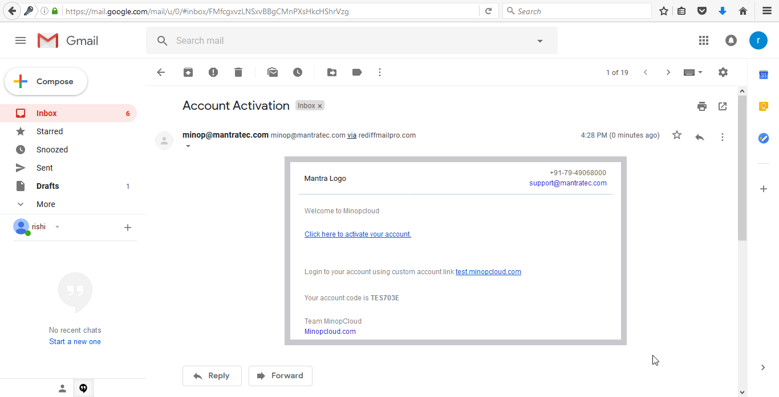
- “Your account is successfully activated” message on screen will display as you click on activate account link.
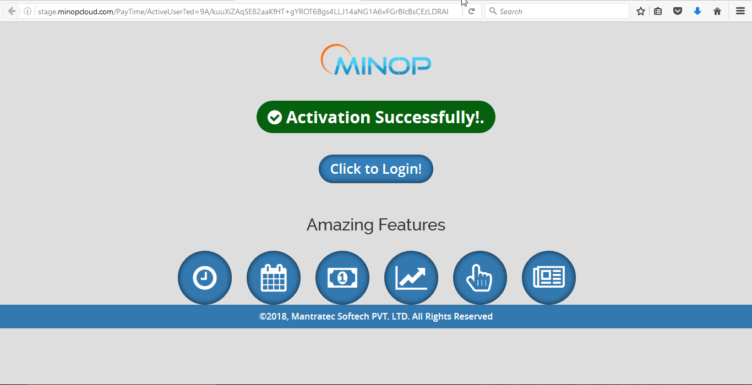

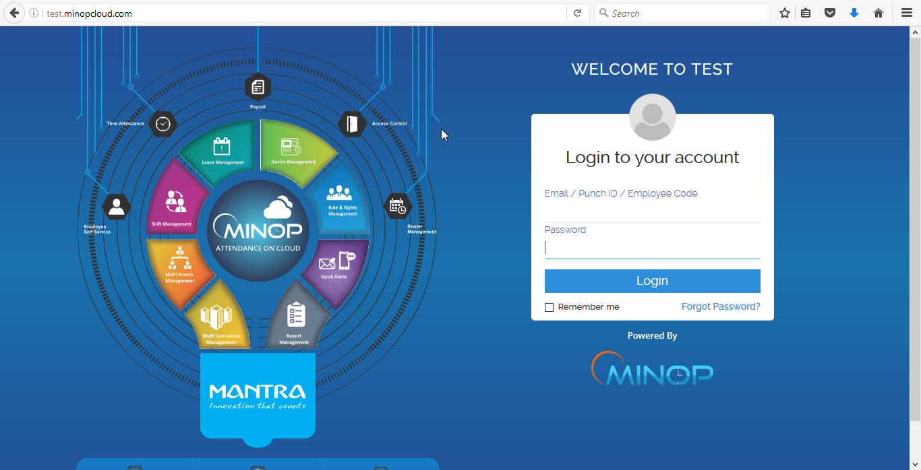

- Enter valid Credentials and click on Login button, after Successful registration when user do Login for first time then he will redirect to the System setting wizard page.
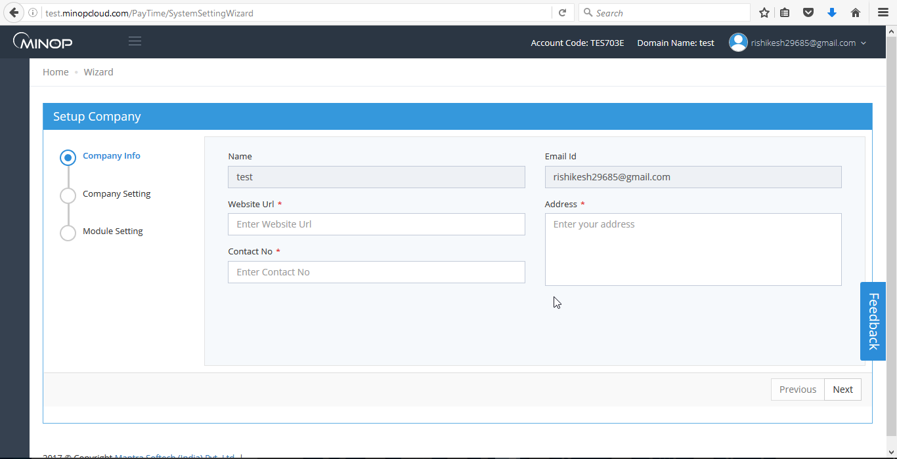
- User will be asked to On/Off master page on screen, On Masters will display in the respected menu and OFF masters will not display in the menu.
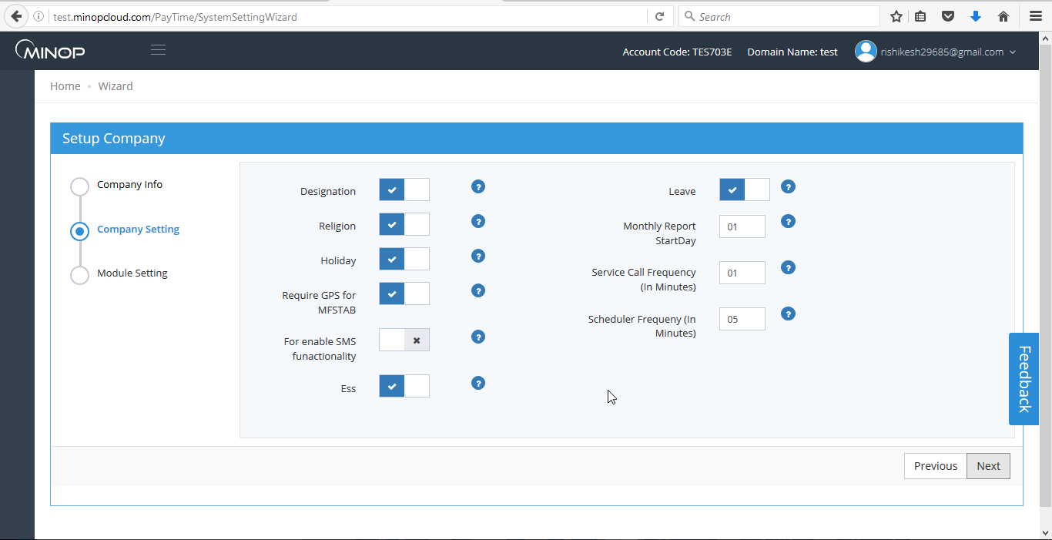
- Select the Modules of your choice and click on finish button.
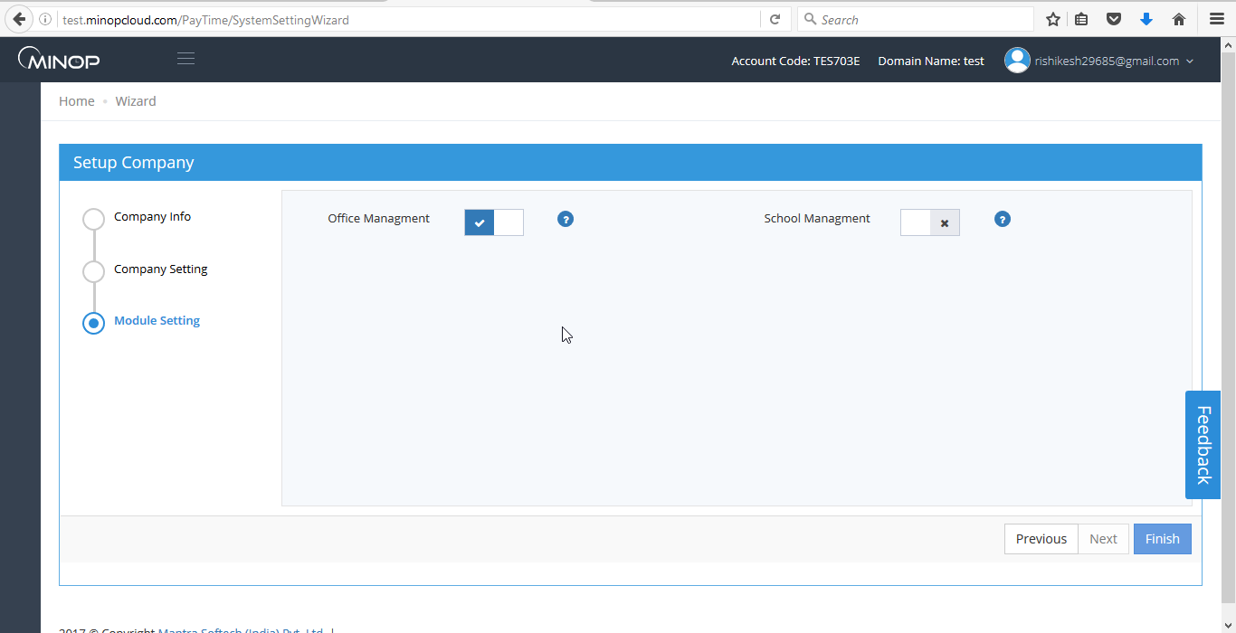
- After click on finish button user will redirect to the Restore Database page. Here if user has old database backup in “.bak” (you may only restore back up of Paytime only rename file and add “.bak” in the end if Paytime backup file don’t have “.bak” in end) file then he/she can restore the database otherwise click on skip button it will redirect to the Admin Dashboard page.
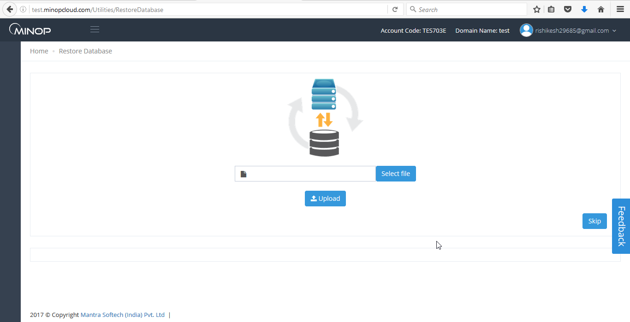
Login
There are total 3 types of user Login available which are as follow,
- Admin User Login – Navigate to http://minopcloud.com/PayTime/LoginPage to Login into Admin Login.
- Employee User Login - Navigate to http://minopcloud.com/PayTime/LoginPage to Login into Employee Login.
- Developer User Login - Navigate to http://minopcloud.com/paytime/DevelopersAccount/ to Login into the Developer Login.

- Admin Login

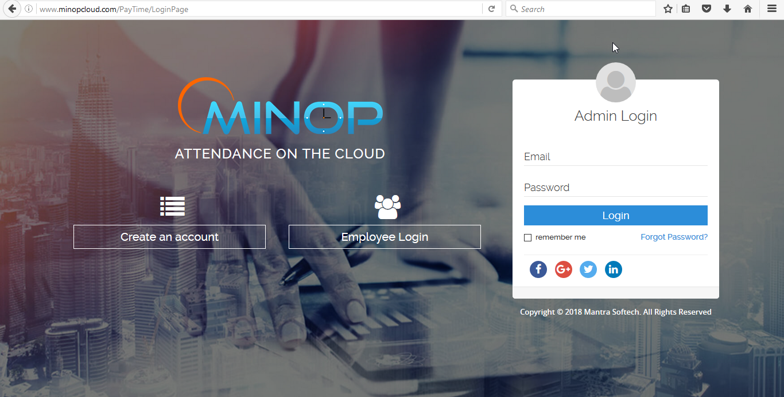
Above image is of first view for Admin login.

  - System Setting Wizard

On Login, If new account is created and doing Login for first time then it will redirect to the System setting Wizard page and if Old user then User will redirect to the Dashboard of the admin panel.

System setting wizard will shoe following option choose that best suits your requirement.
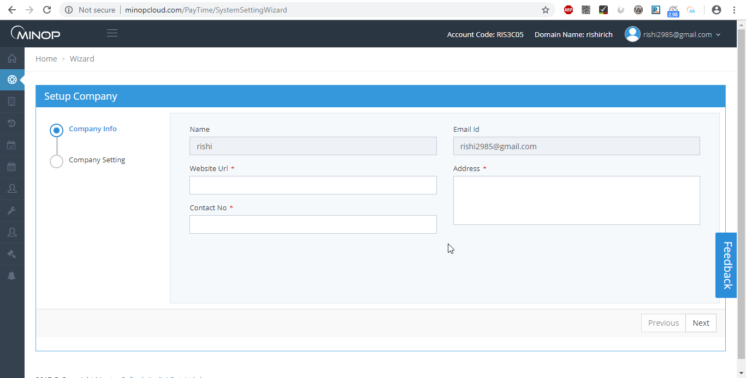
Above image is for first in system setting wizard.
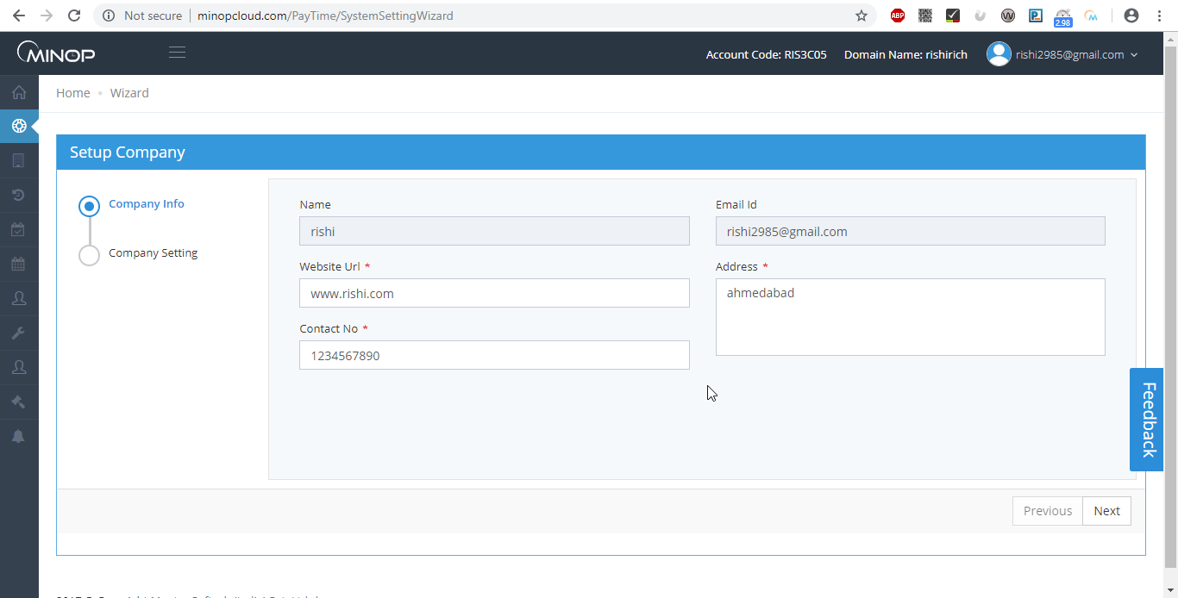
Above image is when all details fill

‘*’ this sign show that field is mandatory you need to enter those field in order to move to the next page.

Fill all details and then click on next.
After clicking in next button next page will be of company setting here there are different option like Designation, Religion, Holiday, Leave, Etc...


Above image shows company setting page.

Turning on off button make huge difference like if you want designation to be added and shown in your account you can turn it on and if you don’t want then you can turn it off it won’t be seen in that particular entire account you may change this setting later on as per requirement. Same thing goes for all other options.

Select desired option as per your requirement and click next it will move you to next page that is of module setting page.


Above image is for module setting.

This page may differ depending on different module added right now there are two option in module setting page one is office management that is general for any attendance system and second is school management it is specially designed for school management setting.

Select appropriate module and click on finish that’s all for system setting wizard.

After clicking on finish button you will be redirected to Restore Database page.

If Old user then Admin Dashboard page will display after user do Login.

There are 6 different block on admin dash board they are as listed below with some summary.

- Strength(total number of employee register with that company)
- At Work(total number of employee that are working at that particular time)
- Birthday(it shows total employee who has birthday on that particular date)
- Late In(employee that has arrived late on that particular day)
- Early out(employee that has departure early on that particular day)
- Device(total number of device register with that account)

For brief detail on each block you can click on them to see its details.

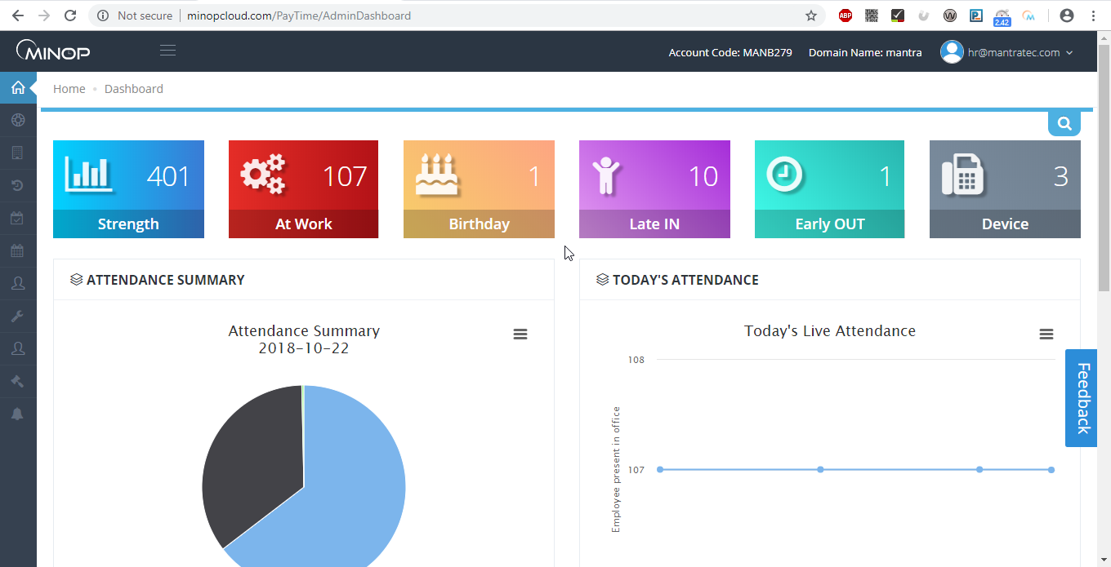
Above image is for admin dashboard general Summary will be show in convenient way that can be analyzed of current company status.

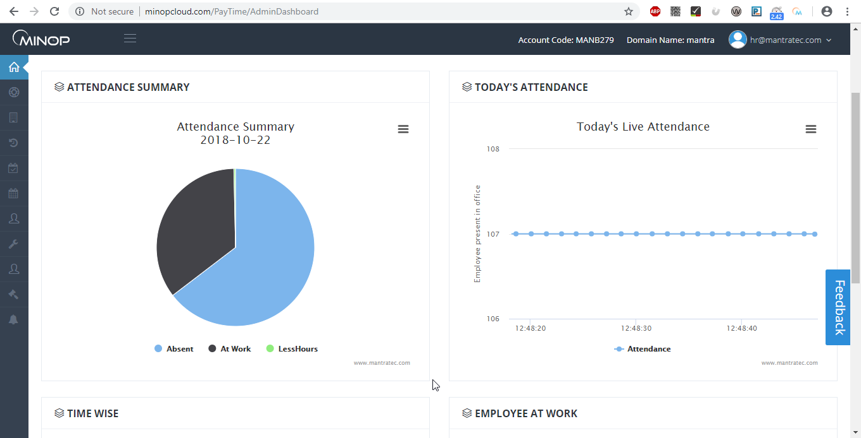
Above image shows pie chart of present day status of all employees on right side and on left side it shows live at work count of employee.

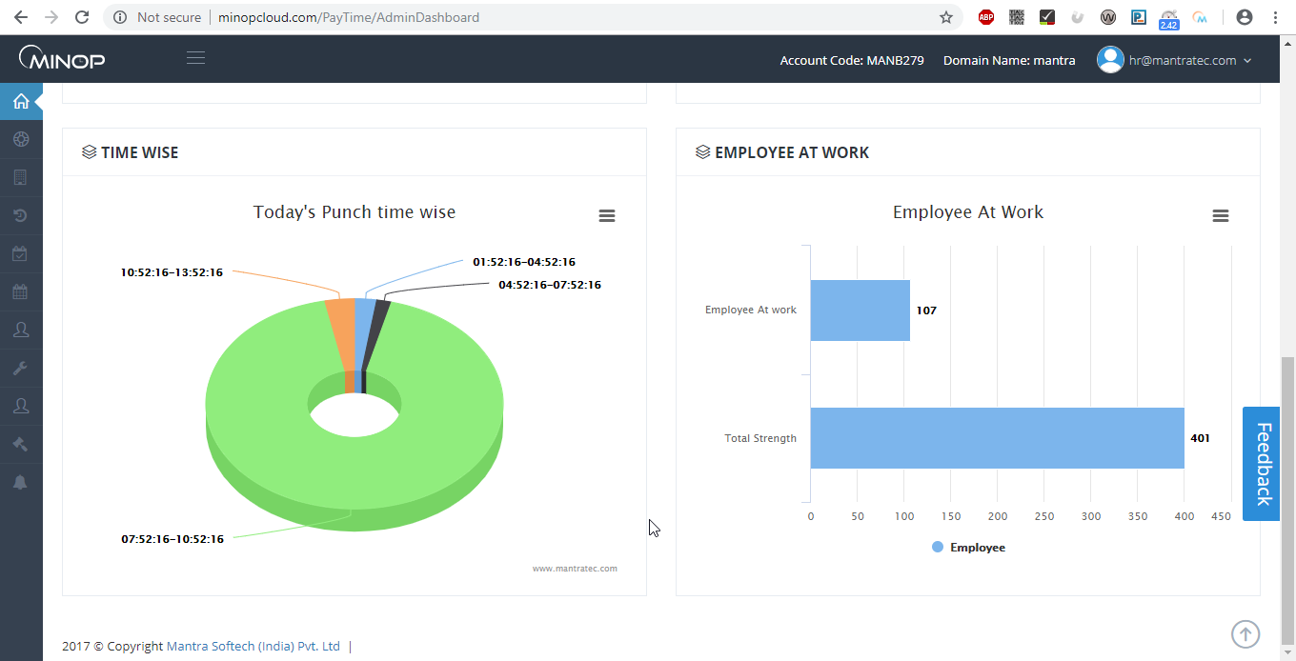
Above image shows pie chart of total punches done in specific time period and on left side bar chart of total employee in company to total number working on that particular time.

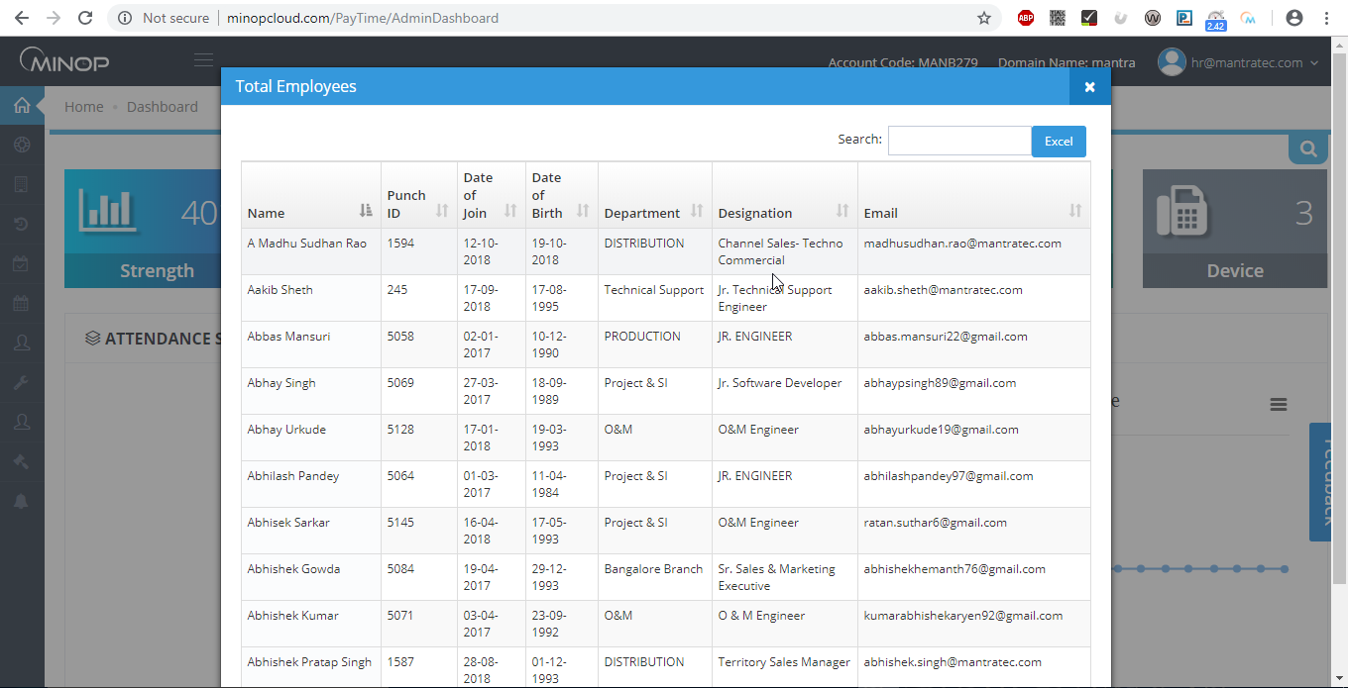
Above image show when you click on strength it will provide brief details like this.

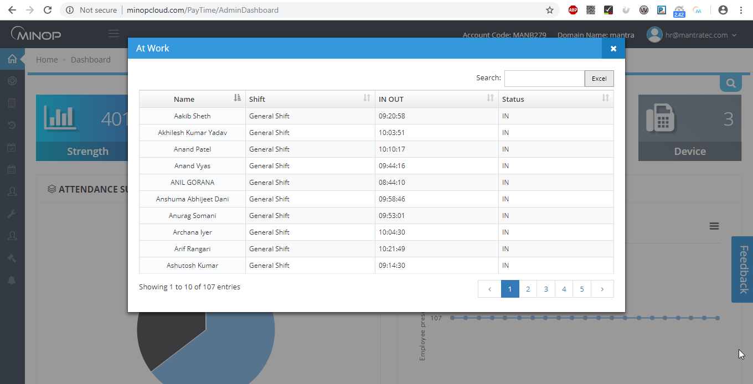

Above image shows when you click on At Work brief details will be available on present working employee.

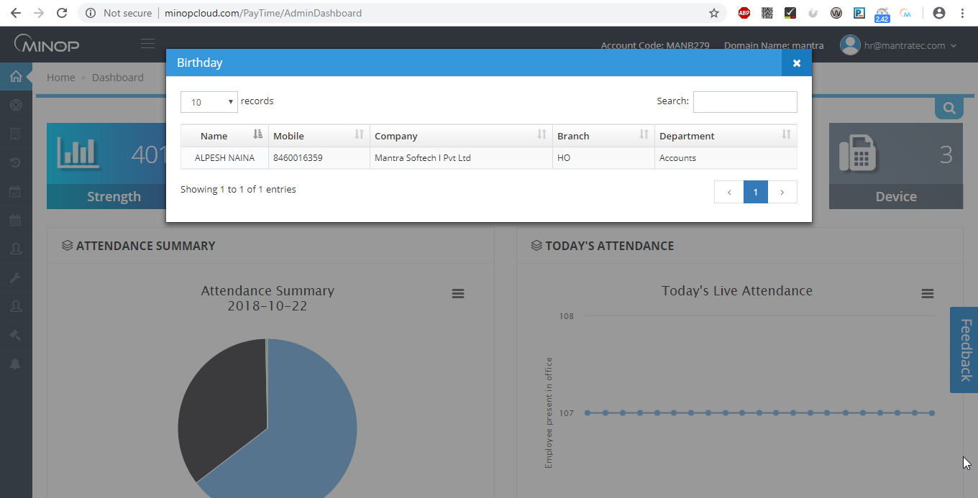
Above image shows details will pop up when you click on Birthday.

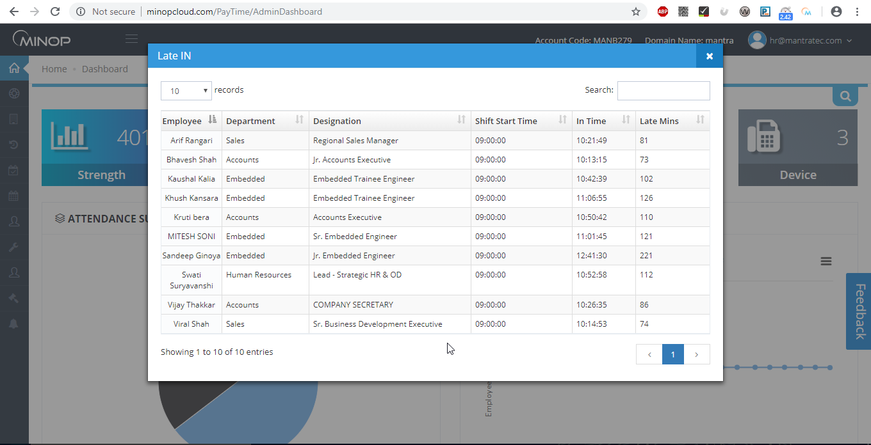
Above image shows when you click on late in block pop will show details of late in employee.

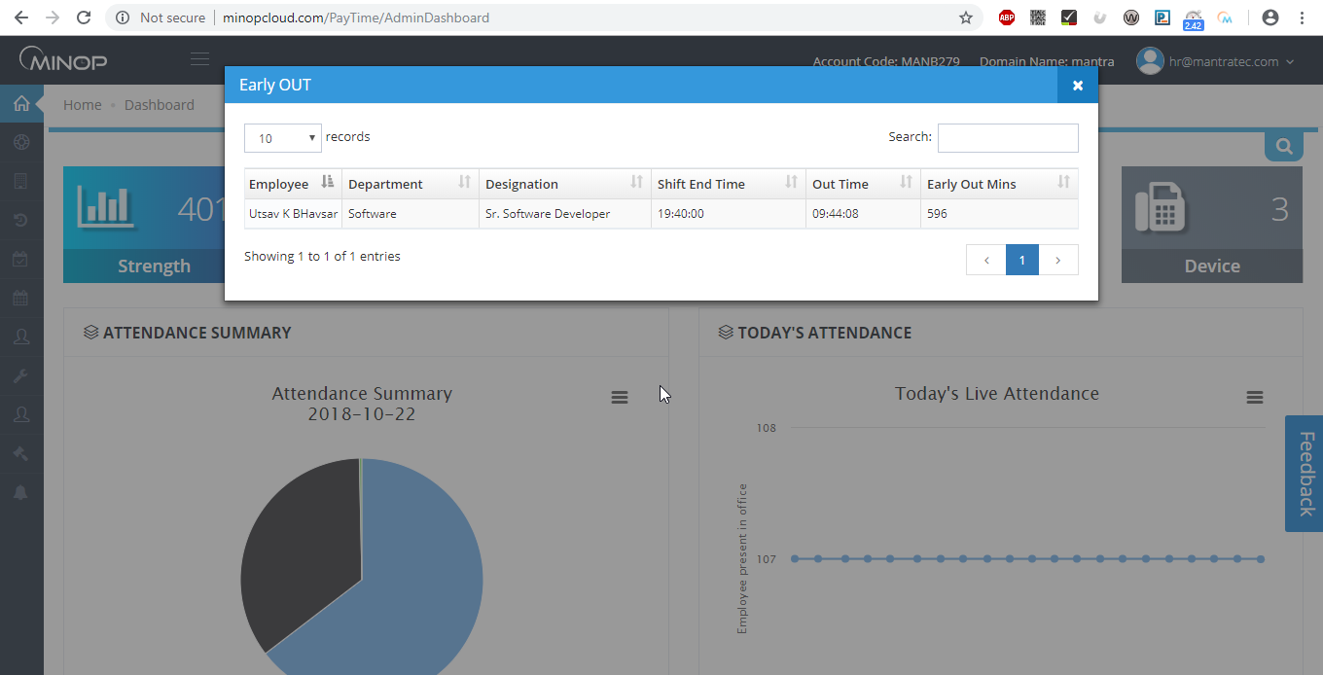
Above image shows when you click on early our block pop up will show early out details.

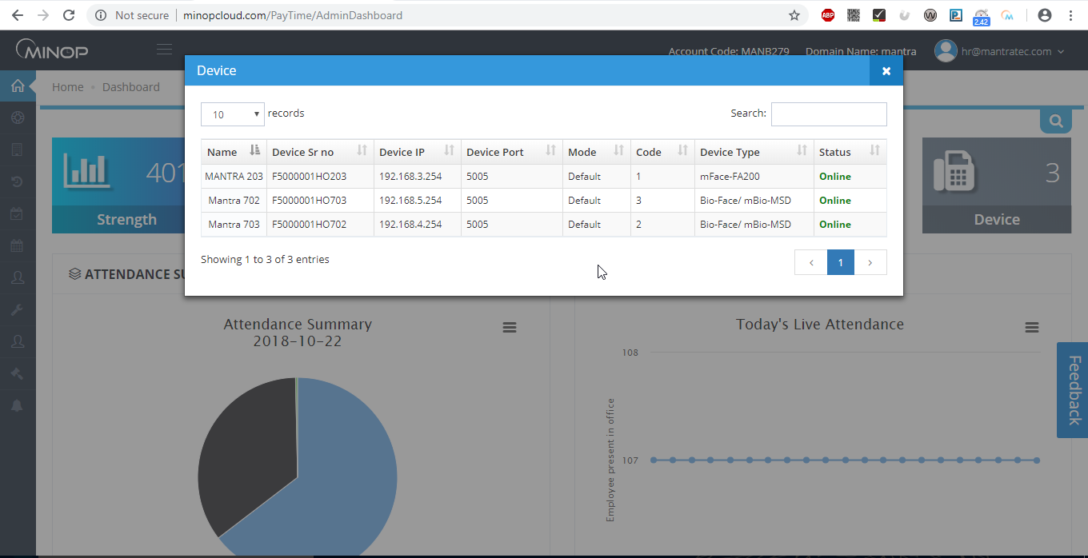
Above image shows device detail list pop up when you click in device block.

  - Employee Dashboard

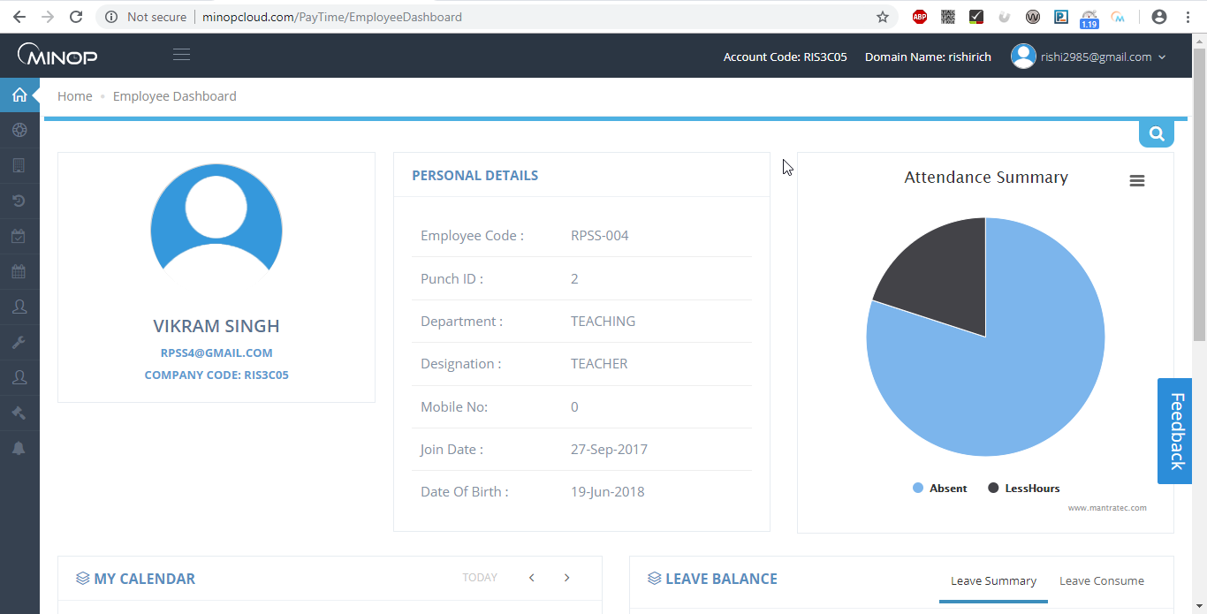
Above image first view of employee dashboard it contains general overview of employee on left side it shows attendance summary of that employee in pie chart.

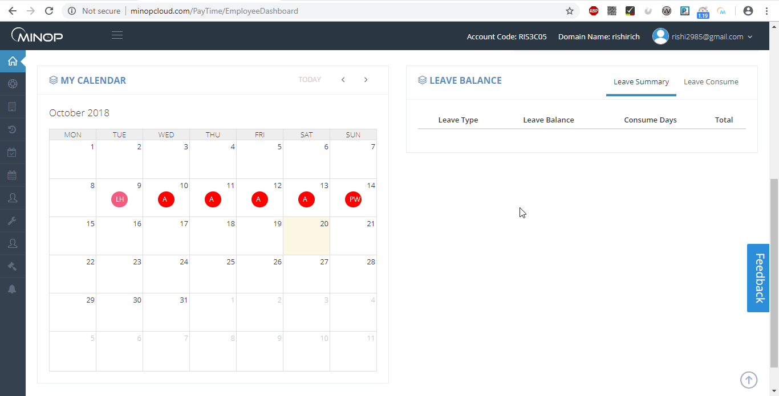
Above image is of employee dashboard on right side it shows employee attendance status in calendar on left side it shows leave summary and leave consumption of that particular employee.
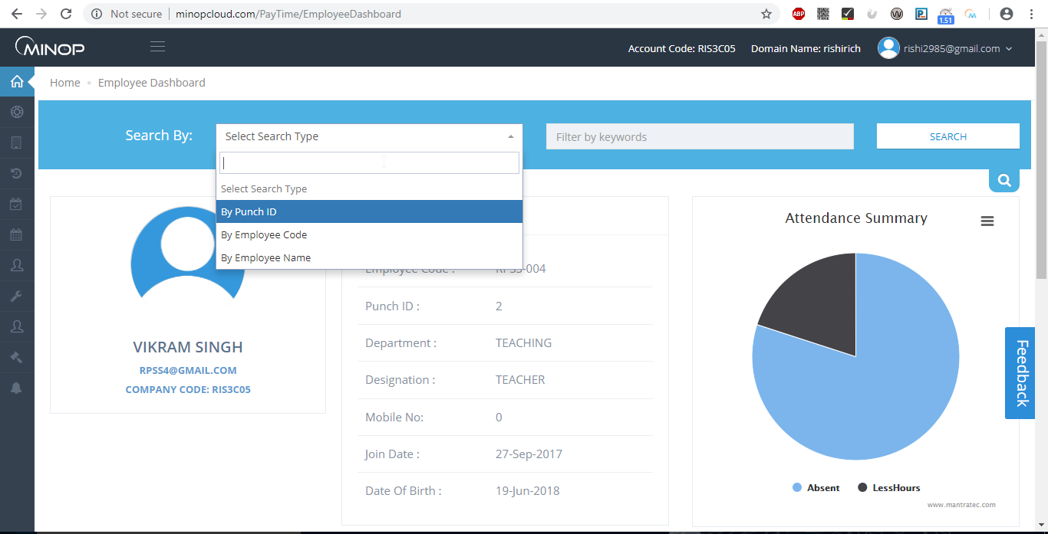
In employee dash board you can search employee on 3 different ways it might be with punch id, employee code or employee name.

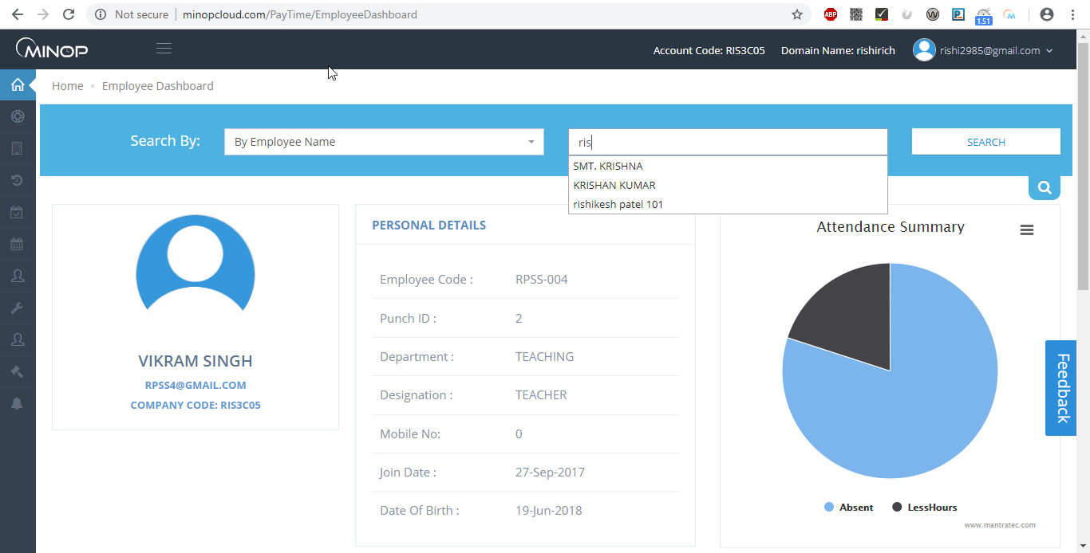
Above mage shows after selecting appropriate option.
- Admin can see Details of Employee’s employee wise. Employee’s leave balance, whole month’s attendance in Calendar View.
- Admin can search Employee PunchID, Employee Code and Employee Name.

1.10 Analytics Dashboard: Analytics Dashboard Menu has the following Attendance Reports.

1.10.1 Daily Reports:

1) Daily In-Out Report
2) Daily In-Out with Device Name Report
3) First IN Last out Report
7) Daily IN Register
5) Error Case Report
6) Absent Report
7) Late In Report
8) Early In Report
9) Early Departure Report
10) Late Departure Report
11) OT Report
12) Continuous Late Arrival Report
13) Continuous Early Departure Report
17) Continuous Absenteeism Report
15) Machine Raw Transaction Report
16) Manual Punch Report

1.10.2 Monthly Reports:-
1) Monthly Muster Report
2) Monthly Working Duration Report

1.10.3 Daily Summary Reports:-
1) Department Summary Report
2) Early In Summary Report

1.10.7 Leave Reports:-
- Leave Balance Report

Example:

Daily Reports:-

1) Daily In-Out Report

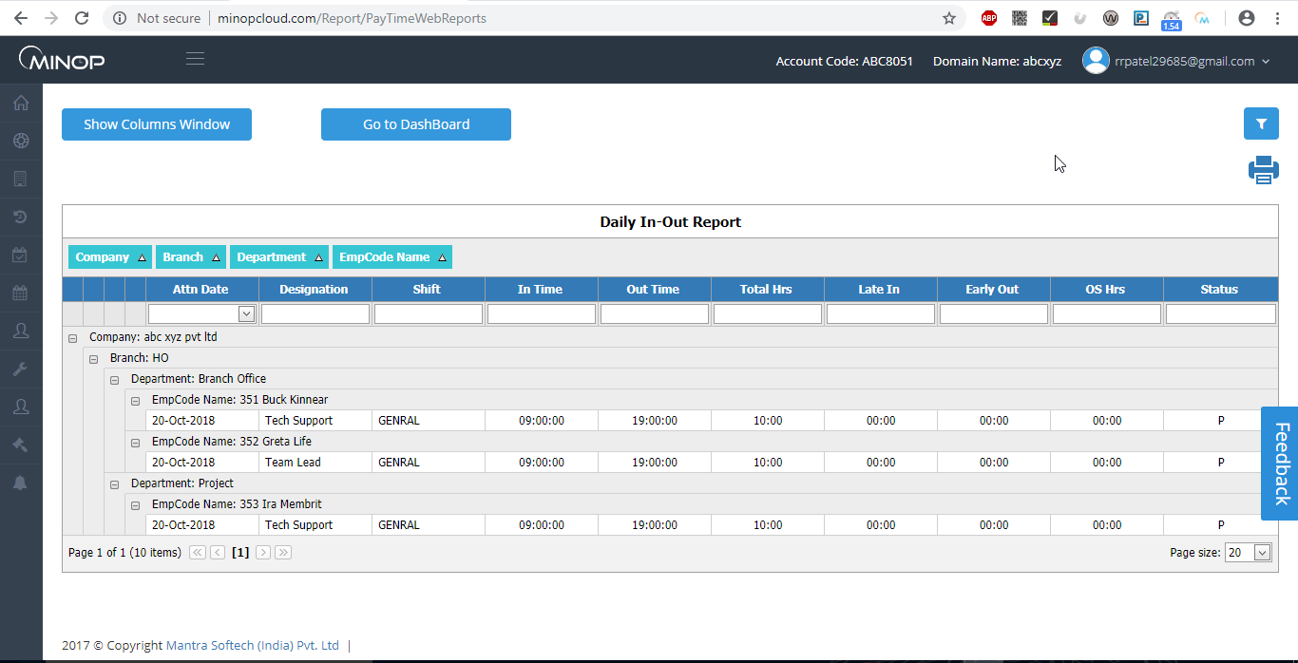
Above image shows report of daily in out format.

1) You can add or Remove Fields
E.g. in Above Report If you Need Less Hour after field of OT Hrs then you only need to Drag ‘Less Hr’
From list located at right corner of screen to Report behind field of ‘OT Hr’.
2) You can change Grouping
E.g. In above Report Grouping is done by Name; if you need that by Shift then you only need to Drag ‘Shift’ to Group Header Area.
3) Hide Columns Selector: - It will hide columns selected displayed in right corner of screen.
7) Show Row Filter: - it allows you to filter your grid data.
5) Merge Cell: - It will merge cells if any columns are repeated in grid.

2) Monthly Muster report

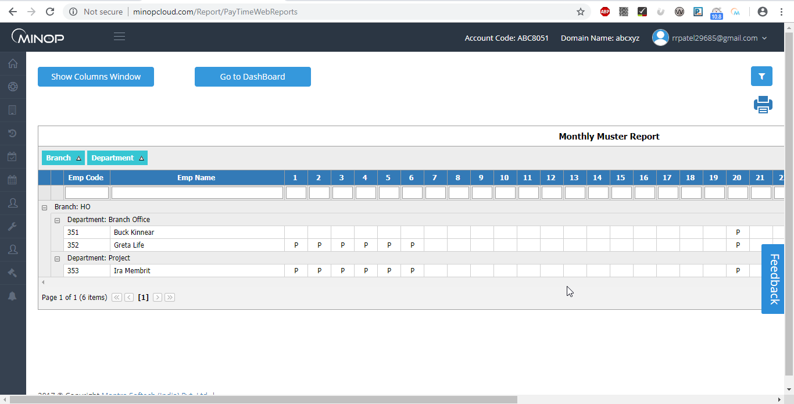
Above image shows report of monthly muster format.

  - Company:

The Company Menu has the following masters.

- Transaction Year
- Company Master
- Branch Master
- Department Master
- Designation Master
- Employee Master
- Device master
- Religion Master

1.2.1 Transaction Year Master

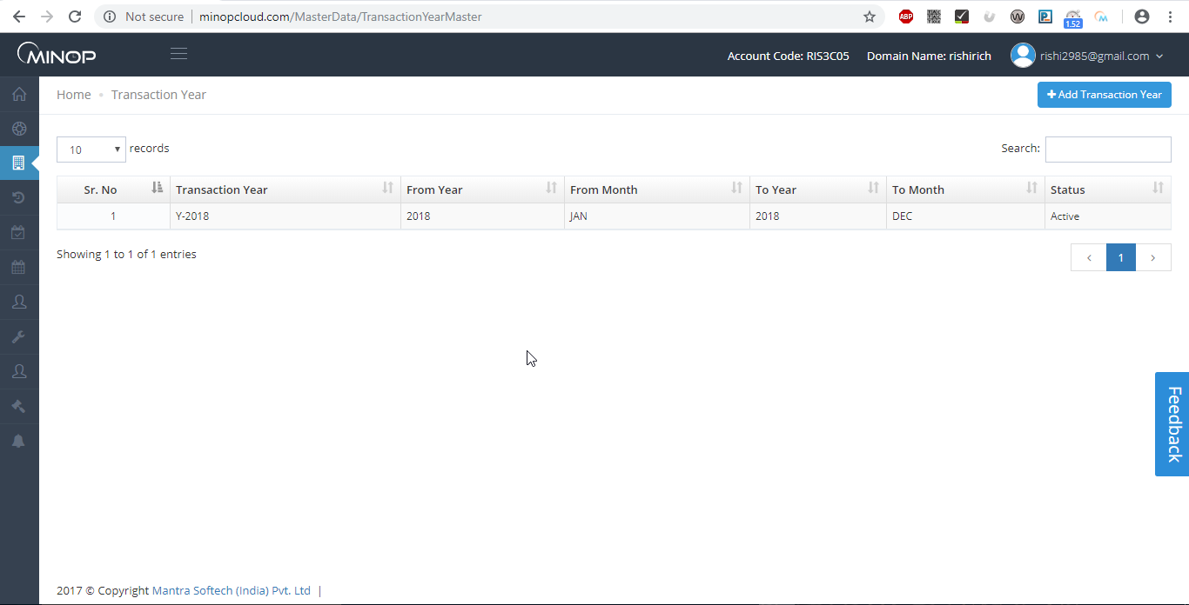
Above image shows view of transaction year master

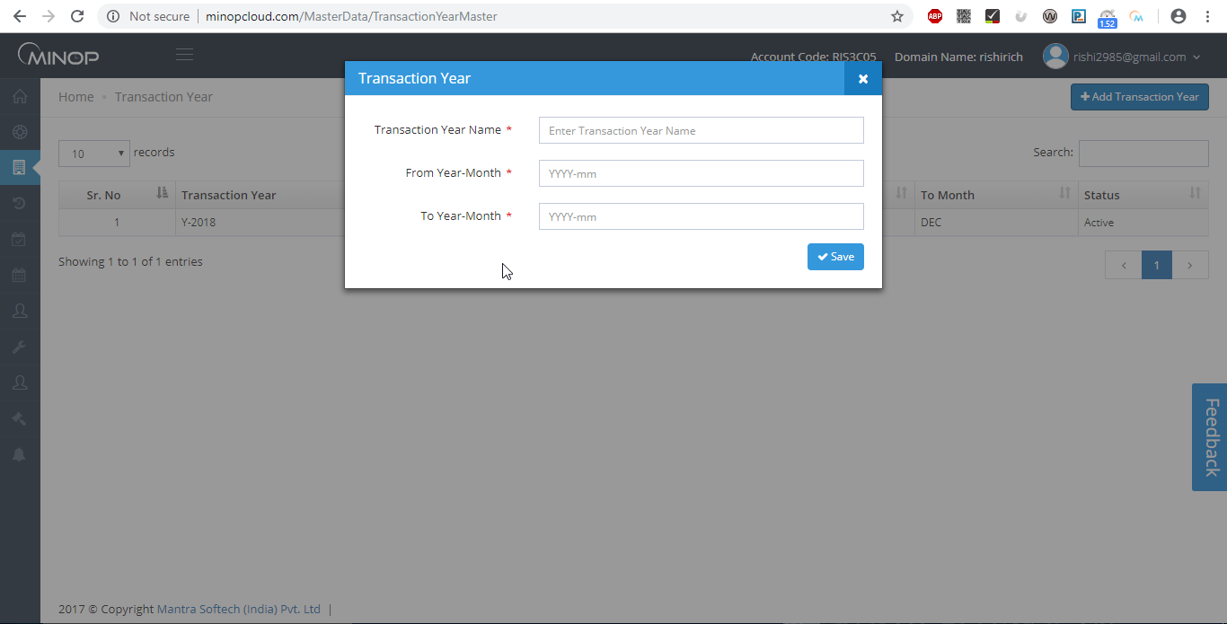
Above image show pop up when you click on .
- Save Transaction Period in Transaction Master.
- To add new Transaction, click on ‘Add Transaction Year, Select Transaction “From Year-Month”, “To Year-Month” and then click ‘Save’.
- If new Transaction Year is added then it will be Active and Previous Year will be Inactive.
- Transaction year is mandatory field to create and maintain leave. Leave balance add will be valid for that particular transaction year only.
- If you want to carry that leave balance to next transaction year you need to create new transaction year.

    - Company Master

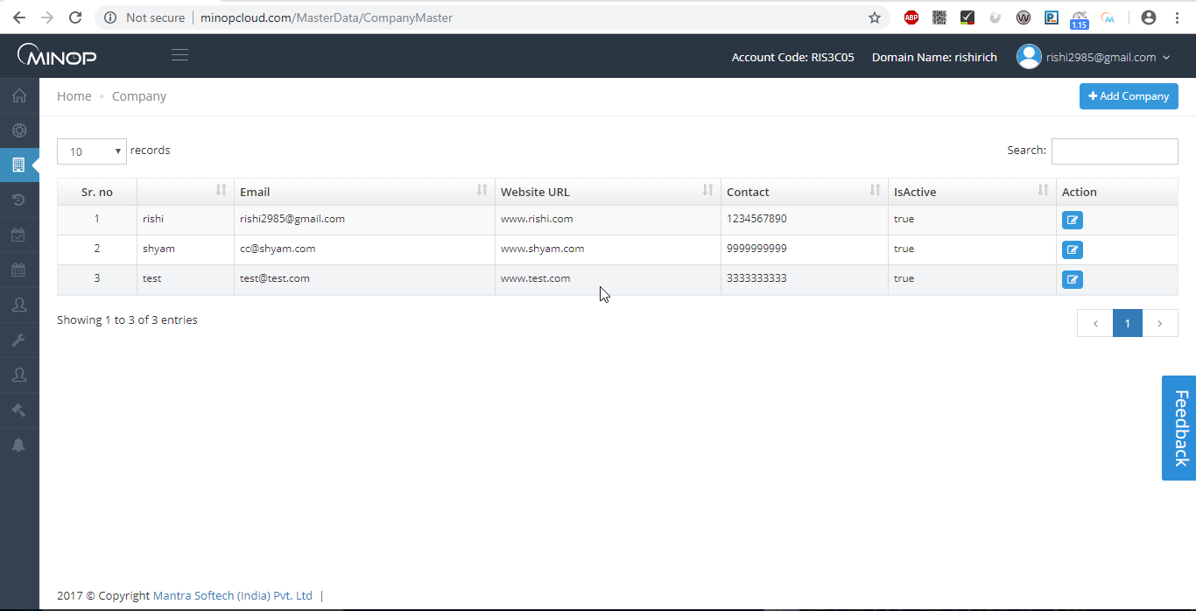
Above image shows company master view.

- When new Account is made than in company page By Default Company is display as added.
- To add new company click on +add company button.

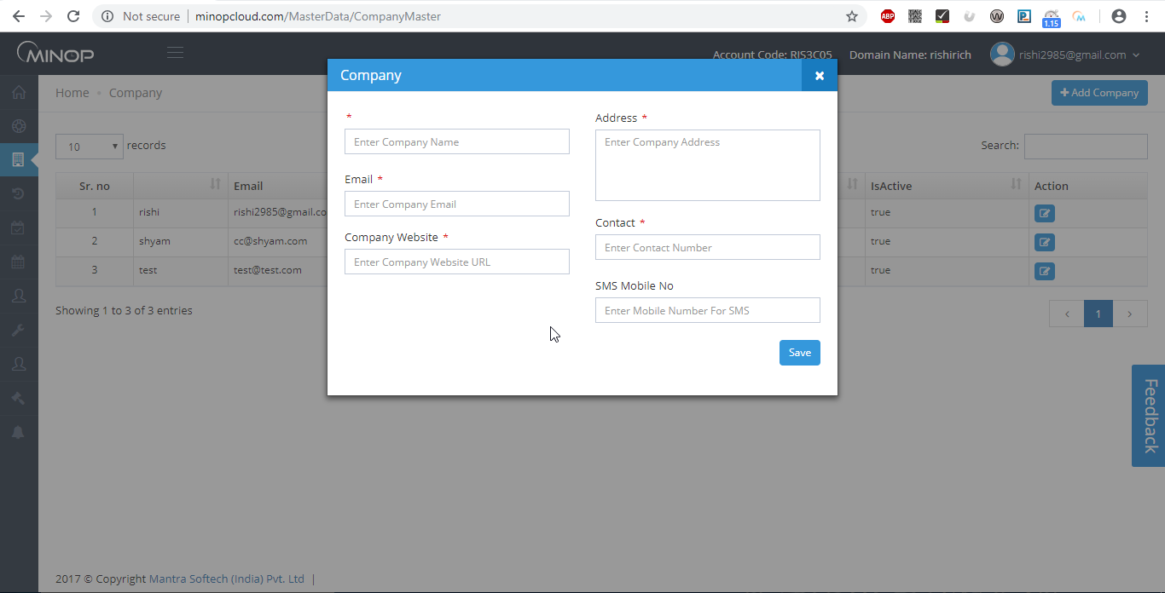
Above image shows pop up when you click on button.

- Save your Company Name, Address, Contact Number, Contact, Mobile No (SMS) and Email ID.

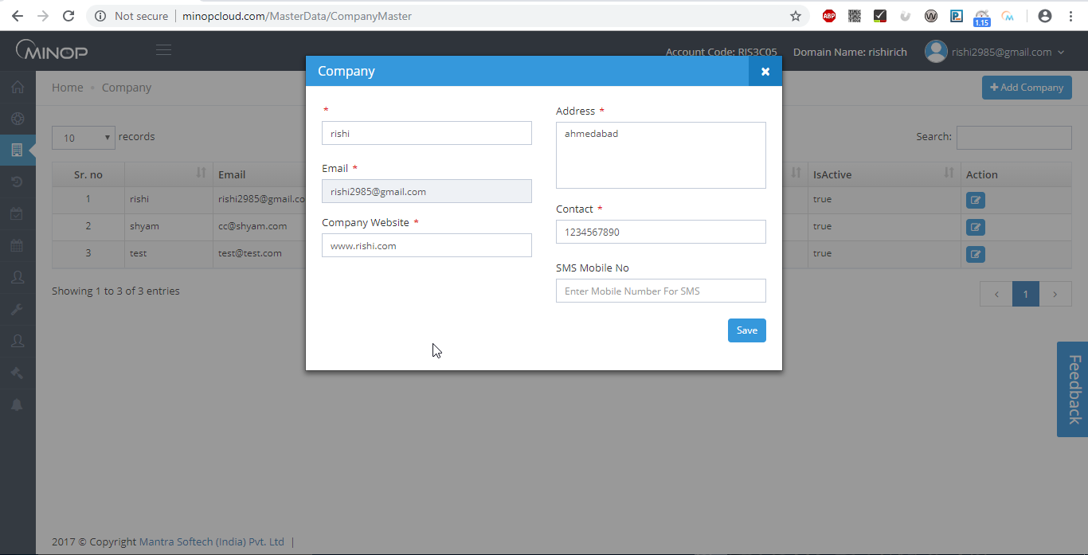
Above image shows example to add details for creating new company.

- If user wants to add other company then he/she can add.
- In Grid it displays all Companies which already entered by you.
- It allows you to Edit Company entries on clicking on ‘Edit’ button.

    - Branch Master

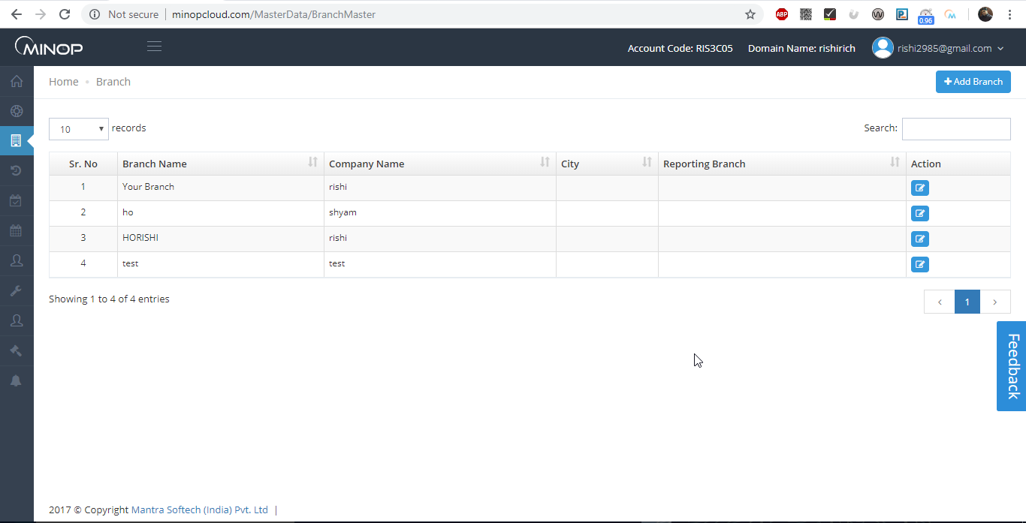
Above image shows view of branch master.

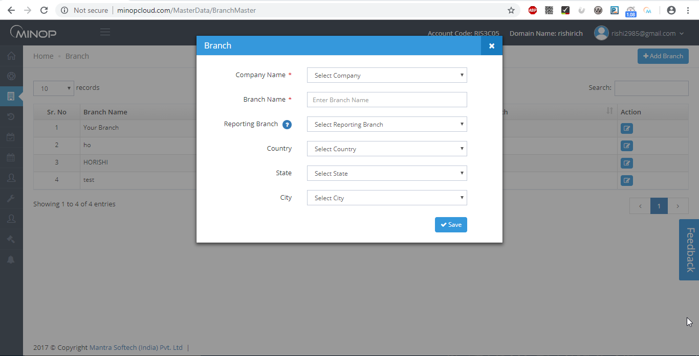
Above image shows when you click on “+add branch” this pop up comes up.

Branch Master brief.
- When new Account is made than in Branch page By Default HO Branch is display as added.
- ➢ To add new Branch, click on ‘Add Branch’ and then select Company then click on ‘Save’ button.
- ➢ In Grid it displays all Branches which are already entered by you.
- ➢ It allows you to Edit Branch entries on clicking on ‘Edit’ button.

    - Department Master

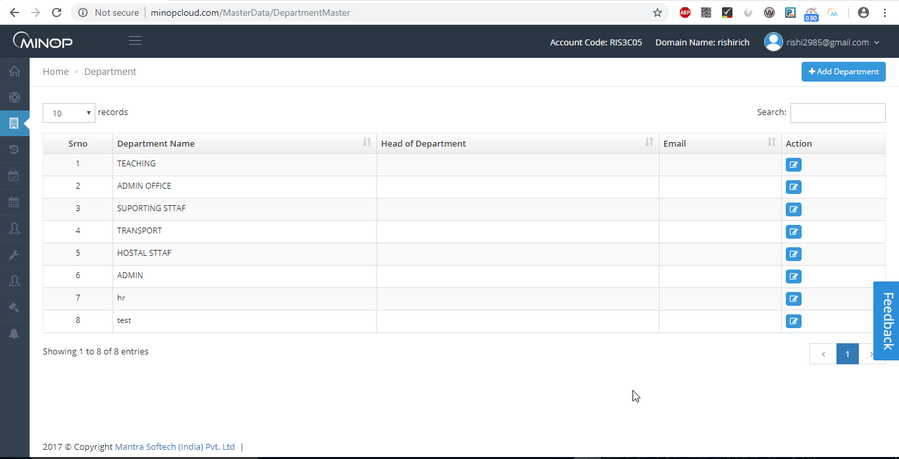
Above image shows view of Department master.
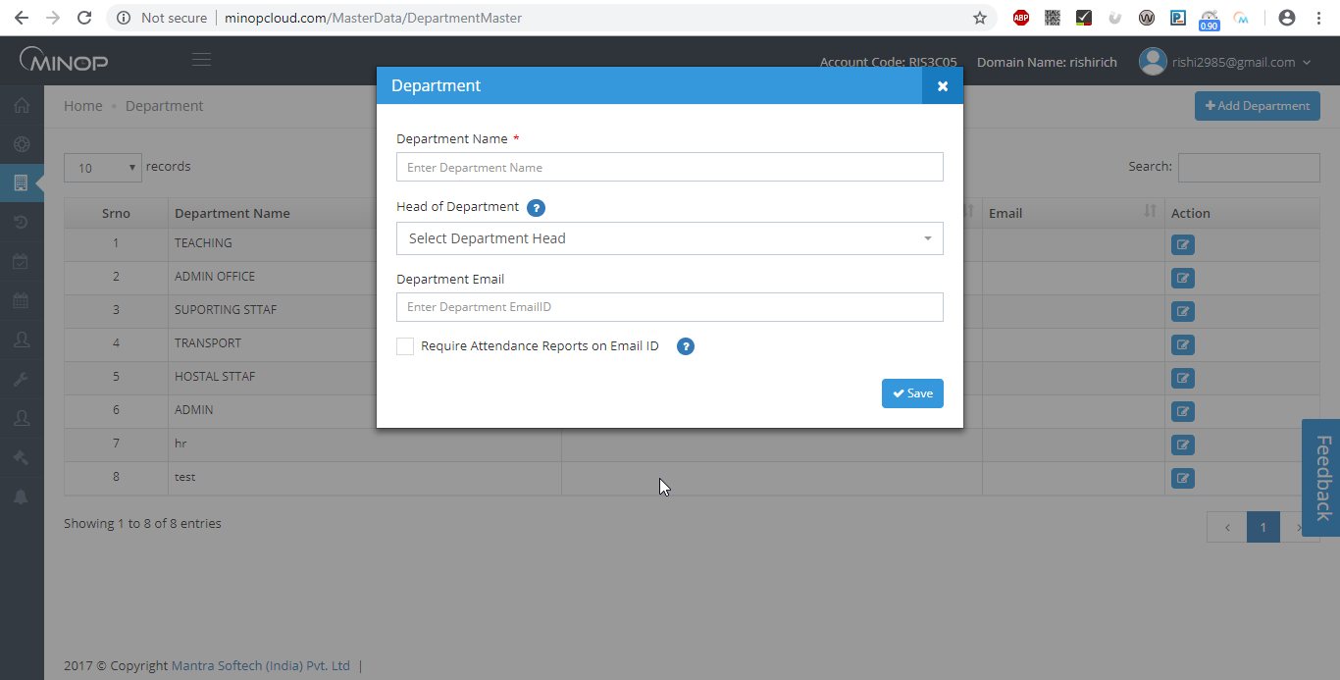
Above image shows when you click on “+Add Department” this pop up will be shown.

Save all available Departments in Department Master.
- To add new Department, Click on ‘Add Department’ and Then fill Name and Head of Department information (register employee name will be listed from employee master), Department Email and then click on ‘Save’ button.
- In Grid, it displays all Departments which are already entered by you.
- It allows you to Edit Department entries on clicking on ‘Edit’ button.
- If Department Head required Attendance Reports of all his/her Employees then tick mark option as shown in Screen.

    - Designation Master

Save all available Designation in Designation Master.

- To add new Designation, Click on ‘Add Designation’ and Then fill Name of Designation and Click on ‘Save’ button.
- In Grid, it displays all Designations which are already entered by you.
- You can Edit Designation entries on clicking on ‘Edit’ button.

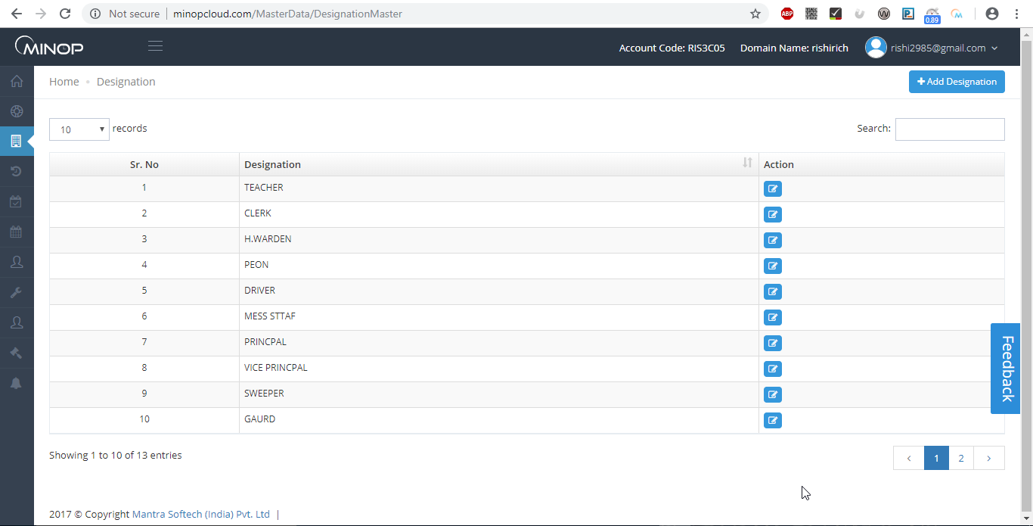
Above image shows view of Designation master.

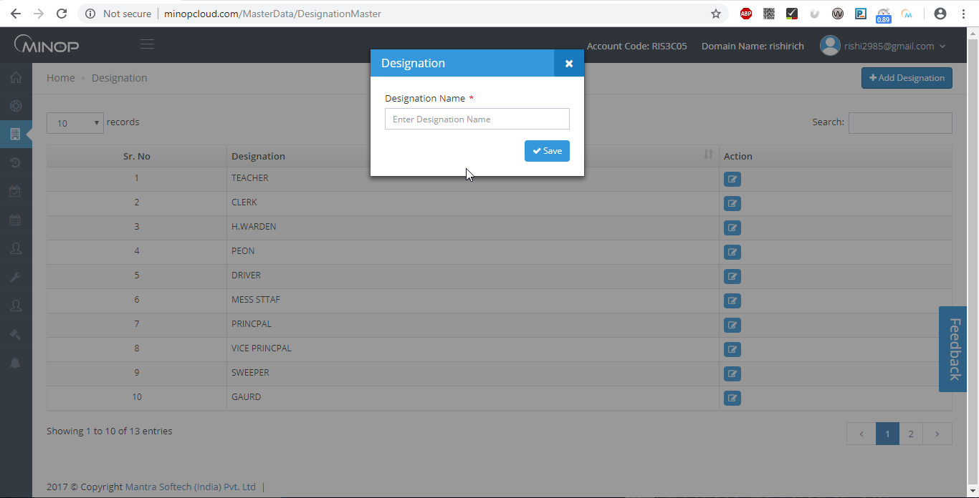
Above image shows when you click on “+ Add Designation” this pop up comes.

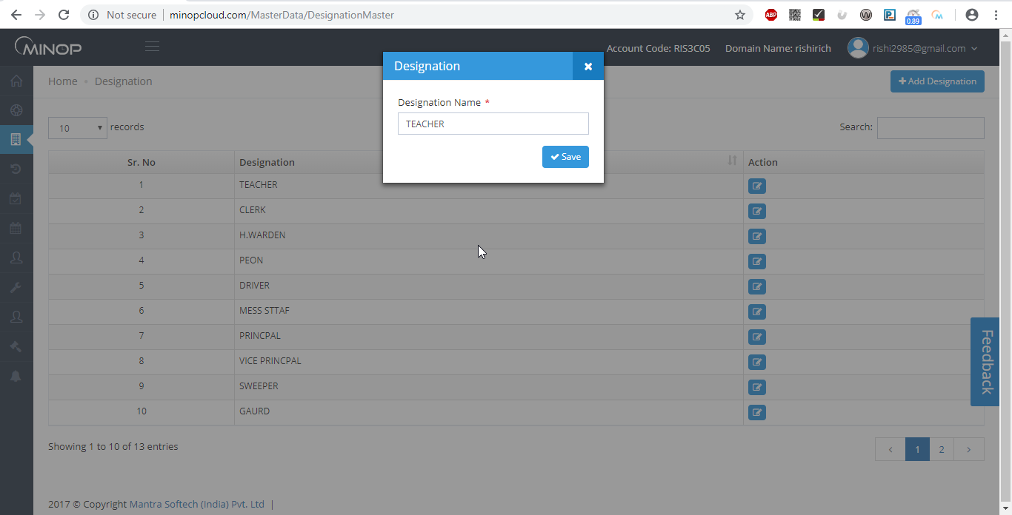
Above image shows example to add details while creating designation.

    - Employee Master

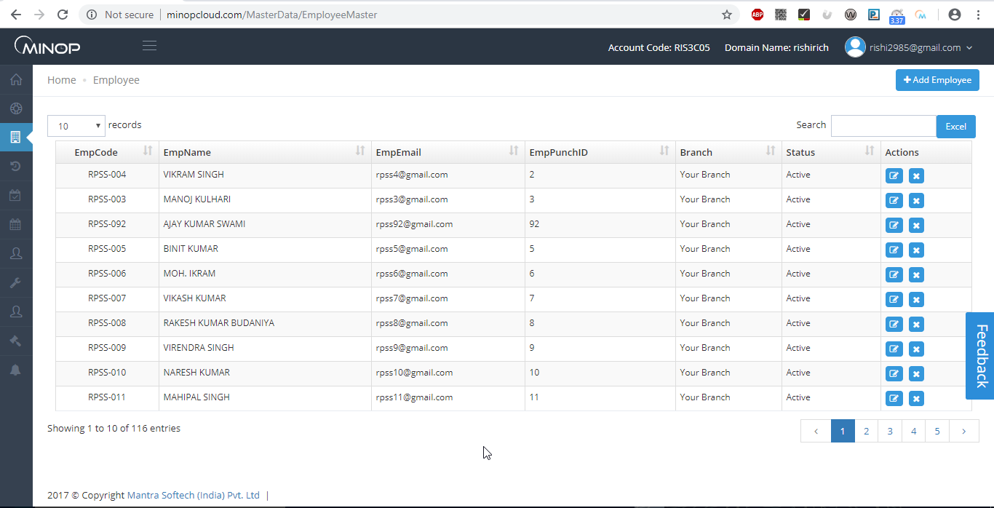
Above image shows view of employee master.
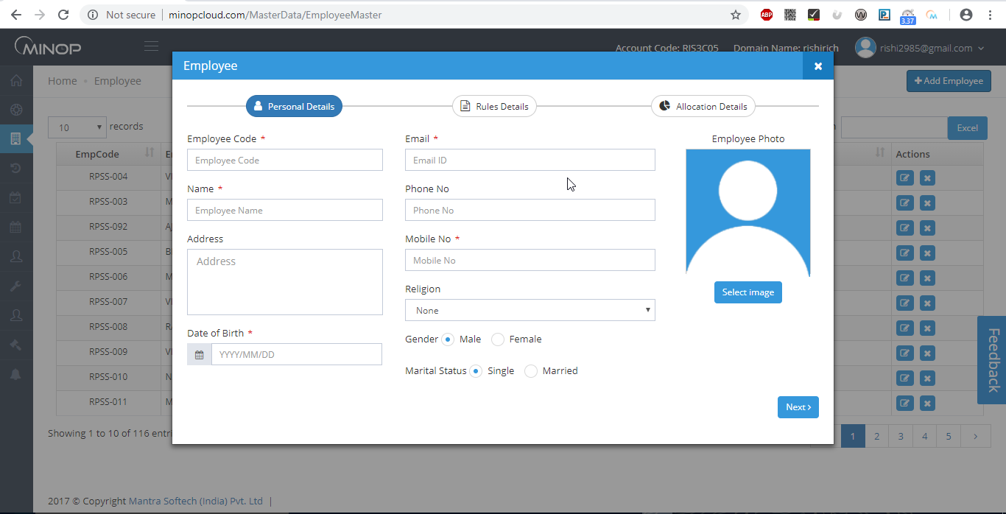
Above image shows pop up that comes when you click on “+add Employee”.

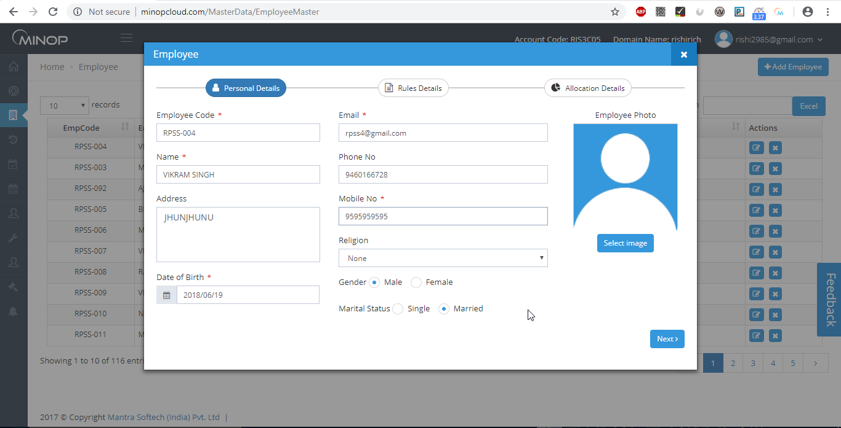
Above image shows example to add details while creating an employee.

Employee Master Brief.
- To add new Employee, Click on ‘Add Employee’ and Then fill Employee details and Click on ‘Save’ button.
- In Grid, it displays all Employee entries which are already entered by you.
- You can edit Employee entries by clicking on ‘Edit’ button.
- By clicking “” button you can add that field from employee master itself.
- If ESS in system setting wizard is off then Email and Mobile Number are not mandatory fields and if ESS in ON then user must enter Email and Mobile Number.

    - Device master

- Configuration of All Devices are needed to be save in Device Master.
- Device ID, Device IP, Port Number, Device Password Details will be available in your Device Menu.
- You can set Device Mode to IN, OUT or Default.

Device Mode:-

- IN – All entries downloaded from the Device will be considered as IN Entries. (If application mode is in fix)
- Out – All entries downloaded from the Device will be considered as Out Entries. . (If application mode is in fix)
- Default – In – Out will be considered from Device In – Out Flag.(depending on application mode in auto mode first will be consider as in and second will be consider as out)
- You have to select Device Type from list displayed in Device Type Fields.
Note:-Check policy for more details on application mode

Push Data Configuration:-

- Server Port –Default server port for Minop is 1018 so you need to make sure in device “manager/server/host port” should be set to 1018.

- Server IP/Host IP (At Device Level) –Default server/host/manager IP for Minop is 103.025.130.030 so you need to make sure this IP is mentioned in device “manager/server/host pc IP”.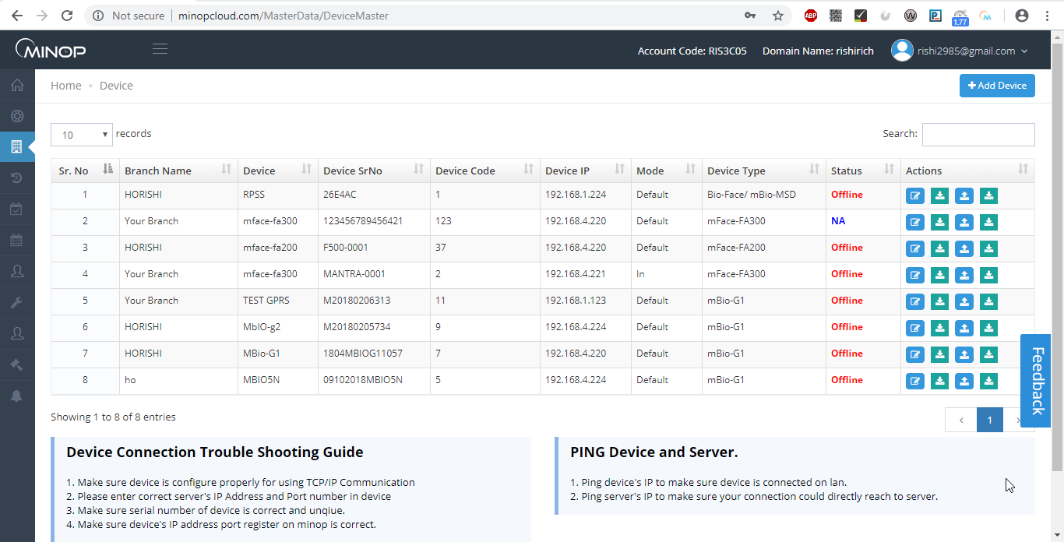
Above image shows view of device master.

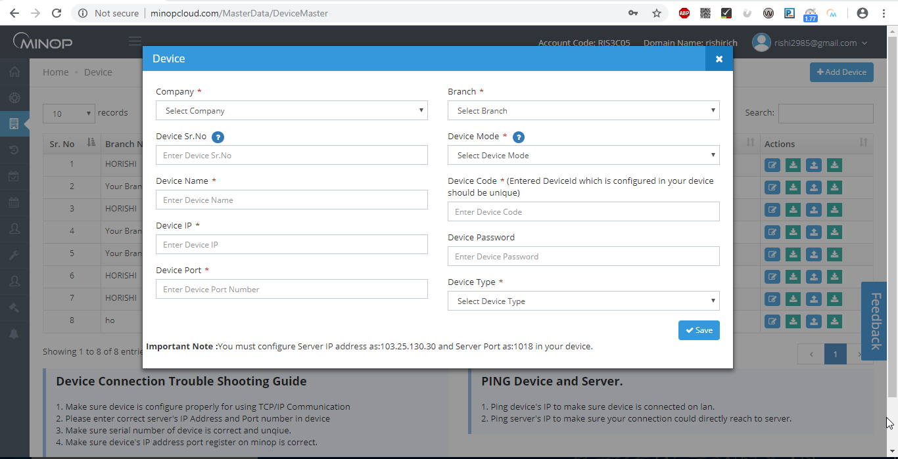
Above image shows view of device master pop up when you click on “+add device”.
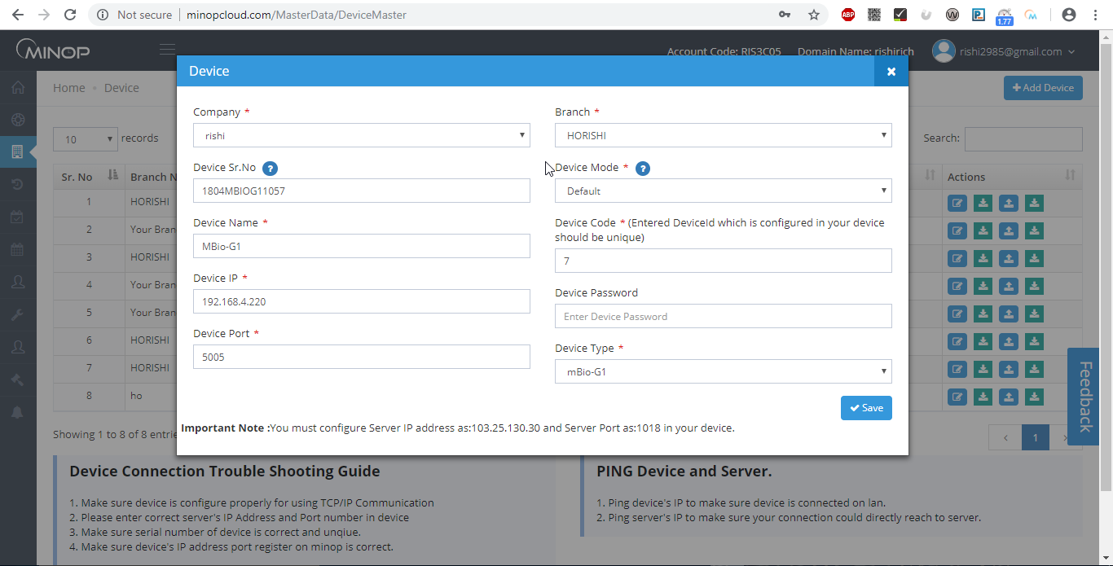
Above image shows example to add device details in device master to register new device.

    - Religion

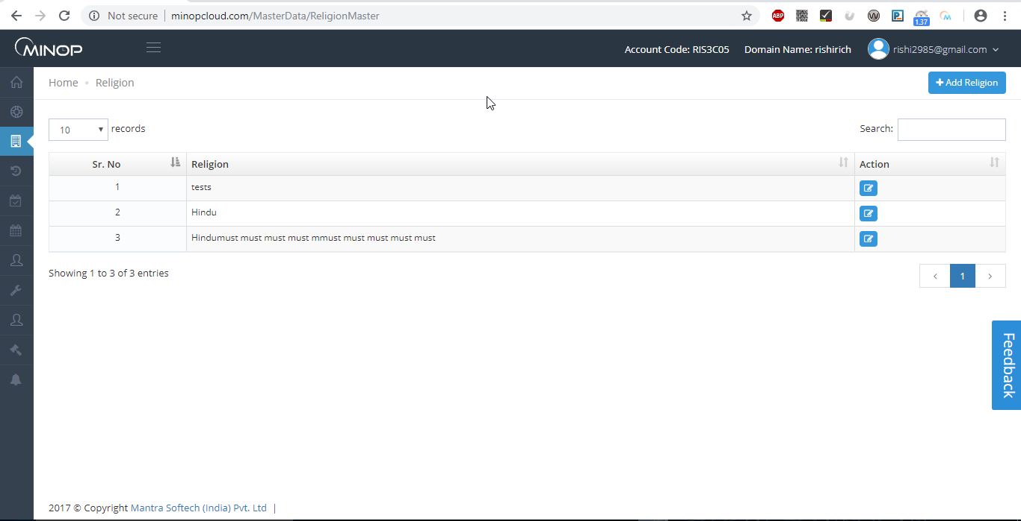
Above image shows religion master view.
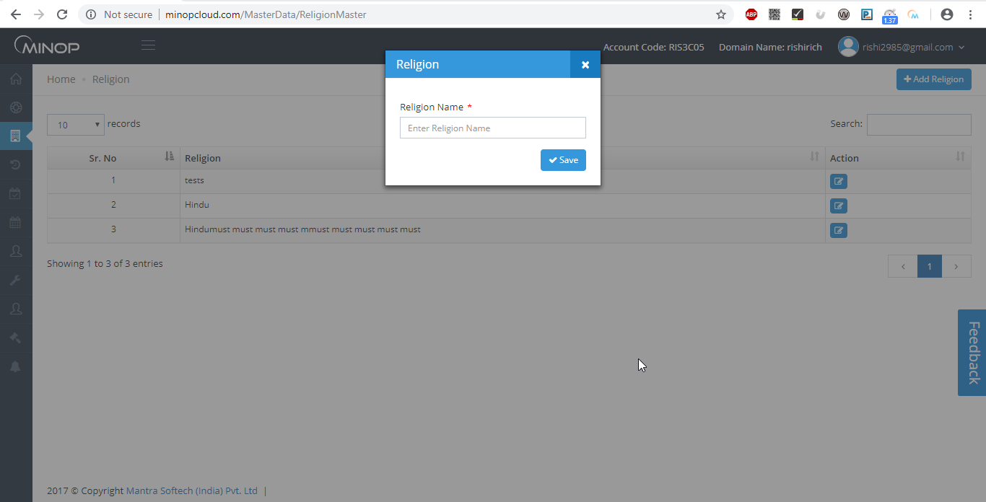
Above image shows when you click on “+Add Religion” pop up.

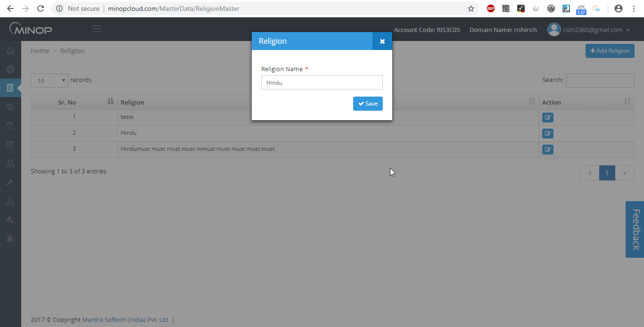
Above image shows example to add religion detail while create new religion field.

Religion Master Brief.

- To add new Religion, Click on ‘Add Religion’ and Then fill Name of Religion and Click on ‘Save’ button.
- In Grid, it displays all Religions which are already entered by you.
- You can Edit Designation entries by clicking on ‘Edit’ button.

Shift Master

    - Shift Group Master

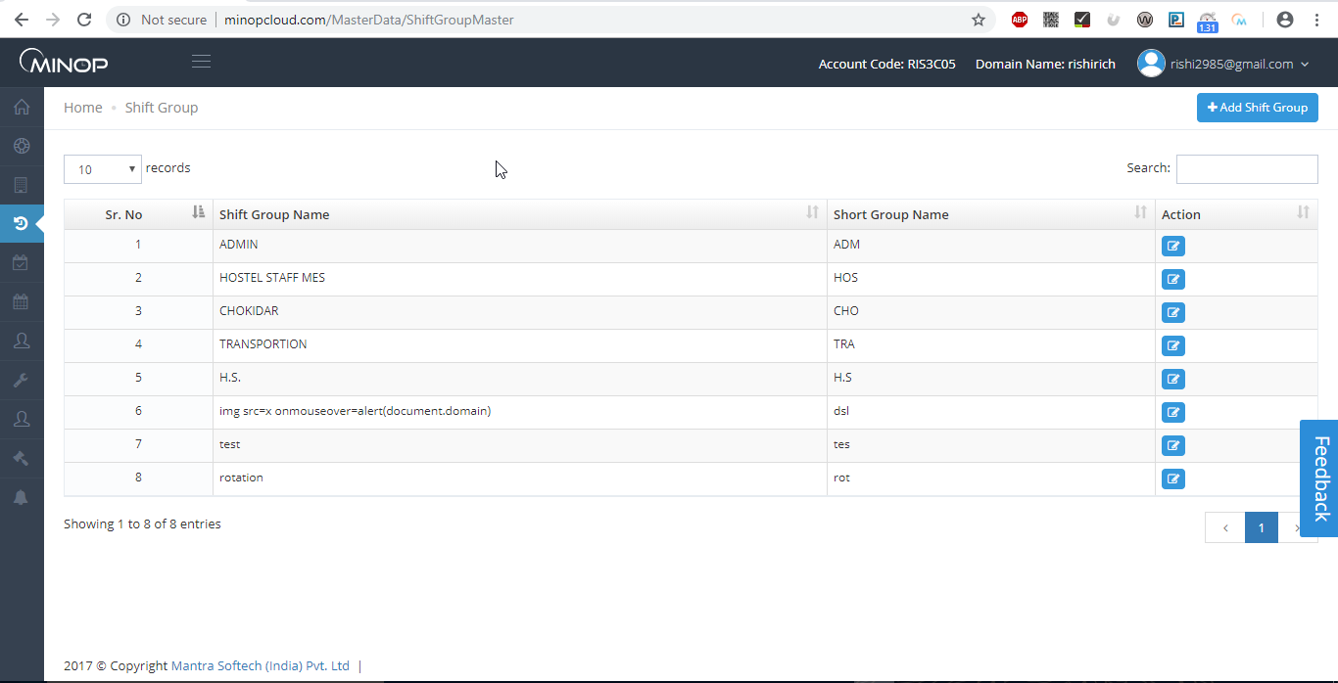
Above image shows view of Shift Group Master.

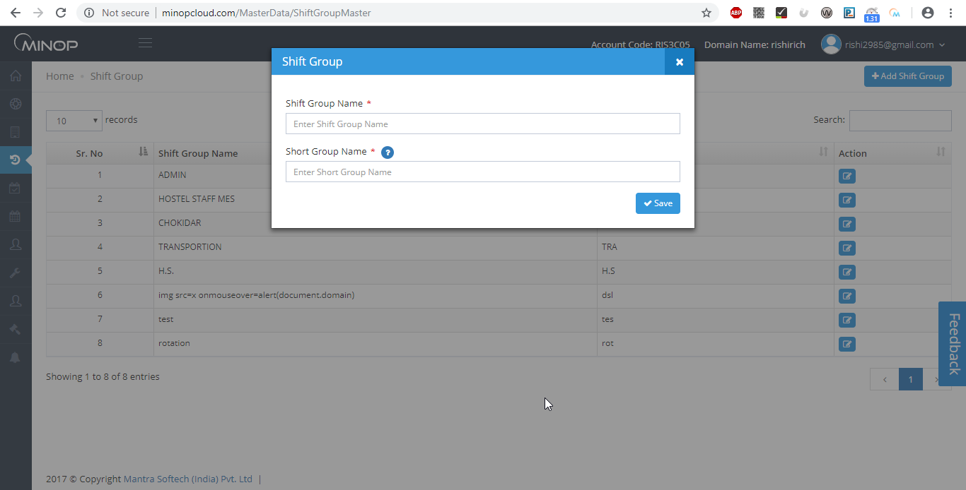
Above image shows pop up of shift group when you click on “+ADD Shift Group”.
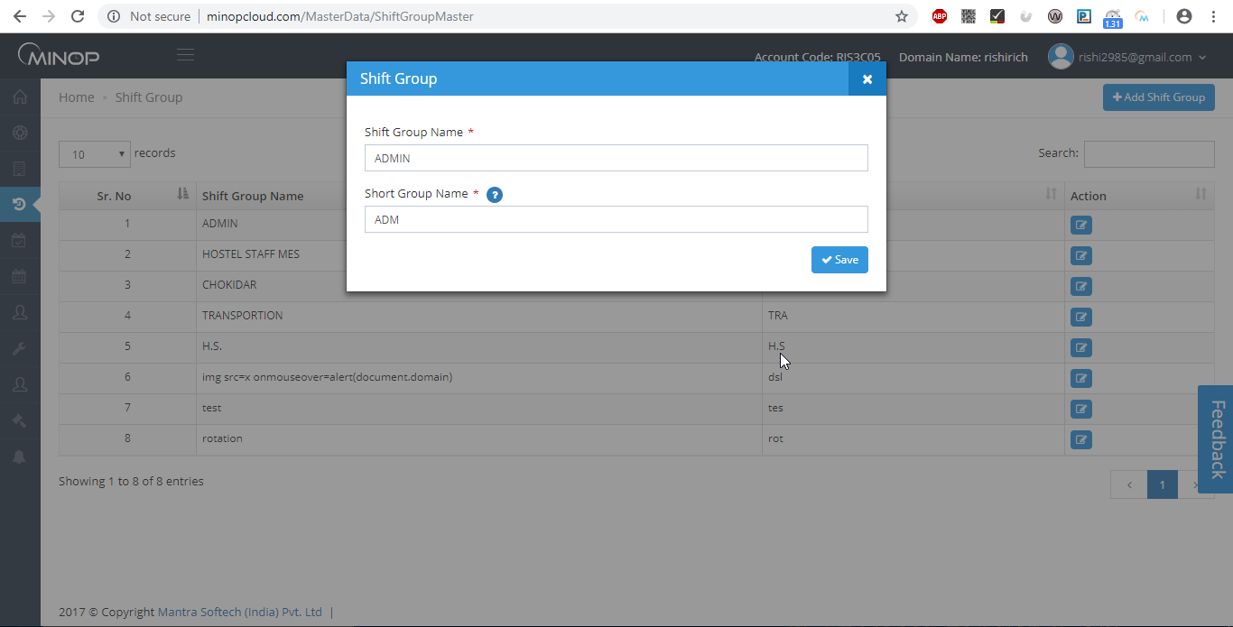
Above image shows example of creating new shift group.

Shift Group Master Brief.
- If Admin User wants to add employee in Rotation shift then add Shift group here and assign this shift group in Shift which you want employee to come in.
- To add new Shift Group, Click on ‘Add Shift Group’ and Then fill Name of Shift Group and Click on ‘Save’ button.
- In Grid, it displays all Shift Groups which are already entered by you.
- You can Edit Shift Group entries by clicking on ‘Edit’.
- This option is used to allocate employee multiple or option or rotational shifts

    - Shift Master

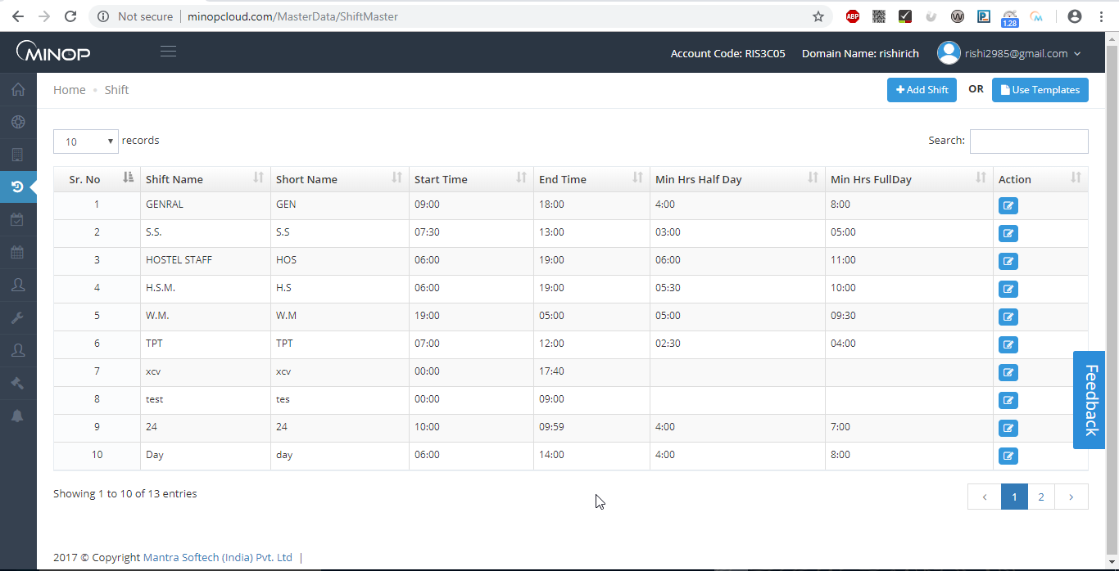
Above image shows view of shift master.

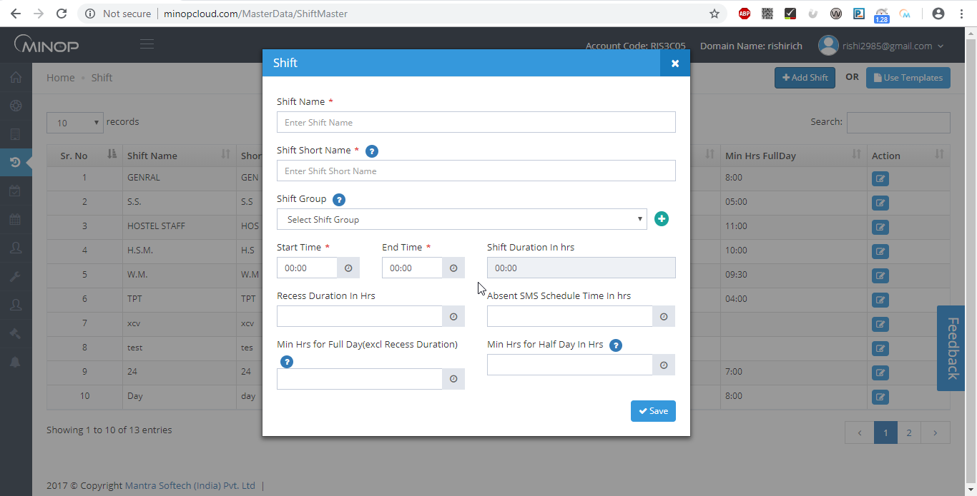
Above image show pop up when you click on “+Add Shift”.
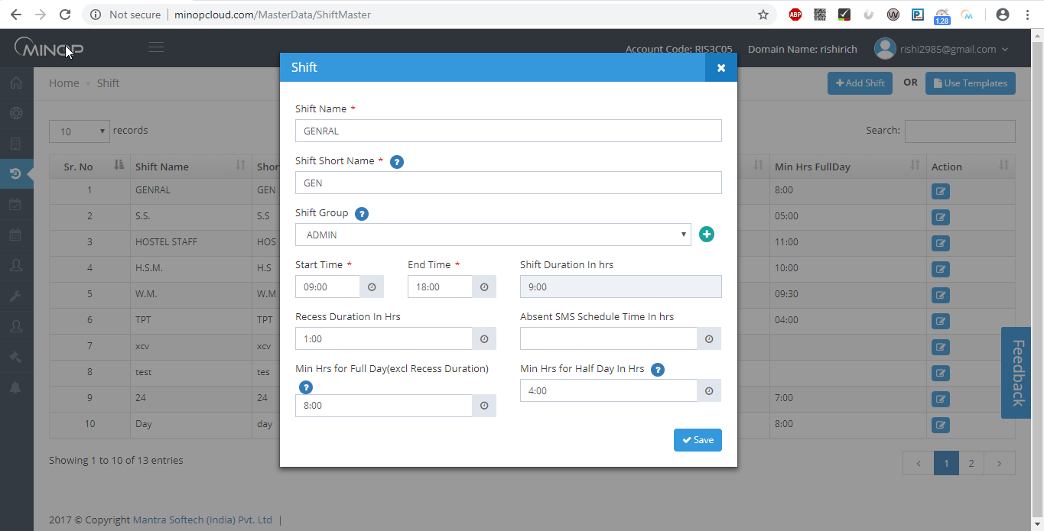
Above image shows example to add details while creating shift.

Save all Shifts required in the Shift Master.
- Name: - Name of Shift
- Shift Group: - Assign Shift to Shift Group (in Auto shift assign Shift Group to Employee)
- Time: - Start Time and End Time of Shift (24 hours format)
- Duration: - It will be automatically calculated based on Shift Start Time and End Time.
- Recess Duration: - It will be deducted from Total Hours.
- Min Hrs. for Half Day: -
   ▪ If Employee worked more than Minimum Hours. for Half Day then his/her attendance will be counted as Half Day.
▪ If Employee worked less then Minimum Hours. for Half Day then his/her attendance will be counted as Less Hour.
- Min Hrs. for Full Day: -
▪ If Employee worked more than ‘Min Hrs. for Half Day’ then his/her attendance will be counted as Present.
- ▪ If Employee worked more than ‘Min Hrs. for Full Day’ then working Hours more than ‘Min Hrs. for Full Day’ will be considered Over Stay (OS) if overtime in hr policy is selected as yes.
▪ If the employee has worked less than ‘Min Hrs. for Full Day’ then system will check if it’s working hour greater than ‘Min Hrs. for Half Day’ then final status will be HD.

    - Shift Allocation

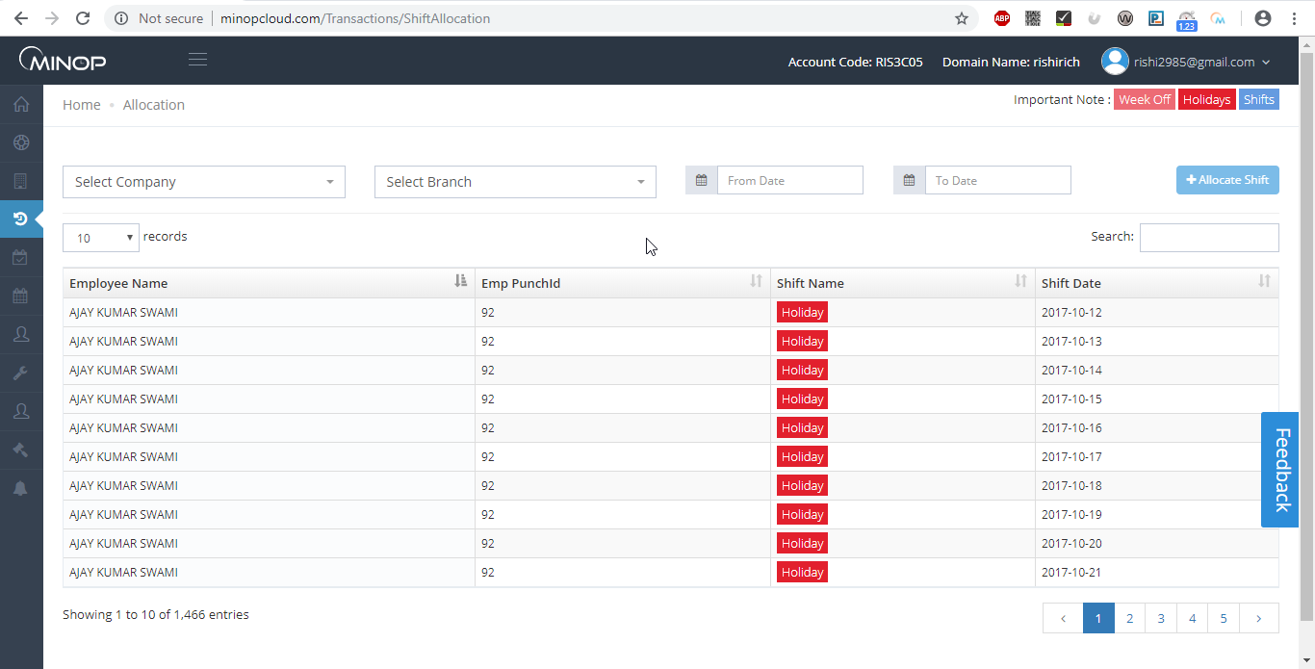
Above image shows view of shift allocation.
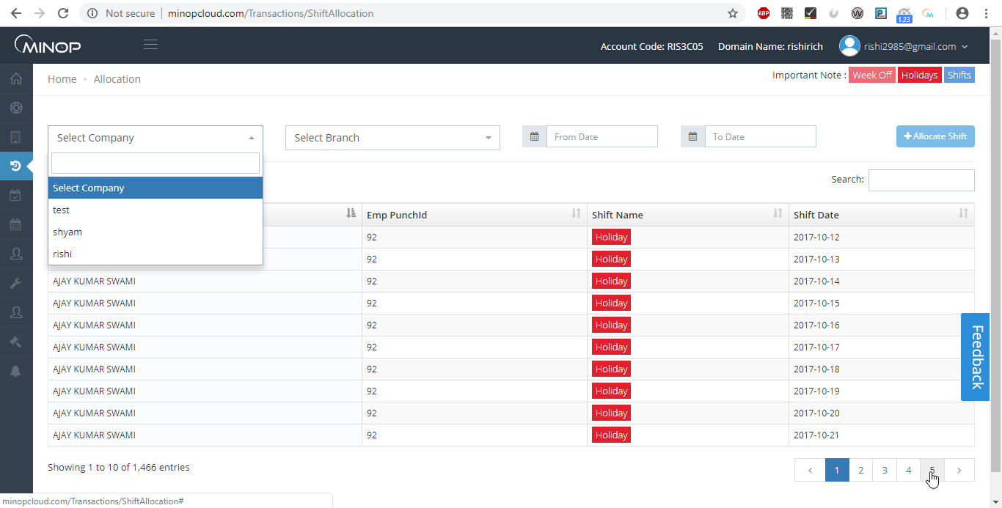
Above image shows selection option to view in grid.

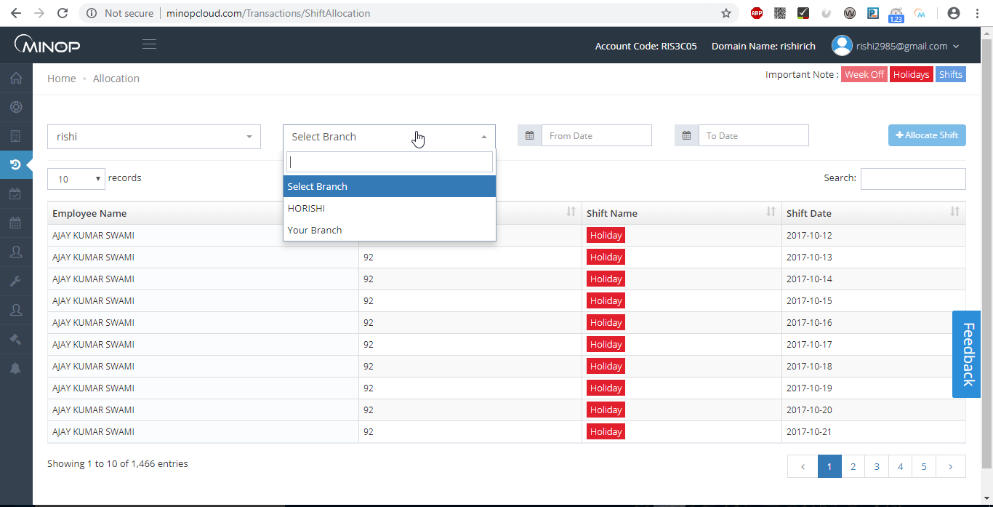
Above image shows to filter information in grid.

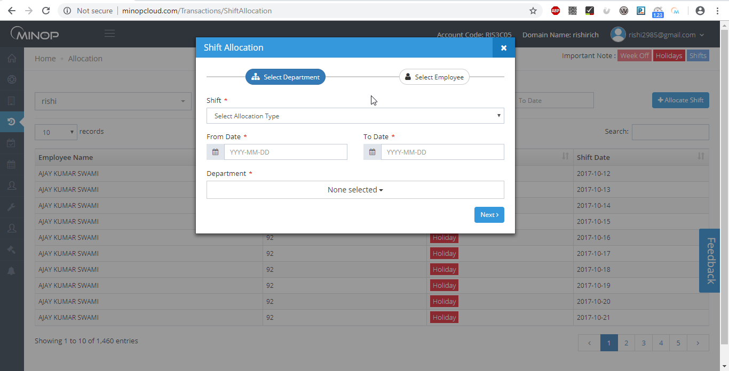
Above image show pop up when you click on “+Allocate Shift”.

- Shift Allocation allows you to allocate Shift to Employee for particular date range.
- To Allocate Shift first select Company then select branch, and click on ‘Allocation Shift’ button and Then fill all related details and Click on ‘Save’ button.
- By Default Employee shift will be carried out from Employee Master. But if your Shift changed on Daily, Weekly or Monthly Basis then you can allocate from above screen.
- Third List display already allocated shift details of Employee Between selected dates.
- You can assign Weekly off and Holiday off for selected dates from above screen.

1.3 Leave Master

1.3.1 Leave Type Master

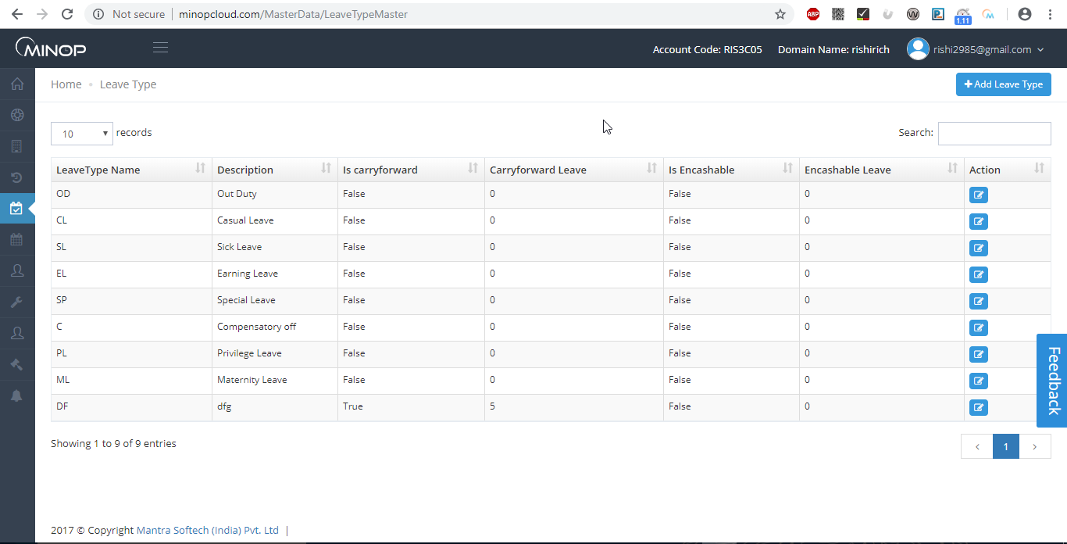
Above image shows view of leave type master.

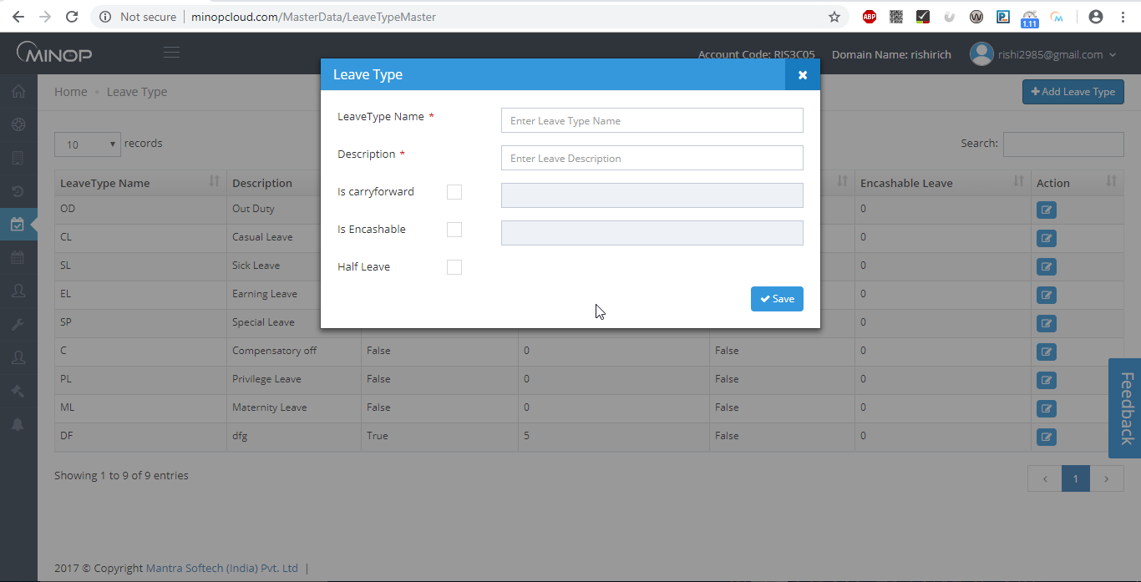
Above image shows pop up when we click on “+Add Leave Type”.

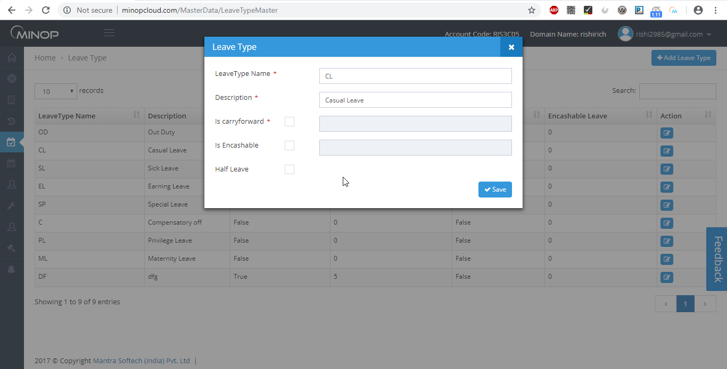
Above image shows example to add details while creating new leave type.

- Save all leaves type offered to employee in your company in Leave Type Master.
- To add new Leave, click on ‘Add Leave Type’, fill Name of Leave Type, Description, check weather Leave is Carry forward or Encashable and number of leave how much it will be carry forwarded or encash after end of transaction year, Half Leave Application or Not and then click ‘Save’ button.
- In Grid, it displays all Leave Types which already entered by you.
- You can Edit Leave Type entries on clicking on ‘Edit’ button.

    - OnDuty/Leave Entry

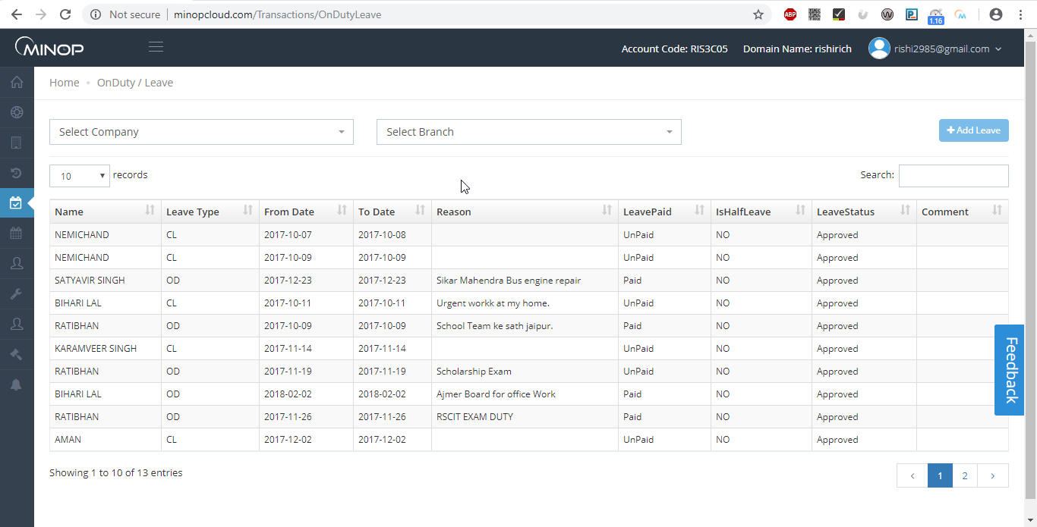
Above image shows view of OnDuty/Leave Entry.

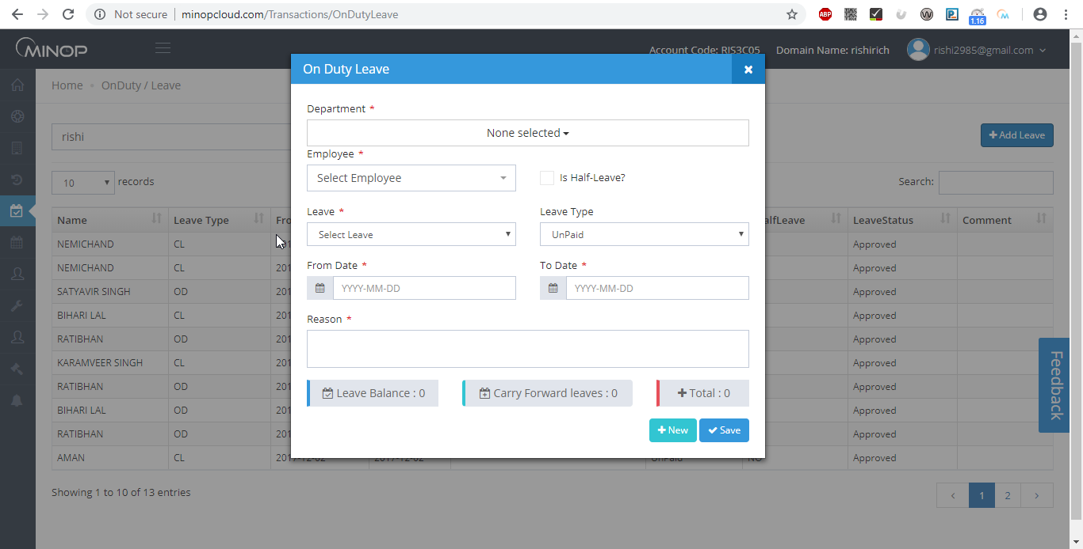
Above image shows pop up when we click on “+Add Leave”

- On Duty Entry:-

- If Employee went for Company related work and unable to punch on Device Terminal.
- In Attendance Report, status will be shown as ‘OD’.

- Leave Entry:-

- You can add Employee’s Full Day or Half Day Leave as per balance available for particular Leave.
- In Attendance Report, status will be shown with leave type name.
- In Half Leave case ‘H’ will be Append before Leave Type Name.

For example: - For Half CL, state will be shown as ‘HCL’.

    - Leave Sanction

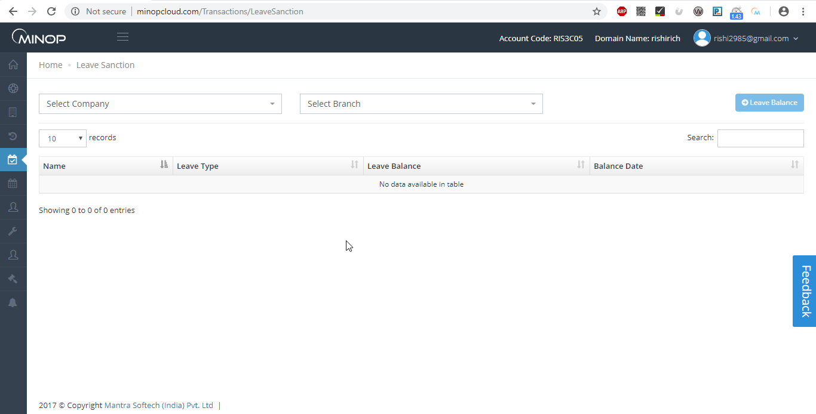
Above image shows view of Leave Sanction.

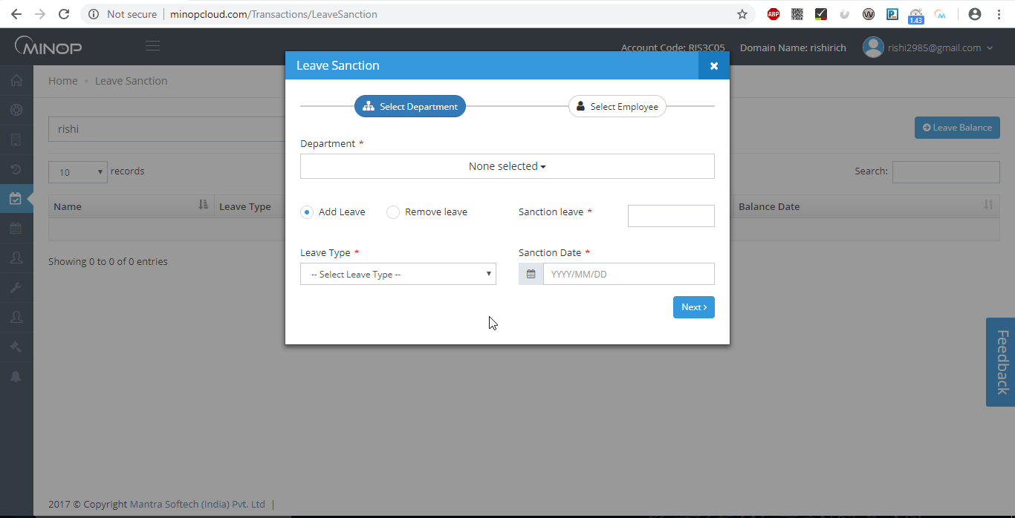
Above image shows pop up when you click on “+Leave Balance”.

- Leave Sanction allows you to sanction Leave balance to Employee for particular Transaction Year as per sanction date.
- For sanctioning Leave, You need to select Leave type, number of leave balance to add, Enter Leave Amount and Employees from the list and Click on ‘Save’ button.
- Third List display already sanctioned Leaves of Employee.

    - Leave Encash/Carryforward

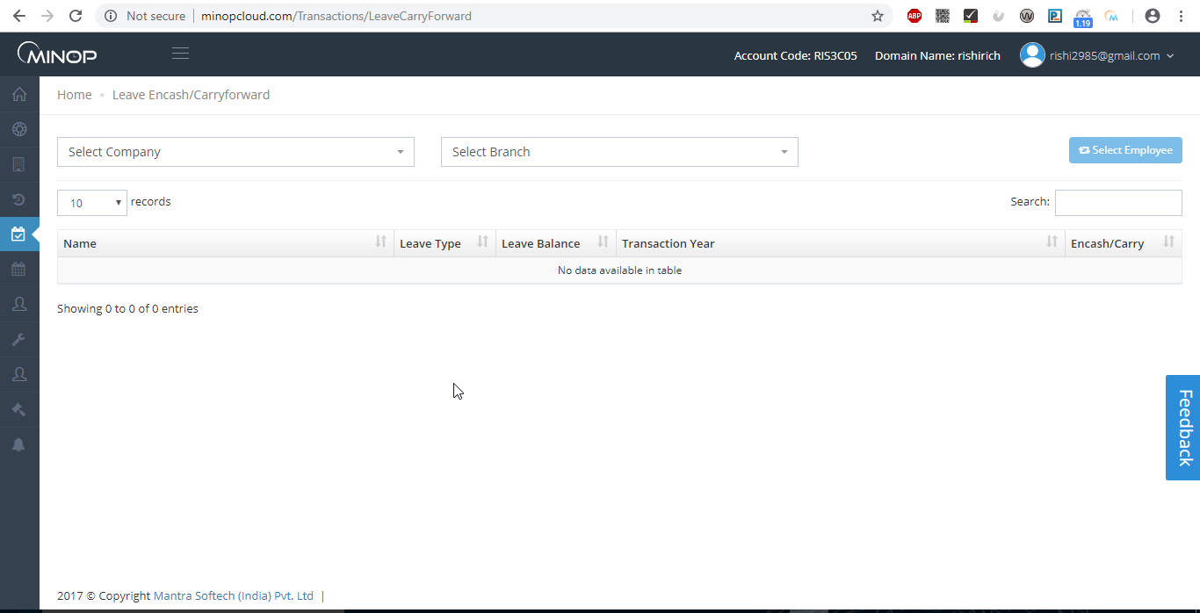
Above image shows view of “leave Encash/Carryforward”

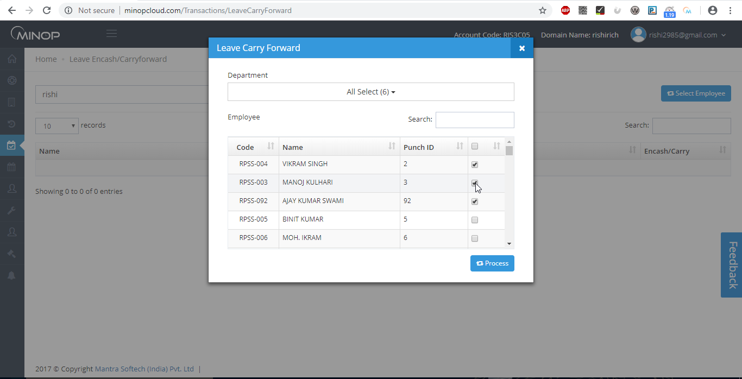
Above image shows pop up when you click on button.
- Leave Encash/Carryforward will Encash or Carryforward Leaves to Next Transaction Year.
- You need to select Department, Employees and then click on ‘Process’ button.

    - Leave Encash/Carryforward Rollback

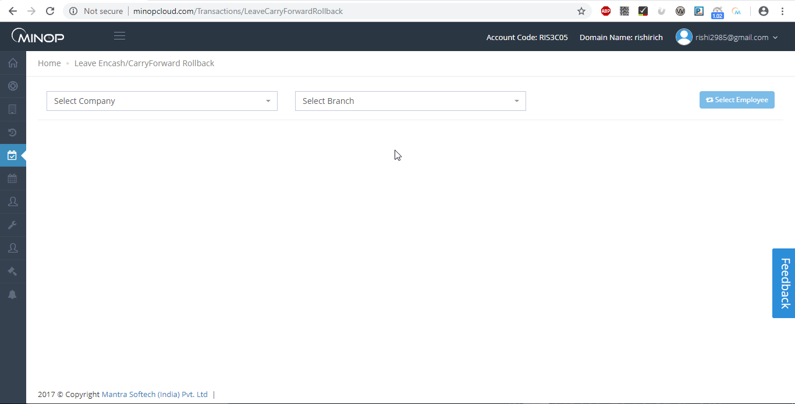
Above image show view of Leace Encash/Carryforward Rollback.
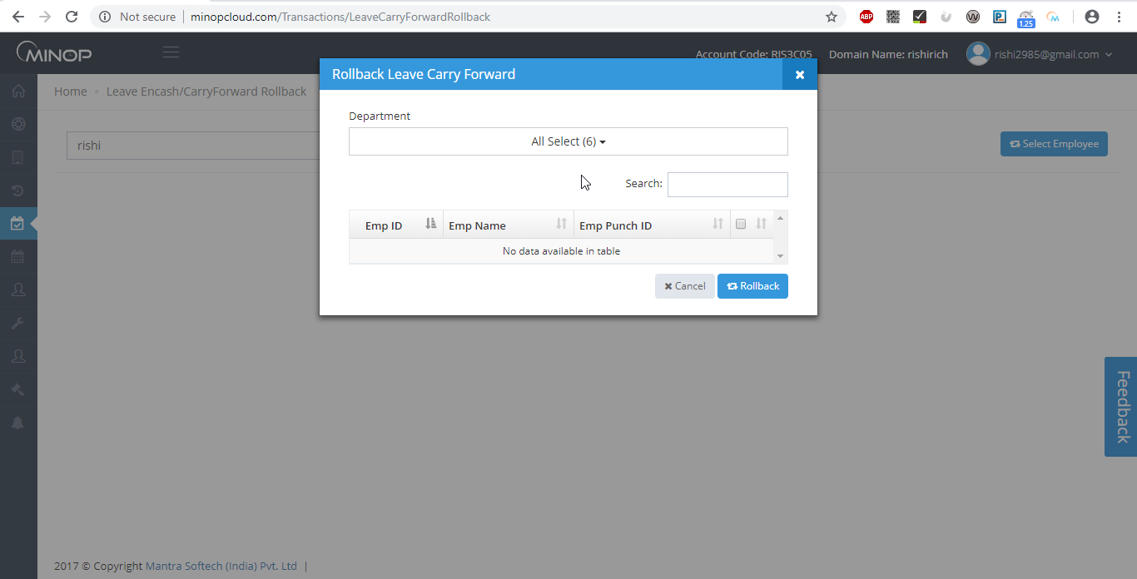
Above image shows pop up when you click on.
- Leave Encash/Carryforward will Rollback your Encash or Carryforward Leaves.
- You need to select Department, Employees and then click on ‘Rollback’.

1.7 Holiday Master

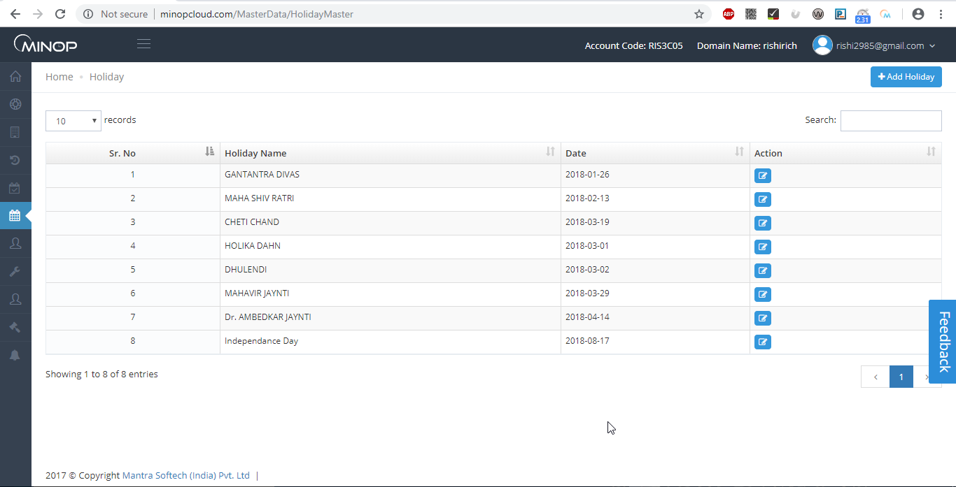
Above image shows view of Holiday Master.
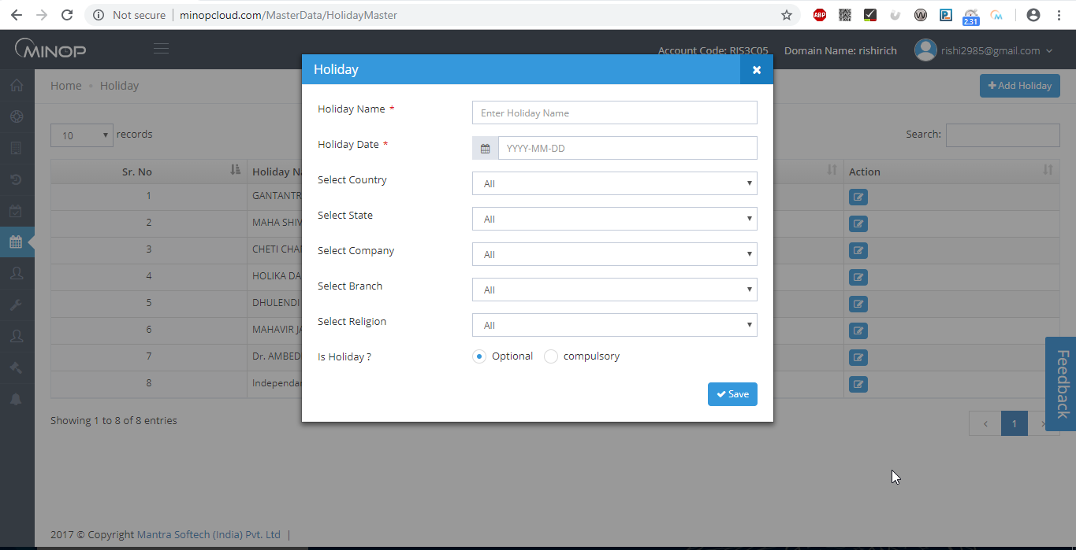
Above image shows pop up when you click on.
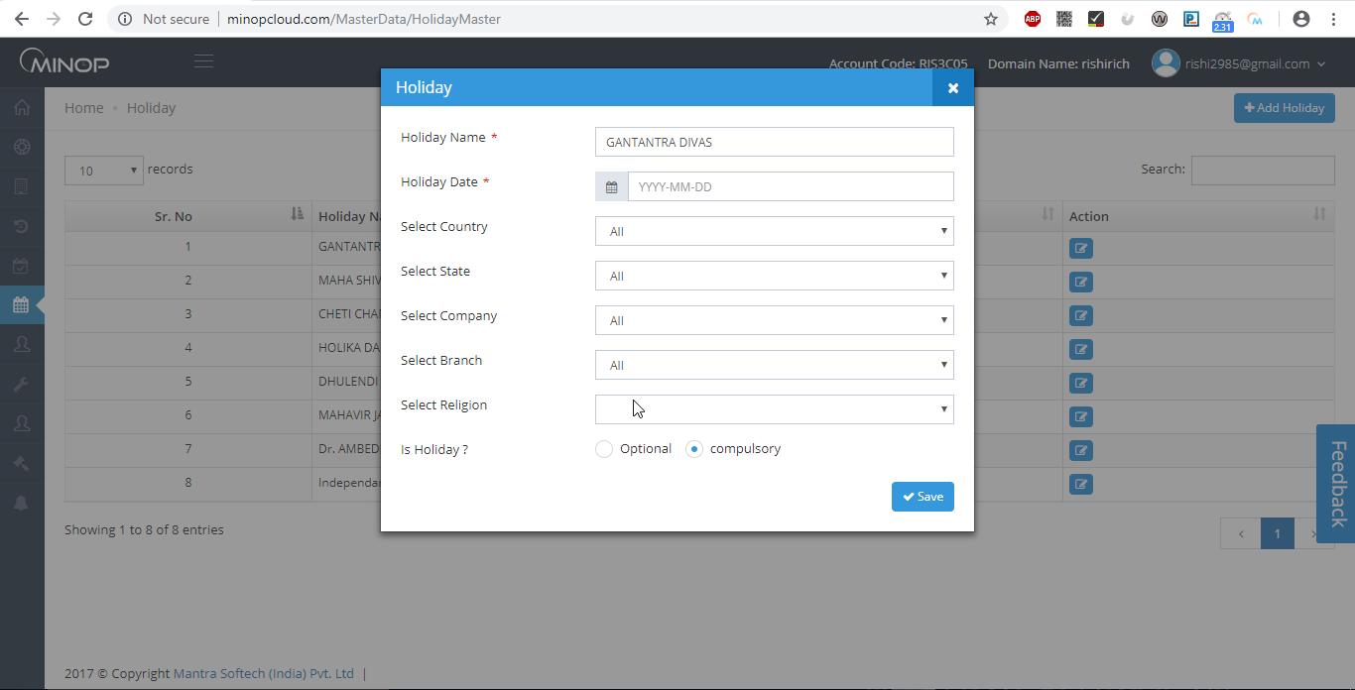
Above image shows example to add Holiday.

- Save all Holidays in Holiday Master.
- To add new Holiday, Click on ‘Add Holiday’ and Then fill Name of Holiday, Select Holiday Date, Country, state, company, branch and Click ‘Save’ button.
- In Grid, it displays all Holidays which already entered by you.
- You can Edit Holiday entries by clicking on ‘Edit’ button.

  - User Management:

The User Management has the following Items.
- Role Master
- Right Distribution

    - Role Master

Save all Roles in Role Master.
- To add new Role, Click on ‘Add Role’, fill Role Name and click on ‘Save’.
- User who has above role assign will have rights of those companies which are selected in above Screen.
- In Grid, it displays all Roles which already entered by you.
- It allows you to Edit Role entries by clicking on ‘Edit’ Button.

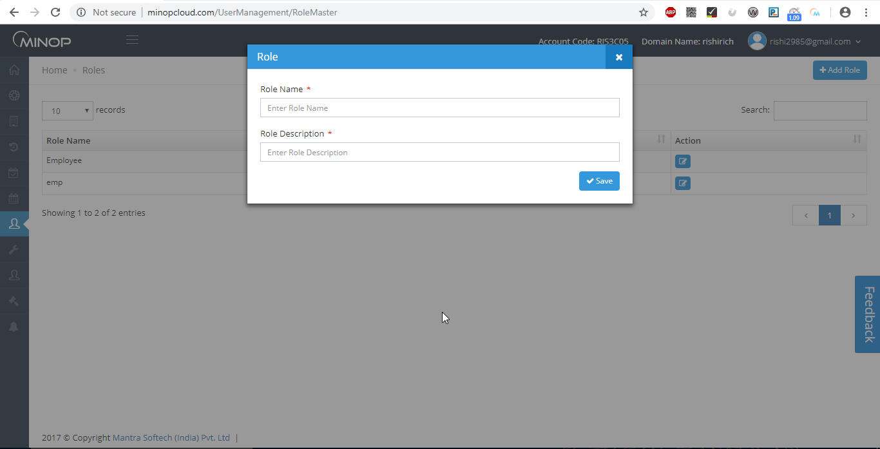
Above image shows pop up when you click on.

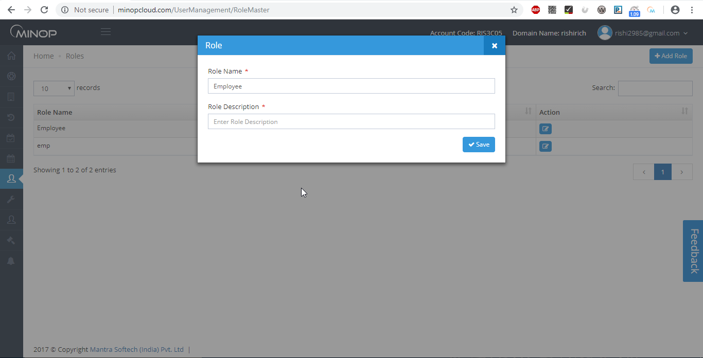
Above image shows example to add role in role master.

    - Right Distribution

- All roles which are entered in Role Master will be displayed in above screen.
- From above screen, you can configure which type of rights like Add, Edit or Read will be given for selected role.

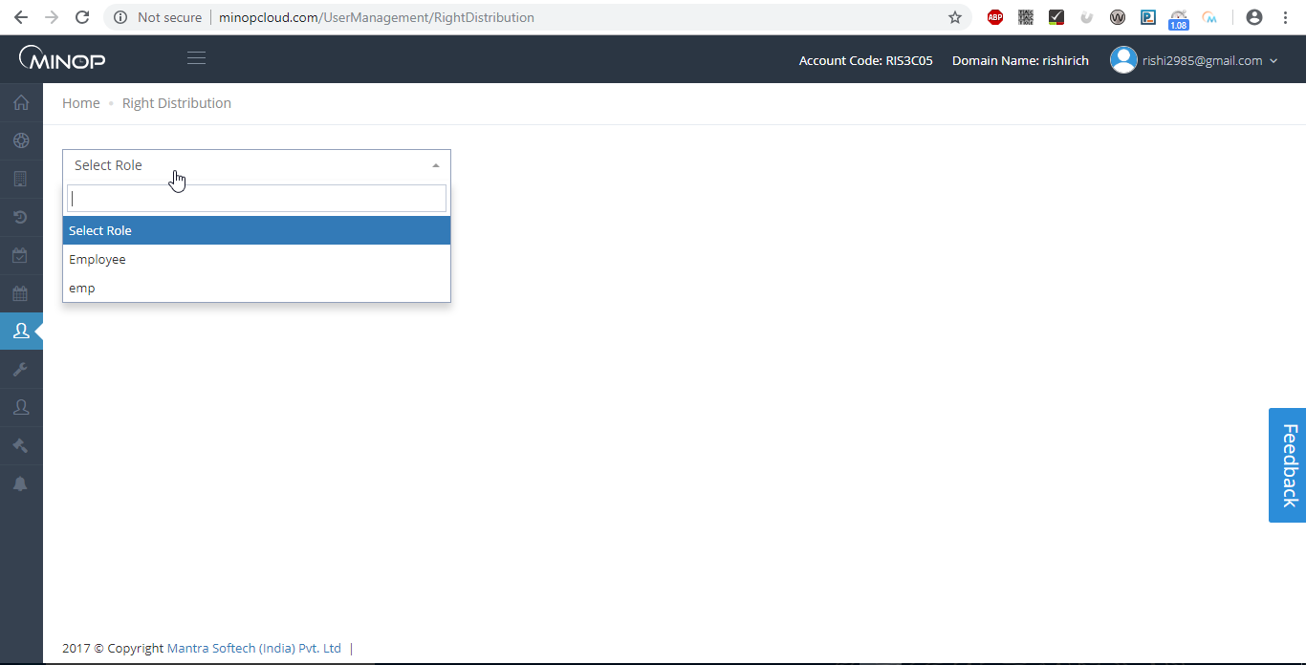
Above image shows view of right distribution.

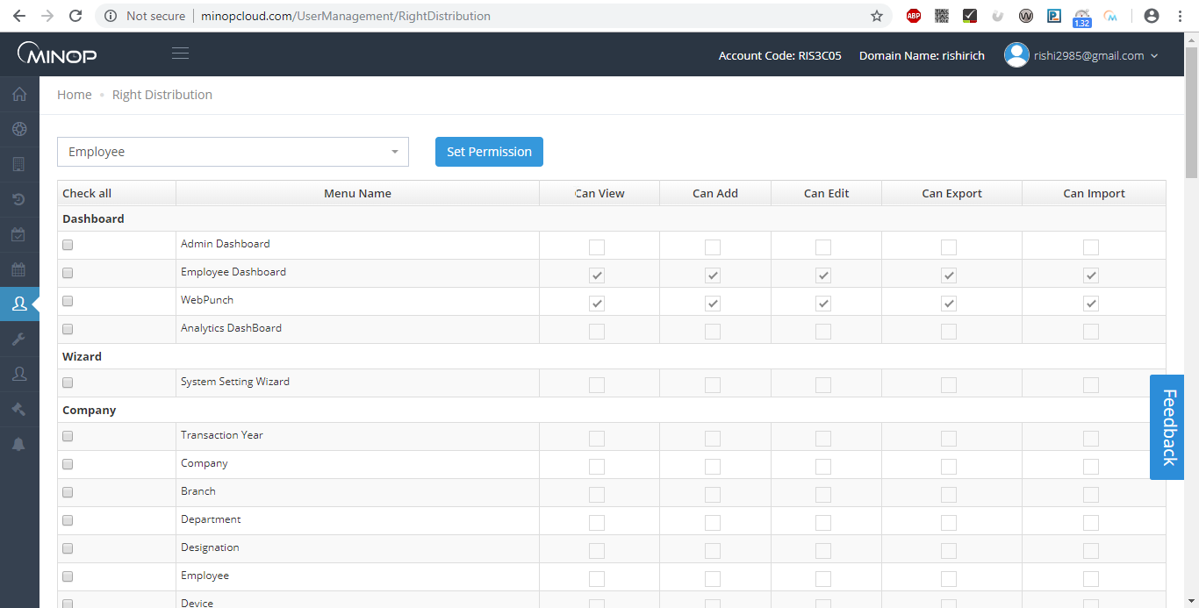
Above image shows example to distribute right to any role.

  - Utilities Menu

1.6.1 Manual Punching

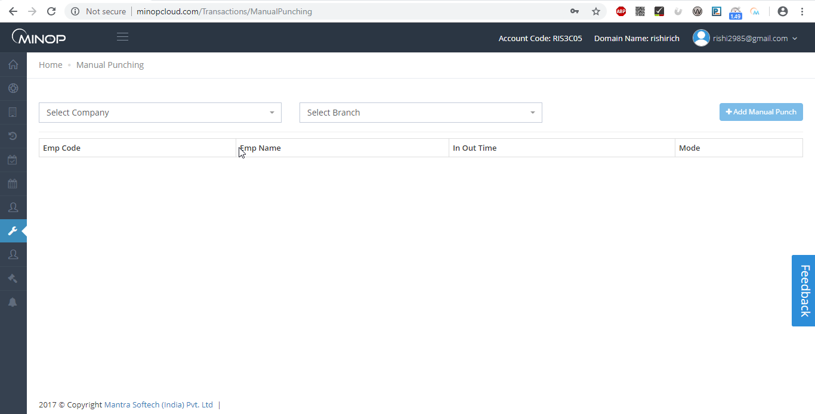
Above image shows view of manual punch.

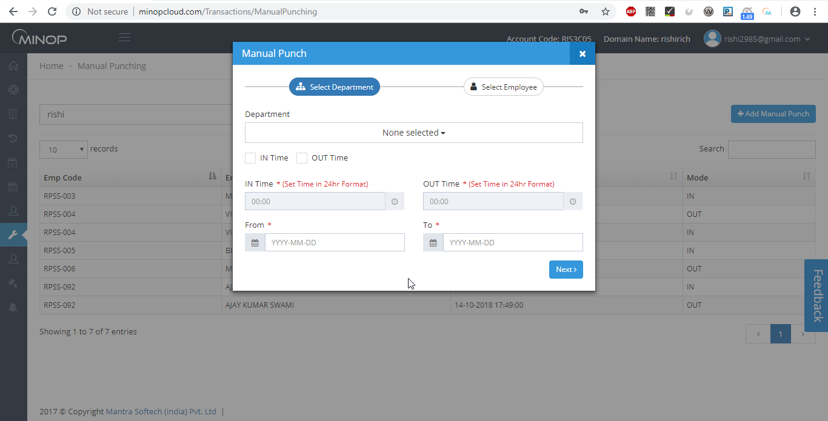
Above image shows example to add manual punch.

- Manual entries of attendance with IN – OUT timing and attendance date can be entered by selecting manual punching option in Utilities menu.
- To save manual entry, select Employee from list, mode of IN – OUT, IN –OUT timing with date to do manual punching then click on ‘Save’ button.
- It is very useful in case of employee forgot to punch in device Terminal.
    - Import Employees
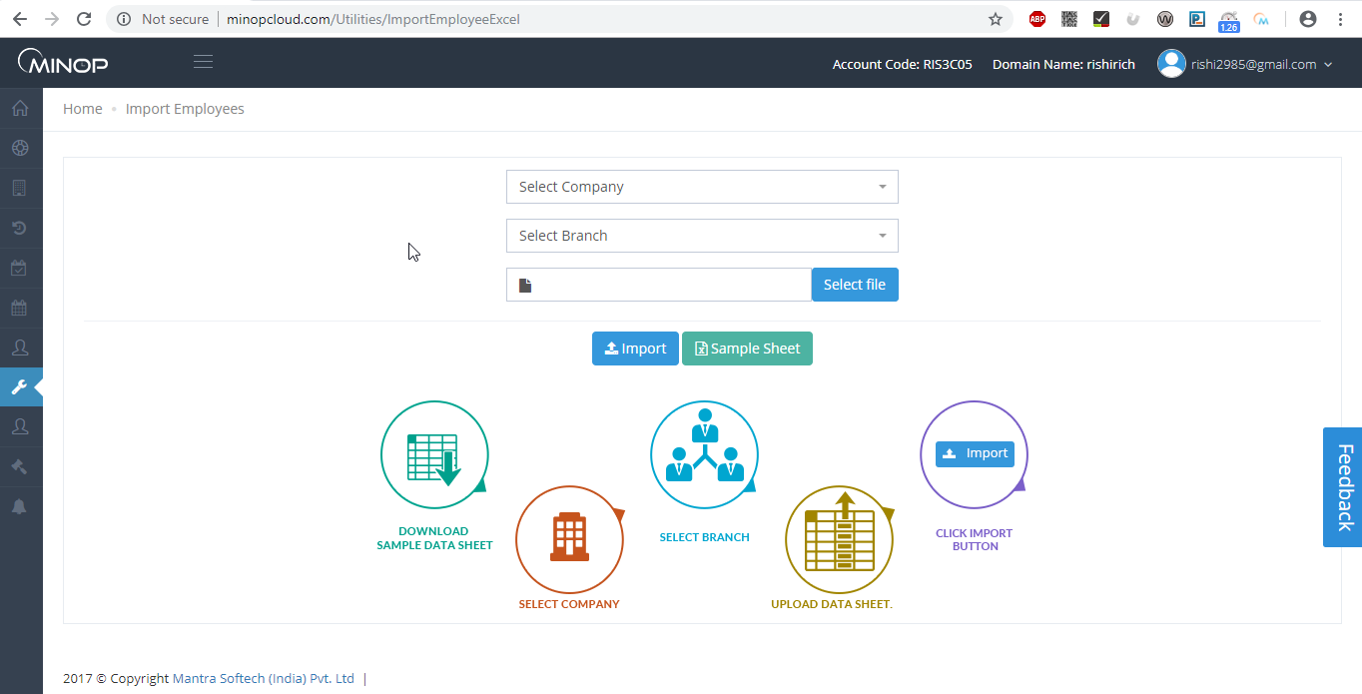
Above image shows view of import employee.
- It allows you to import Employee Master Entries which can be in CSV or Excel file.
- In Sample Sheet there is a sheet named as ‘Terms for Data Import’ in which all details are described on which fields are mandatory to import Employee Data.

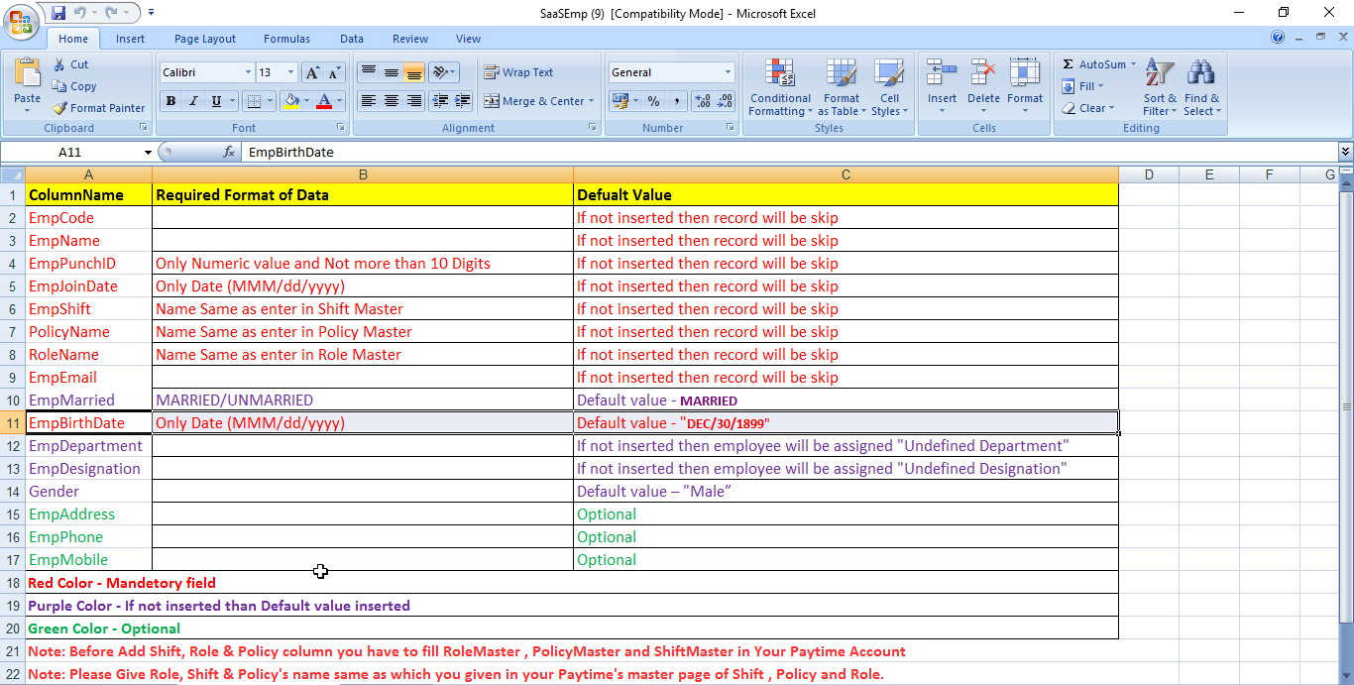
Above image shows general view for importing employee master sheet.
    - Restore Database
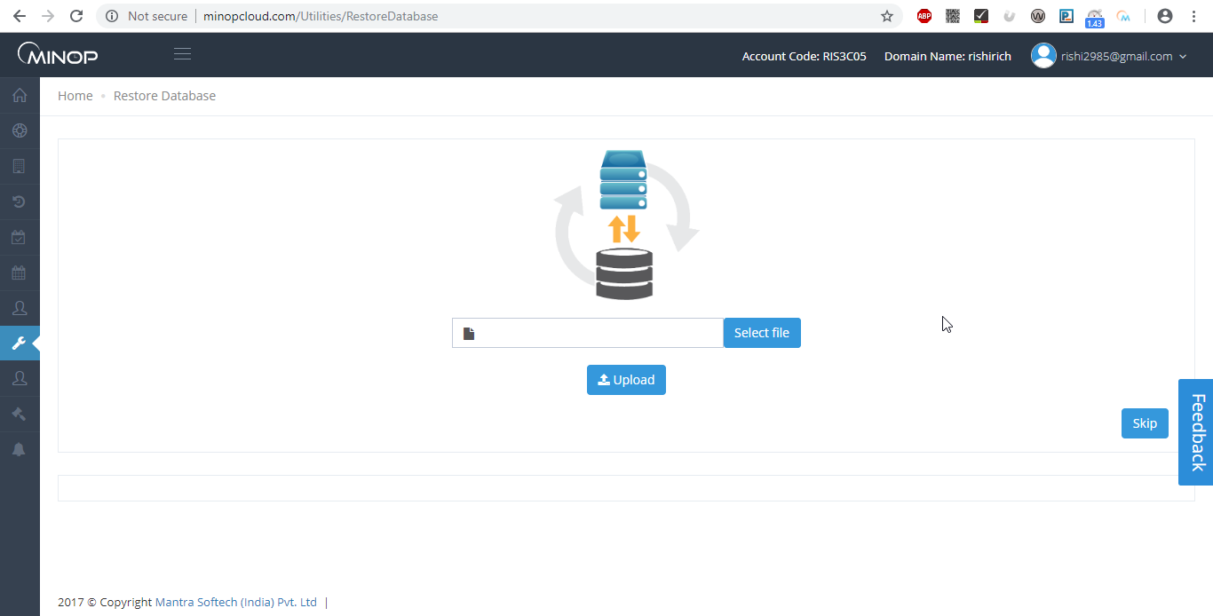
Above image shows view of Restore Database.
- It allows you to restore Database which is in .bak file format.
- Steps will display once you upload .bak file.
Note: Only PayTime back up file will be restored.

    - Transaction Monitor

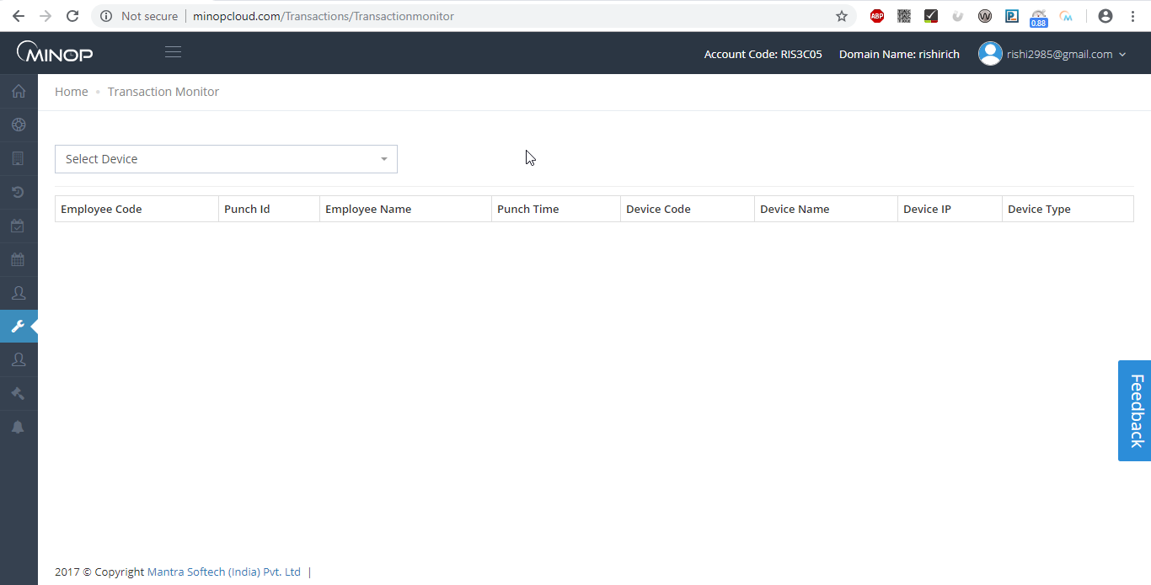
Above image shows view of Transaction Monitor.

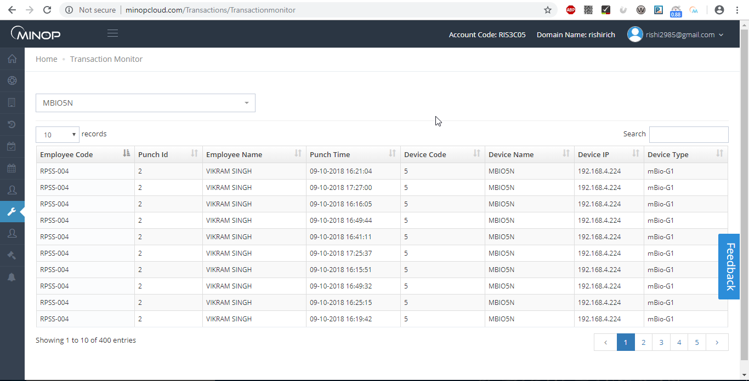
Is Above image show example to check data in transaction monitor with device selection.
- It allows User to see transaction data device vise, User has to select device from dropdown to see transaction data of that device.
- User can search, sort data in Grid.

    - Device Service

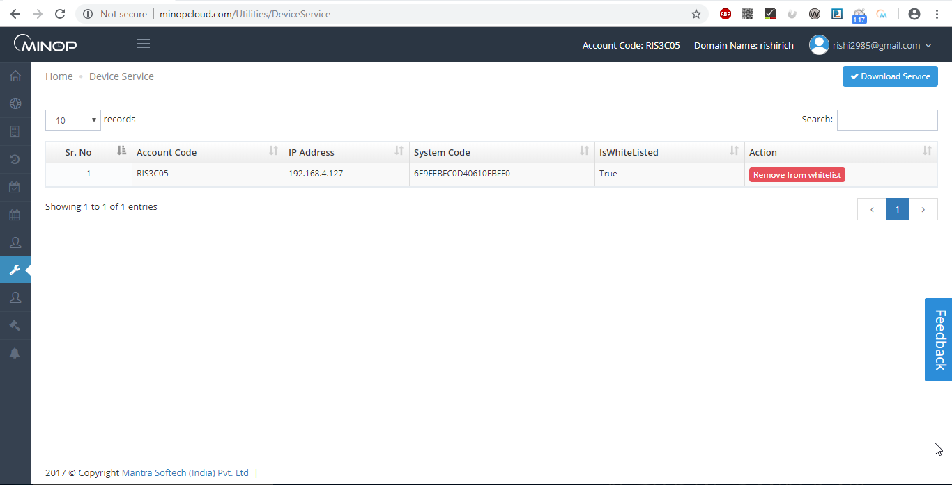
Above image shows view of Device Service.

- Device service is used when device is not having serial number.

    - Device Command
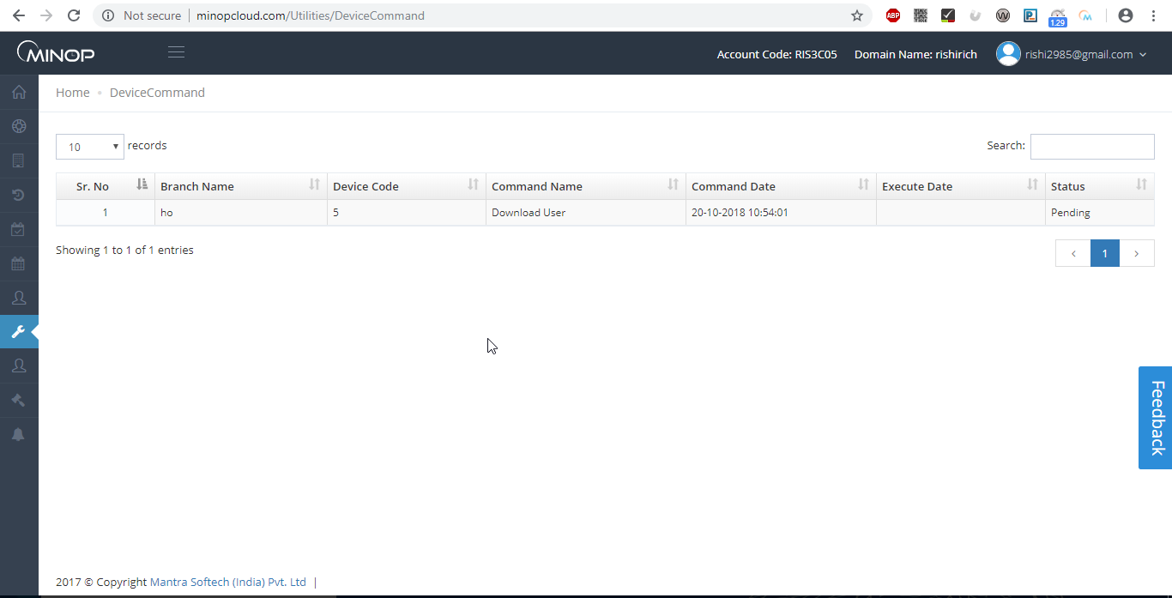Above image shows vie of device command.
- Device command is used to check status of device command executed.

    - Attendance
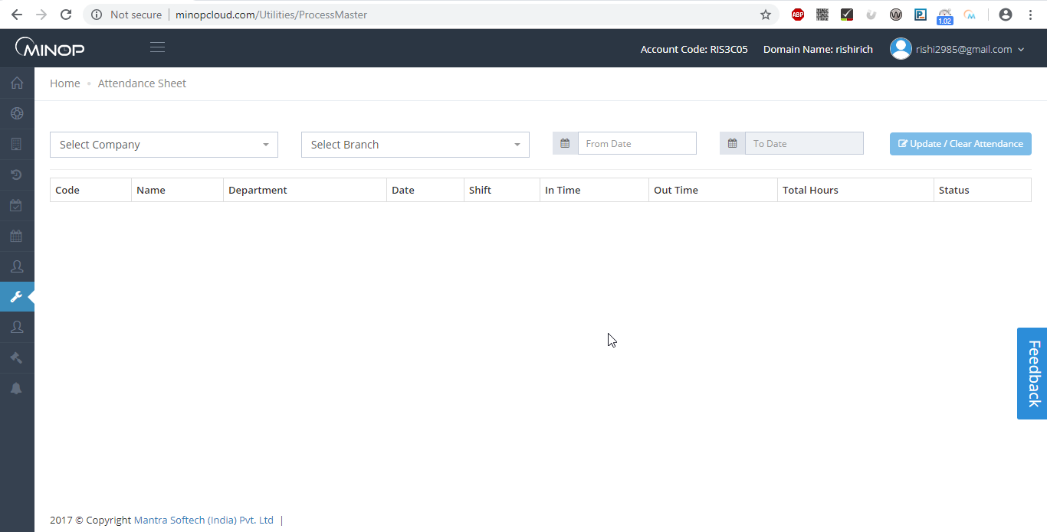Above image shows view of Attendance.

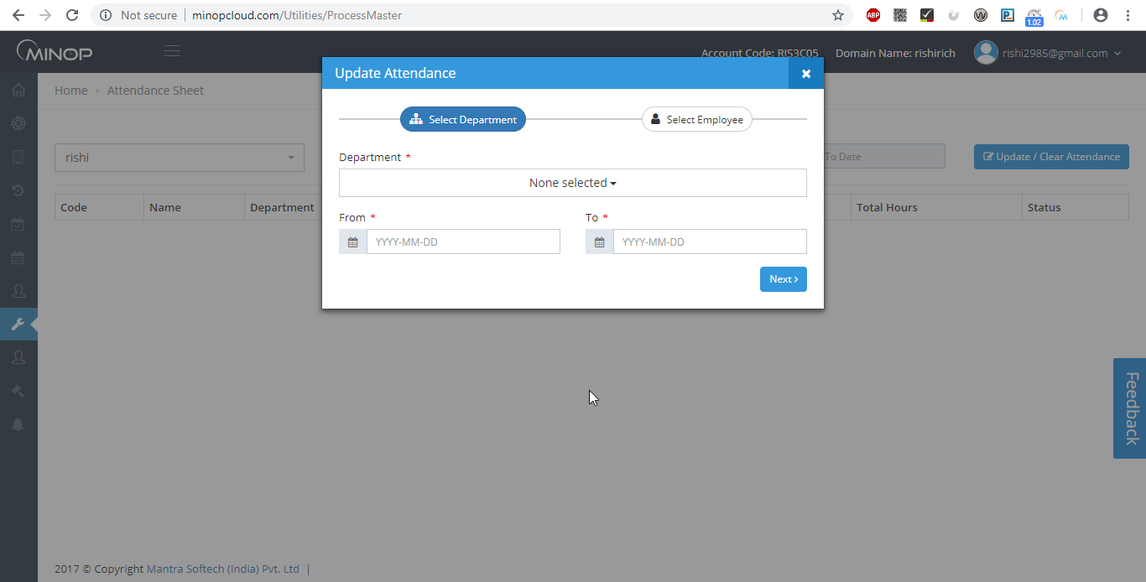
Above image shows pop up when you click on.

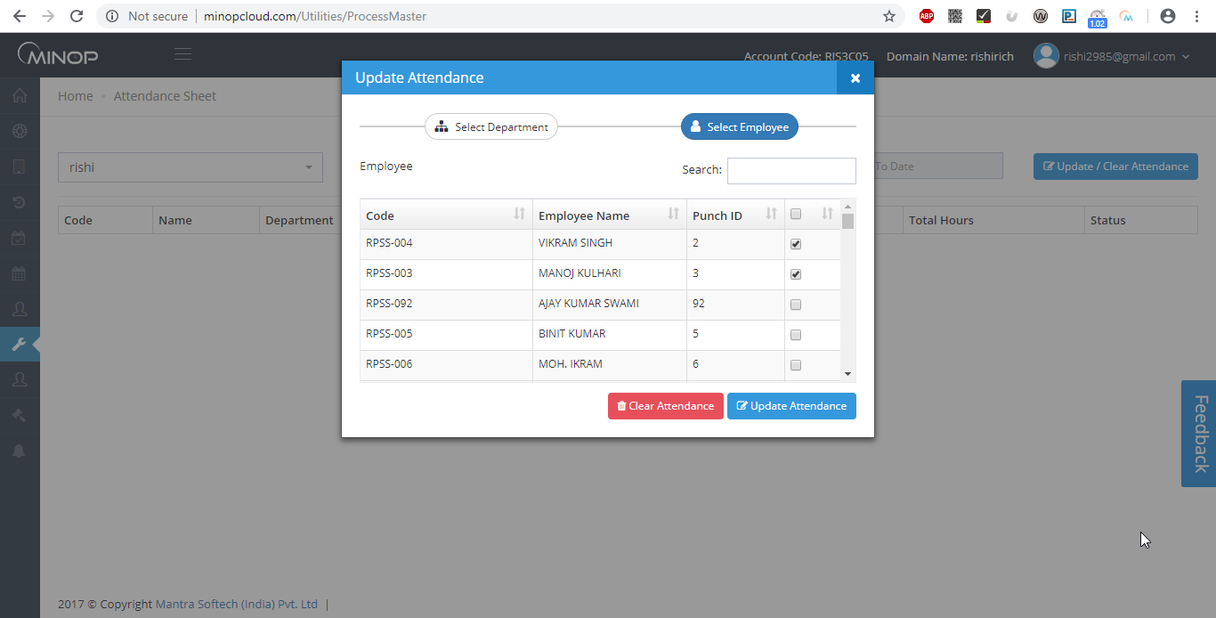
Above image shows example to update or clear attendance.
- Admin can Update Attendance OR Delete Attendance of any employee by selecting Company Branch Department and employee and particular date.

    - Scheduler Master
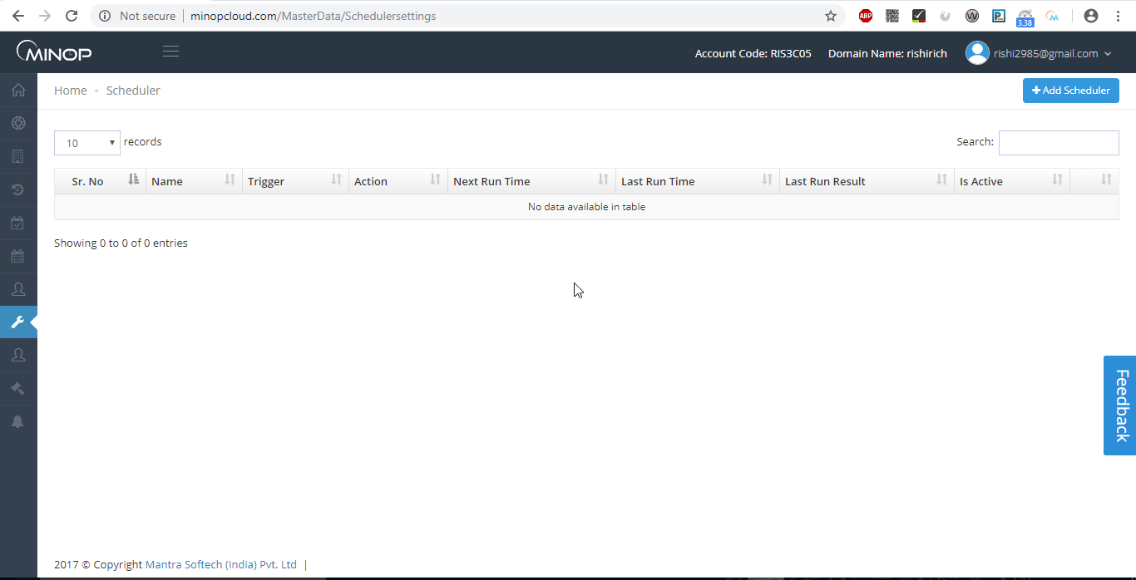
Above image shows view of scheduler view.
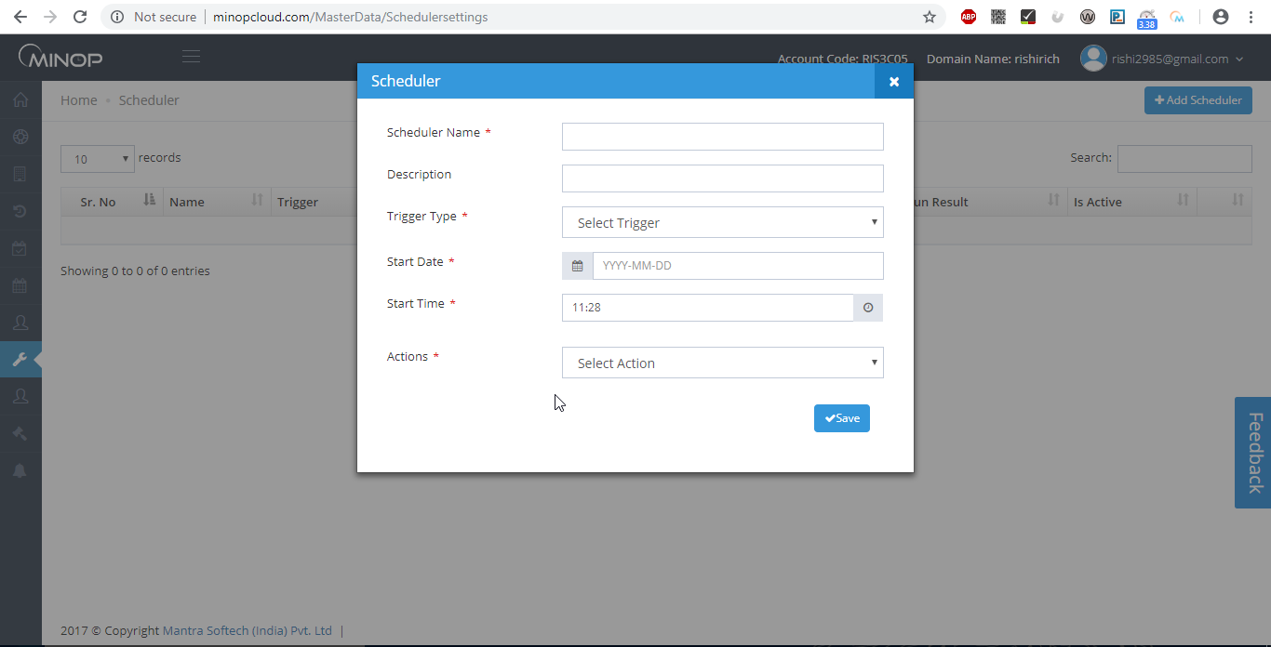
Above Image shows pop up when you click on “+Add Schedular”

- Device Transaction will be automatically processed as per entry done in Schedule Master.

- Recurring on Specified Time
  - Daily

- You can set Daily Frequency conditions.

- For Example: - Above Screen shows that Data will download at Every Minute between 12:00 PM to 12:30 PM on Every Day.

    - Custom fields

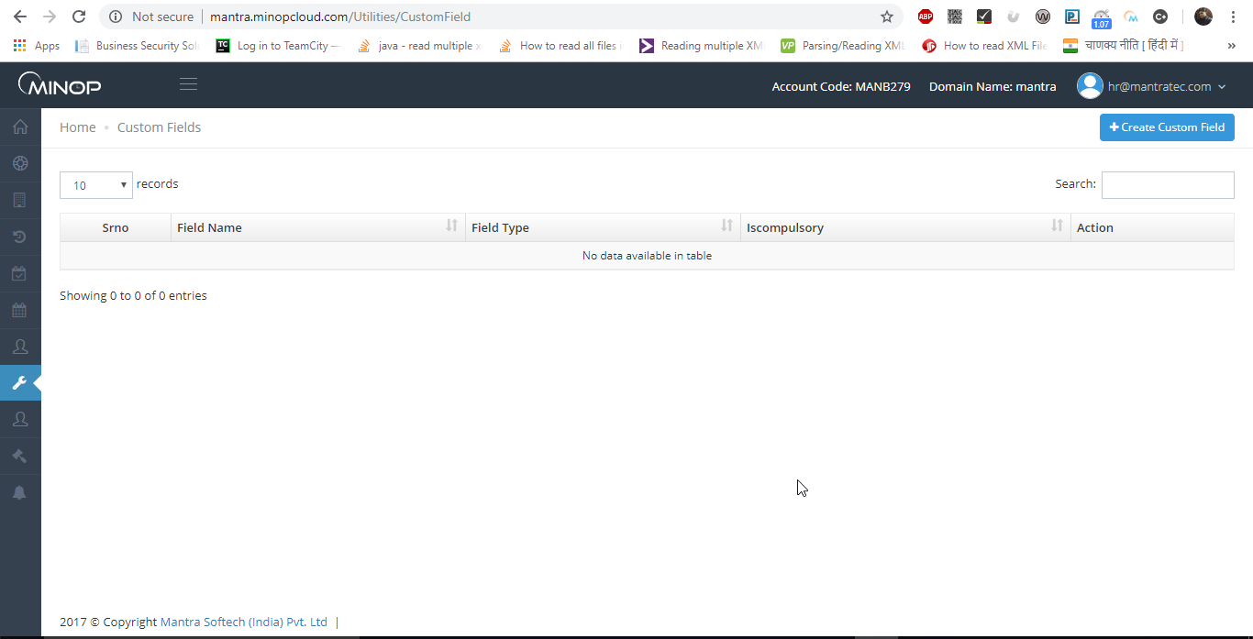
Above image shows view of Custom fields.

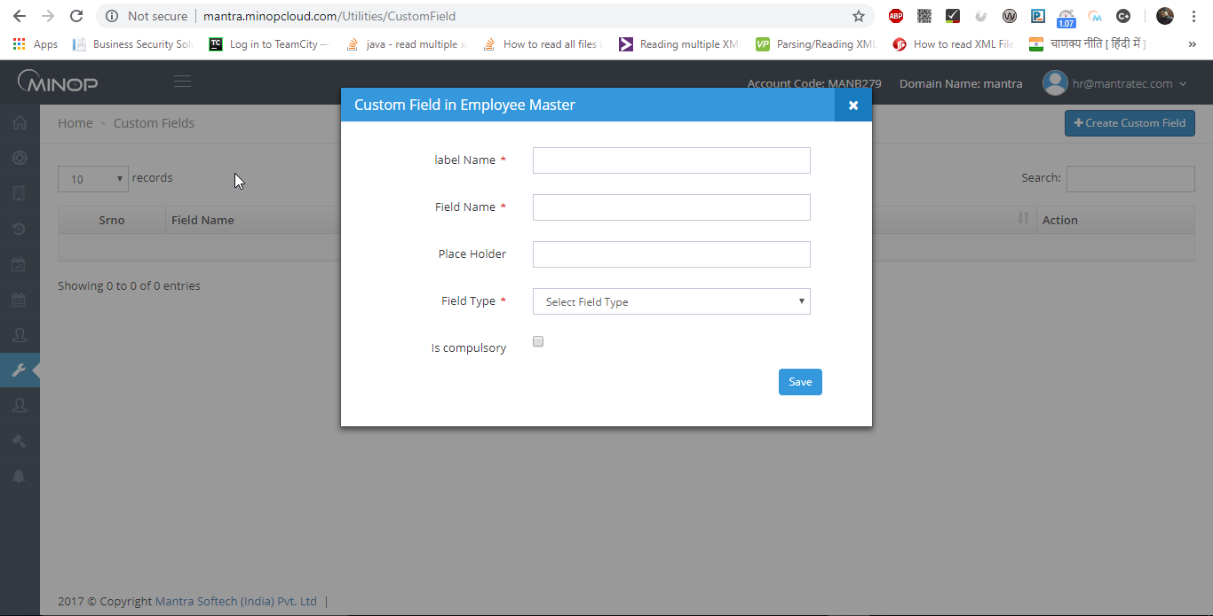
Above image shows pop up when you click on “+Custom field panel”
- If User want to add custom fields (i.e. if he want to add self made fields) in employee master page then it is added from here.
- User can add/edit custom fields from here.
- If User want the custom field as mandatory then also it can applied from here.

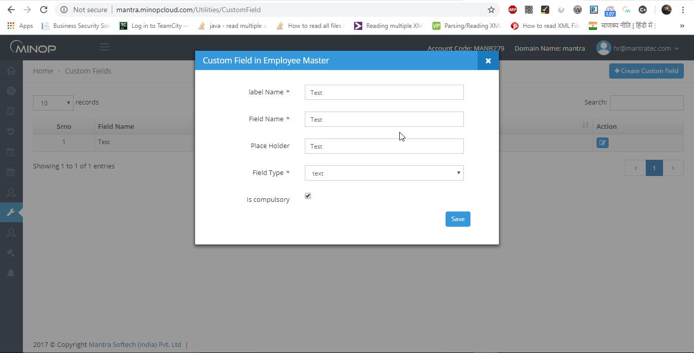
Above image shows example for adding custom field.

    - Custom Template

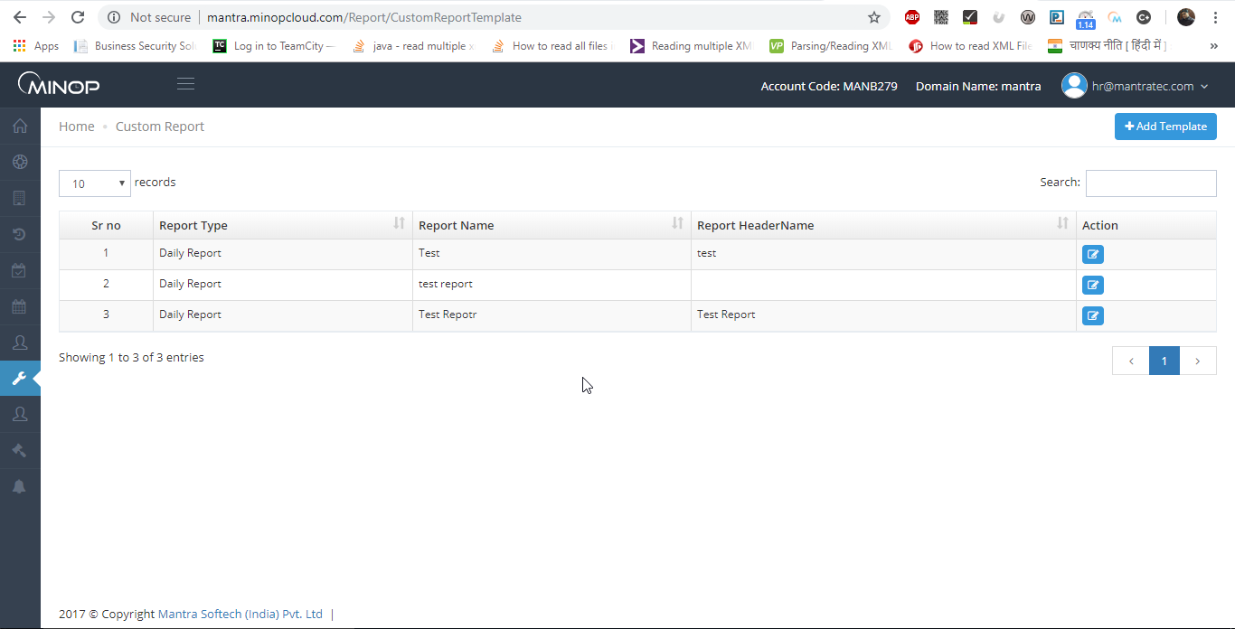

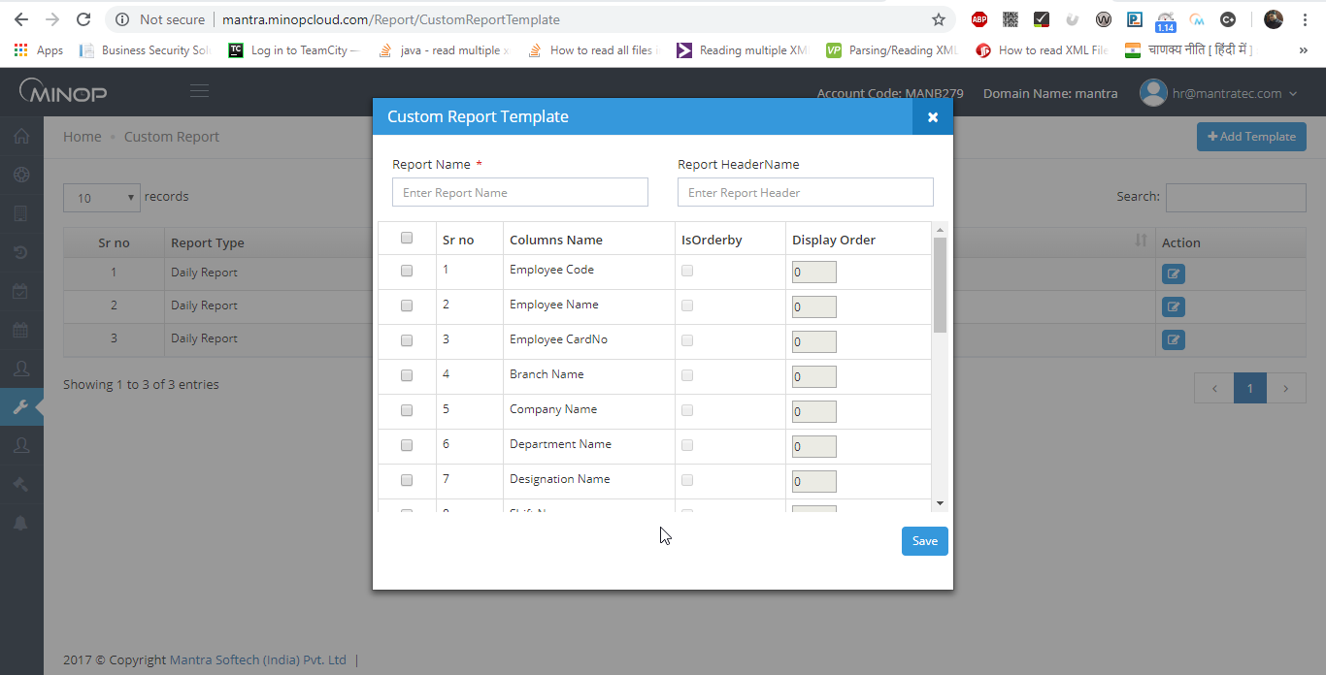

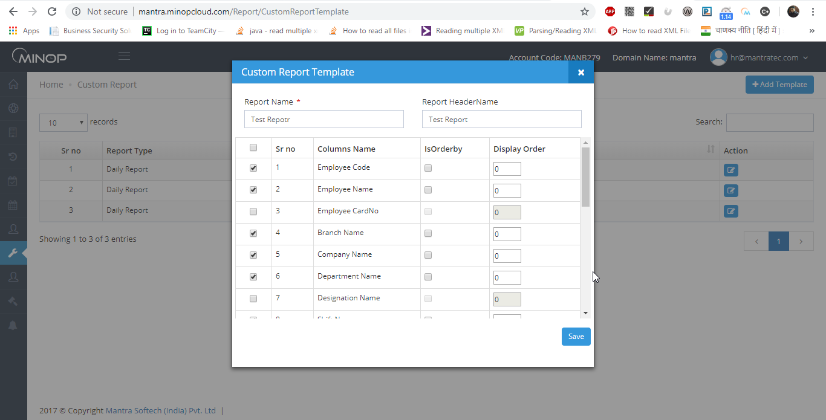

- If user want to see customize report then he/she can add template form here which will be reflected in the Analytics report page after added from here.
- Select Columns name, Order By, Display Order and report will be display as per selected fields and order.
- User can View/Add/Edit report from here.

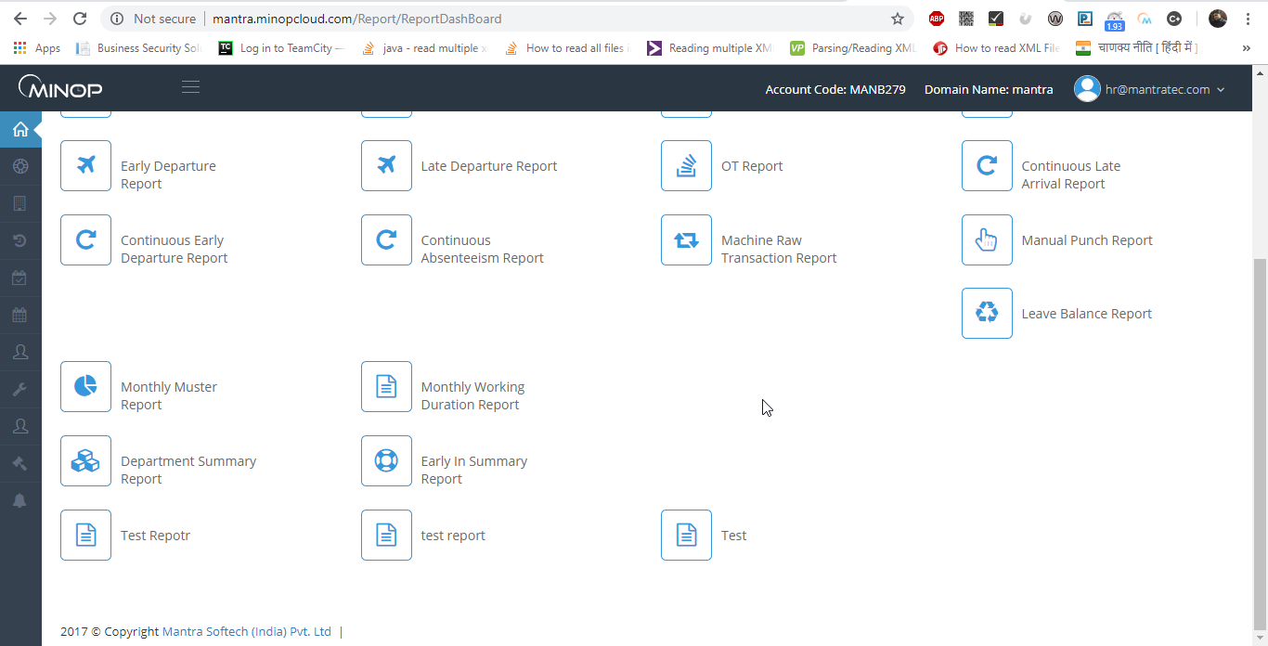

  - ESS

1.7.1 Approve Leave

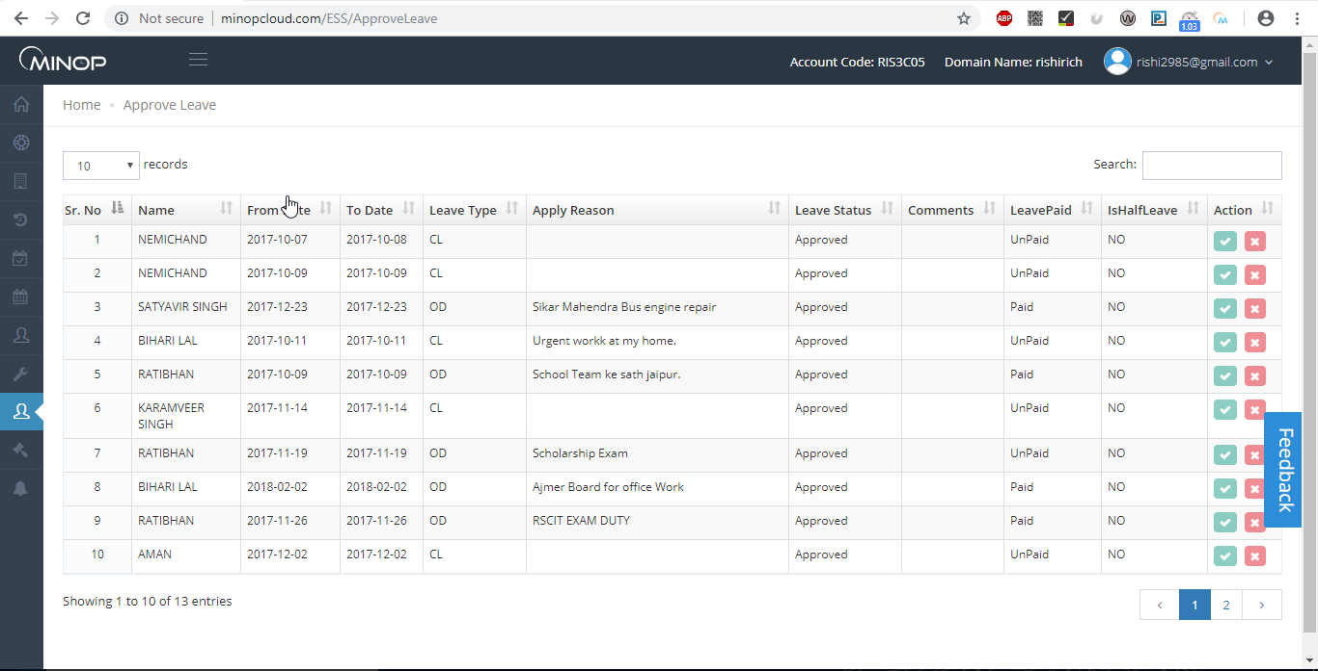

- Admin can Approve/Reject leave of employee. To Approve/Reject leave admin has to click on Approve/Reject button.
    - Approve Attendance

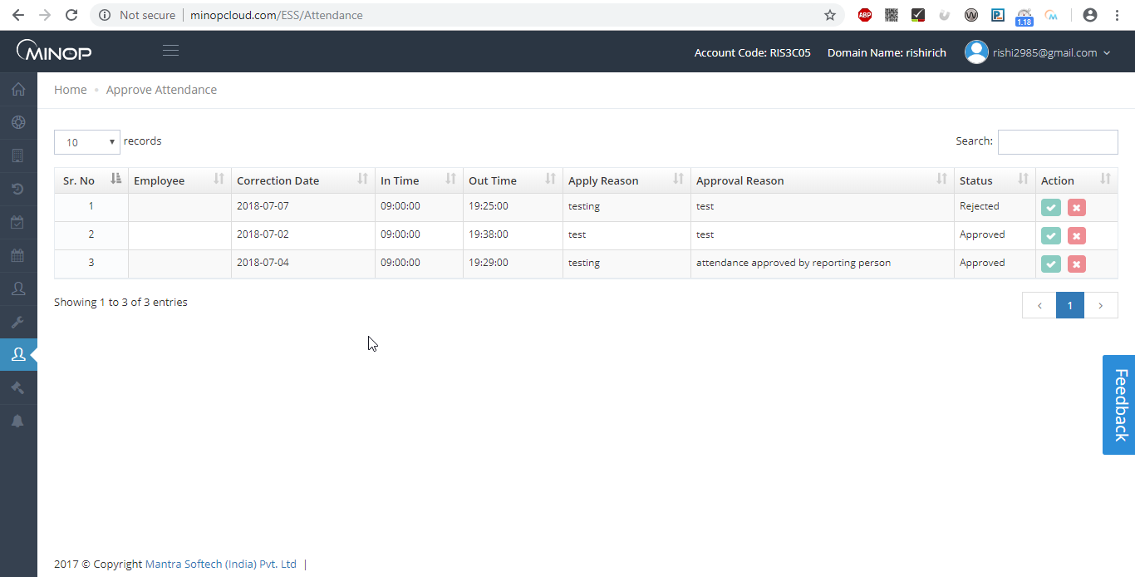

- Admin can Approve/Reject Attendance of employee. To Approve/Reject Attendance admin has to click on Approve/Reject button.

    - Approve Webpunch

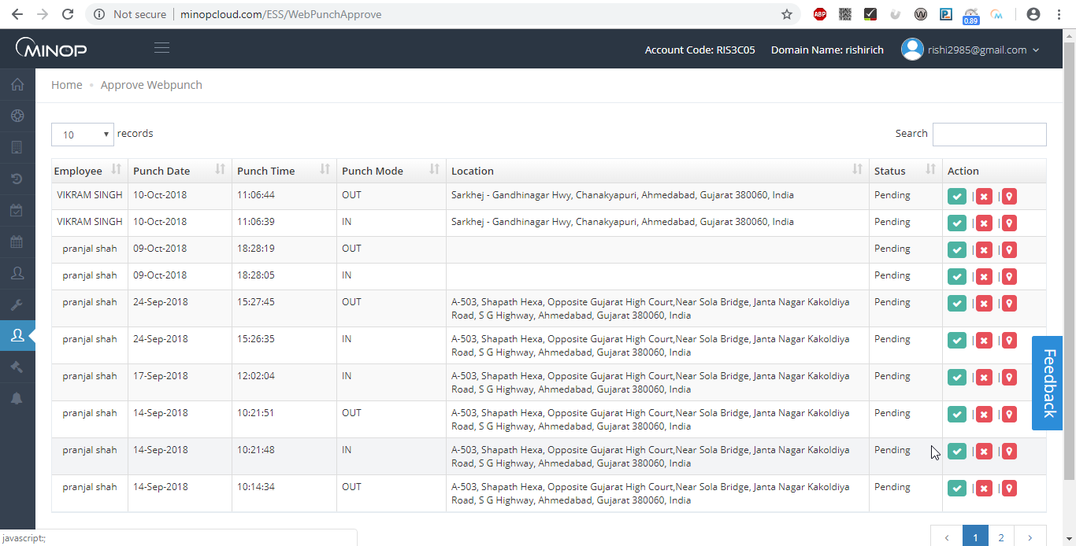
- Admin can Approve/Reject WebPunch of employee. To Approve/Reject WebPunch admin has to click on Approve/Reject button.

  - Policy

User can set attendance parameters and attendance related rules by creating Policy.

1.8.1 HR Policy
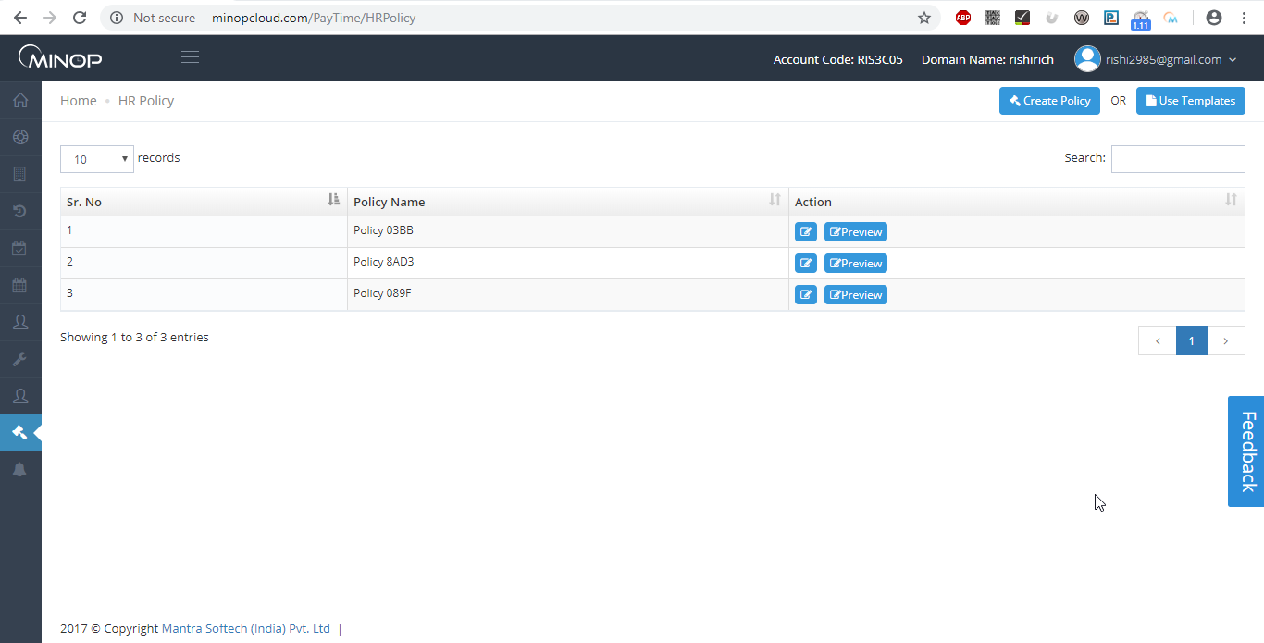

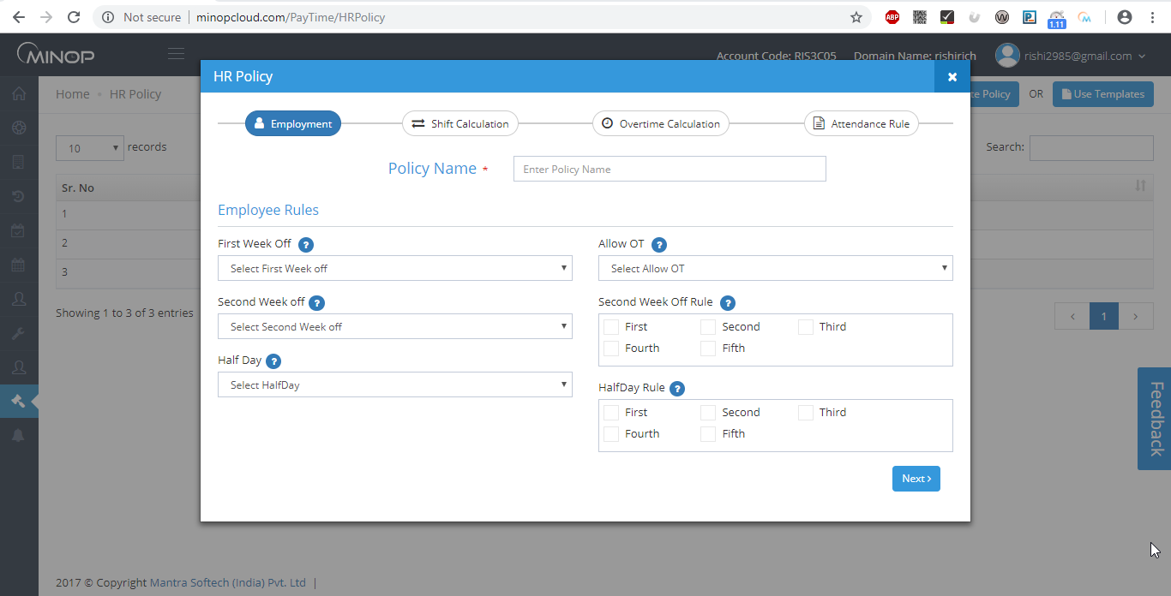
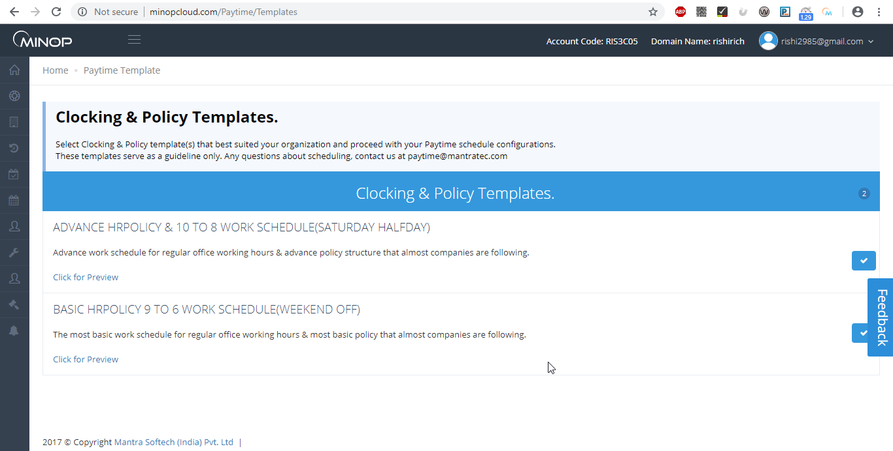

Attendance Parameters:-
- User can Add new Policy by clicking on User Template button
1. Out Punch Accepted within – To assign maximum working hours limit.

2. Time Duration between Two Punches – Allowed second punch as per the assign time for particular Employee.
e.g. – If you have set 1 minute
First punch: - 10:20:15 AM
Second punch: - 10:20:20 AM
Third punch: - 10:22:00 AM
Than only first and third punches will be considered and the second punch will be discard.

3. Grace time for Late IN – if you assign 15 minutes and an employee comes after 15 minutes of Shift Start Time then it will be considered as a late comers.

4. Grace time for early out – if we assign 15 minutes and an employee goes early 15 minutes of Shift End Time then it will be considered as early goers.

5. Application mode:
➢ Fixed – You can set Device Terminal as IN or OUT Source.
➢ Manual – If you want IN or OUT key from machine then set Application mode to Manual.
➢ Auto – In Auto mode software will automatically calculate IN and OUT Time as par First IN First Out method. It will not consider IN or OUT key from machine.
OT Parameters:-
➢ You can set Minimum Hours to calculate as OT Hours. E.g. if you want OT hour will be calculated after completion of 30 minutes then you can set as per that.
➢ OT Hours can be calculated as
1. Working Hours – Shift Hours
2. Working Hours – Present Hours
3. After Shift End Time
7. Before Shift Start Time
➢ If you want to set Weekly off Hours and Holiday off Hours as OT Hours than can tick mark option as per shown in above screen and also set Minimum Hours for calculating OT.
➢ If Weekly off and Holiday off need to set as ‘Absent’ for Employee who are not present for whole month than set tick mark option as per shown in above screen.

1) Present Rules
a) Any Error Case: Status will be calculated as Present for all Error Case Punches.
b) Calculate Half Day/Present: Status will be calculated as Present or Half day base on Total Hours in Error Case Punches.
2) Half Day Rules
a) Late Count : After define Late Count , status will be calculated as Half day
b) Early Dept Count : After define Early Departure Count, status will be calculated as Half day
c) Late or Early Dept. Count : After define Late or Early Dept. Count, status will be calculated as Half day
3) Absent Rules
a) Late Count : After define Late Count , status will be calculated as Absent
b) Early Dept Count : After define Early Departure Count, status will be calculated as Absent
c) Late or Early Dept. Count : After define Late or Early Dept. Count, status will be calculated as Absent
7) Total Hours Rules
a) After Shift Start Time : Total Hours will be calculated after Shift Start Time
b) Before Shift End Time : Total Hours will be calculated before Shift End Time

1.8.2 HR Policy Allocation

- Admin can allocate policy to multiple employees from this page.
- To allocate policy click on Allocate Filter and then select HR Policy, company, branch, Department and Employees and then click on Allocation button.

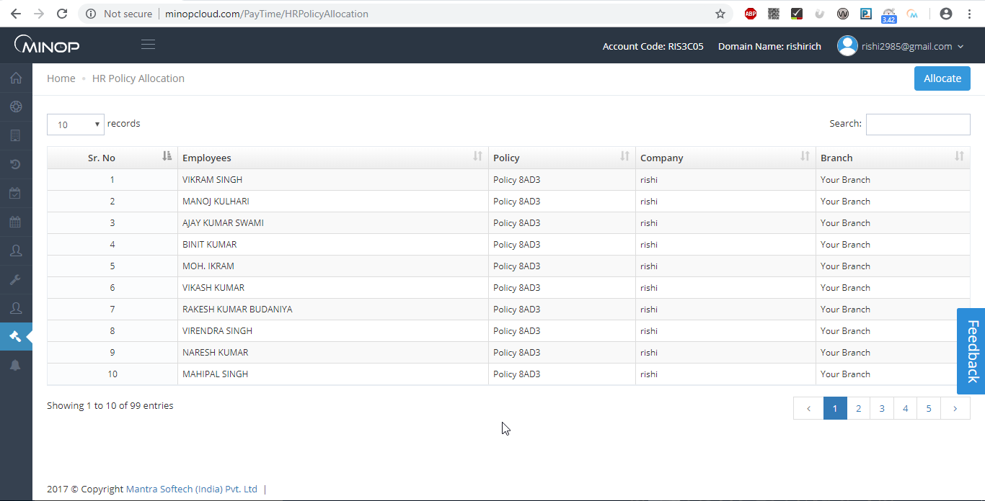

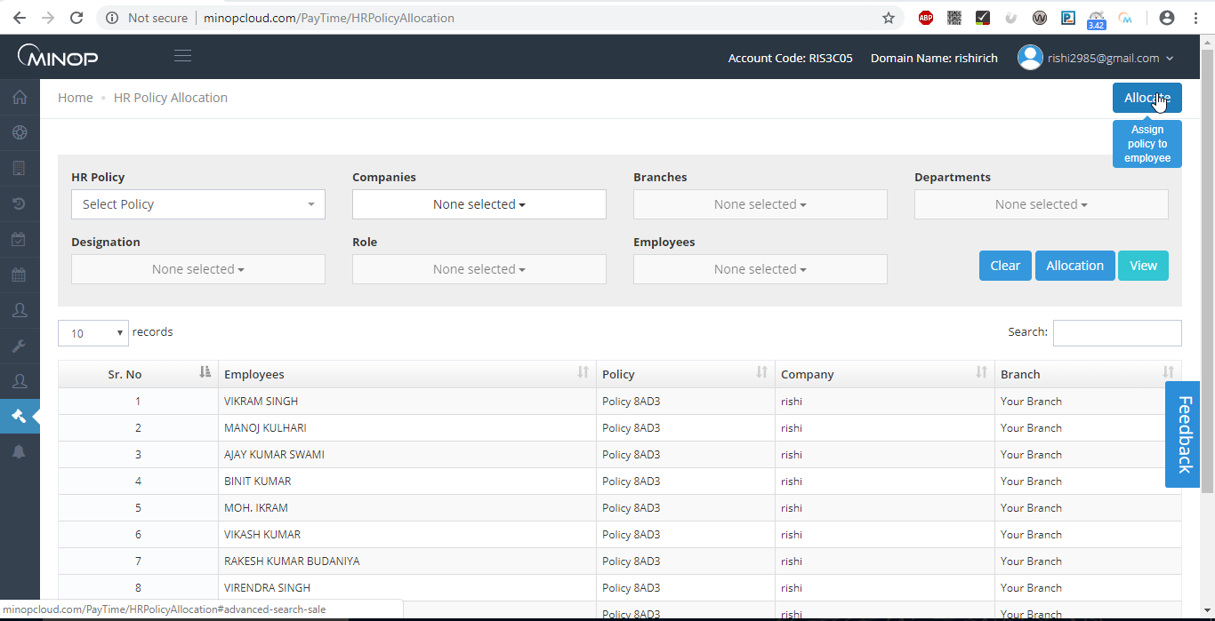
  - Alerts:

The Alerts Menu has the following Items.

- Email SMTP Configuration
- Send Mail

    - Email SMTP Configuration

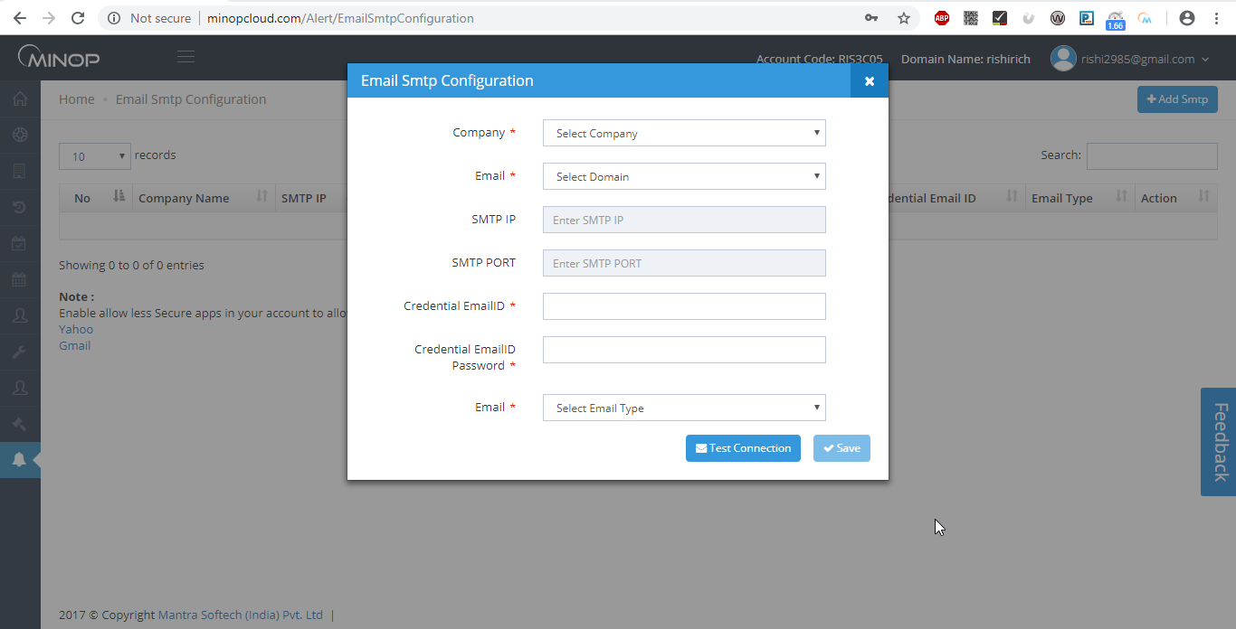
Credential Email ID: - Email ID from Attendance Reports will be sent.
Credential Email Password: - Password for that Email ID.
➢ First you need to Test Connection, on successful of that, you will allow to save configuration.

    - Send Mail
Send Report To:-

➢ You can configure that email will be sent to which Entity like Company Head, Department Head or All Employees.

Which Reports To Send:-

➢ You can configure that which Reports will be set in Email for Daily and Monthly both.
➢ You can sent daily and monthly Reports manually or can configure schedule from Scheduler Master.
➢ To send Email manually select Date or Month and then click on Send Email.

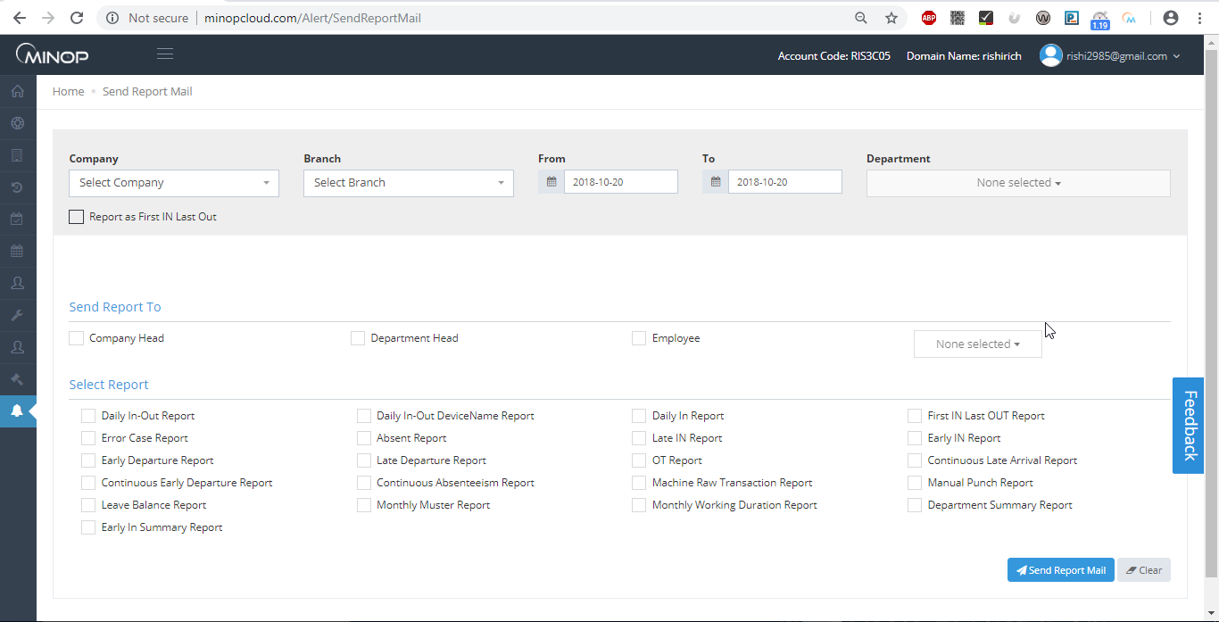

    - SMS Configuration

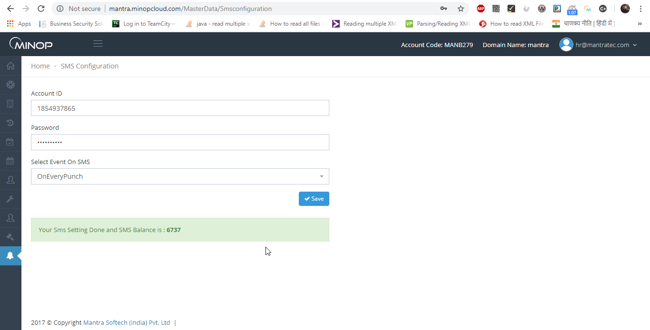

- You need to enter SMS User Credential detail in above screen.
- Employee can get SMS on below Events as per SMS Event Allocation.
- On Every Punch

1.10 Profile Account

- User can add/edit personal information and change the password from here.

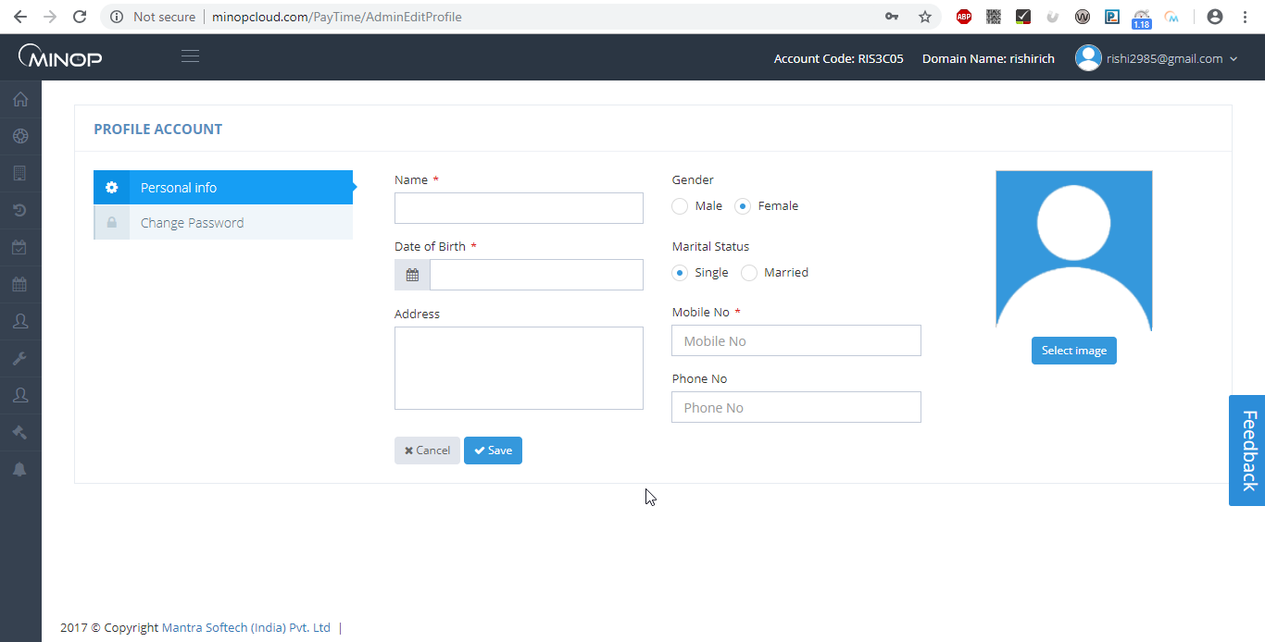

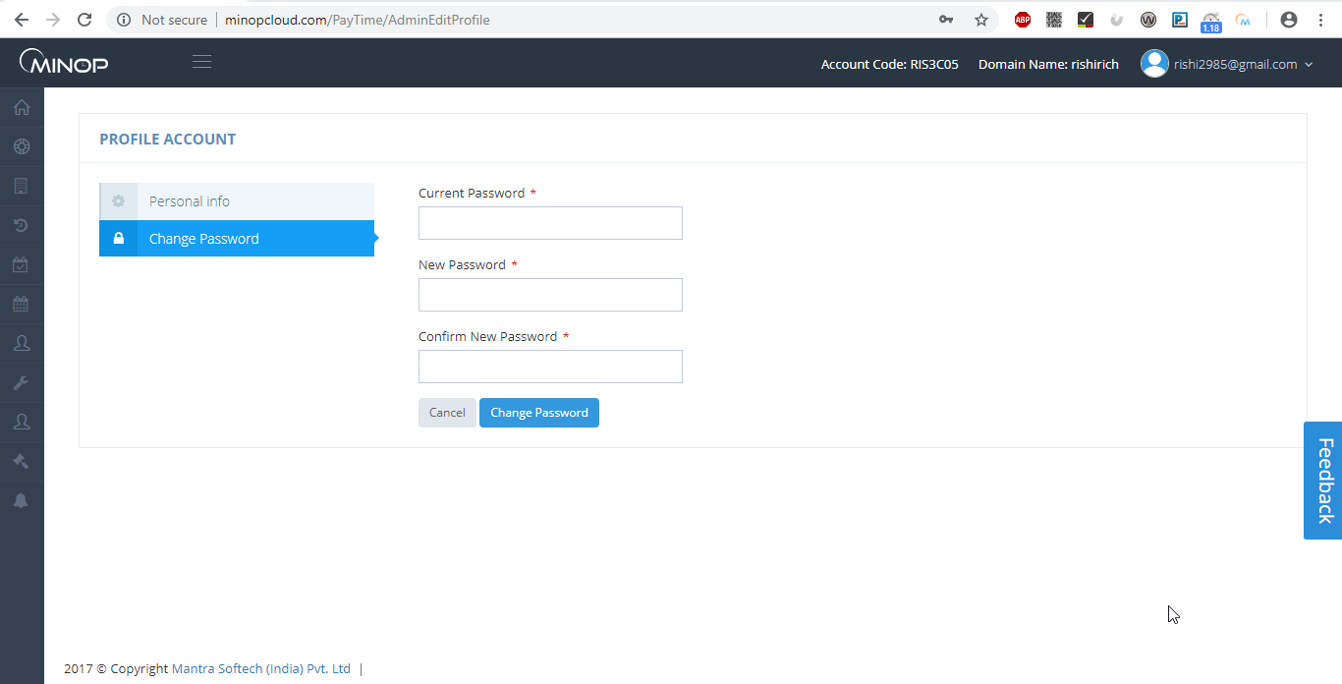

- Employee Login

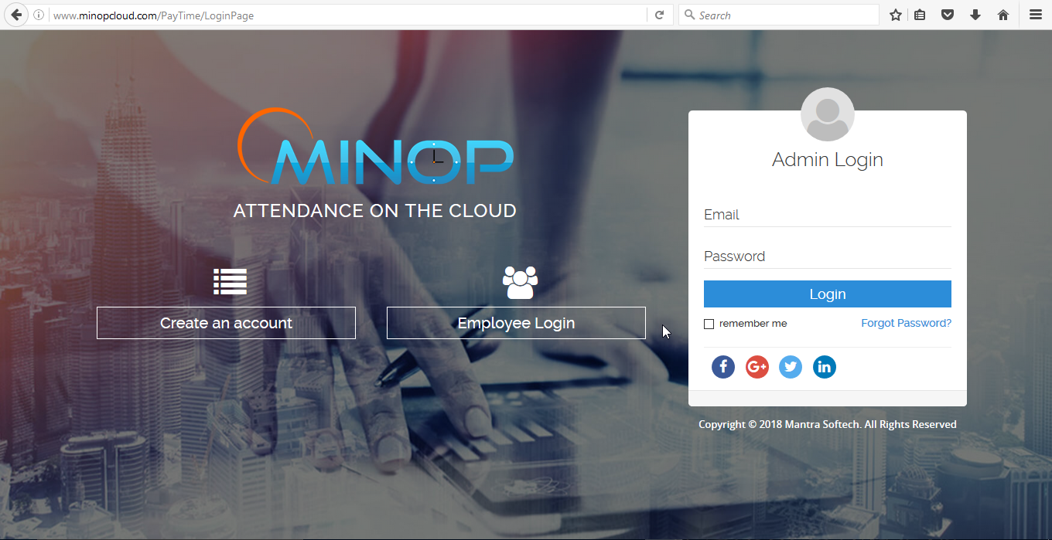

Click on Employee Login to do Employee Login

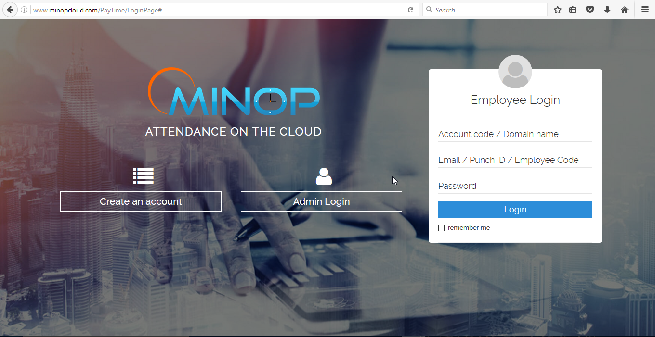

After Login User will be redirect to the Employee Dashboard Page.
User can see Attendance Summary, Leave Balance, Monthly Calendar report

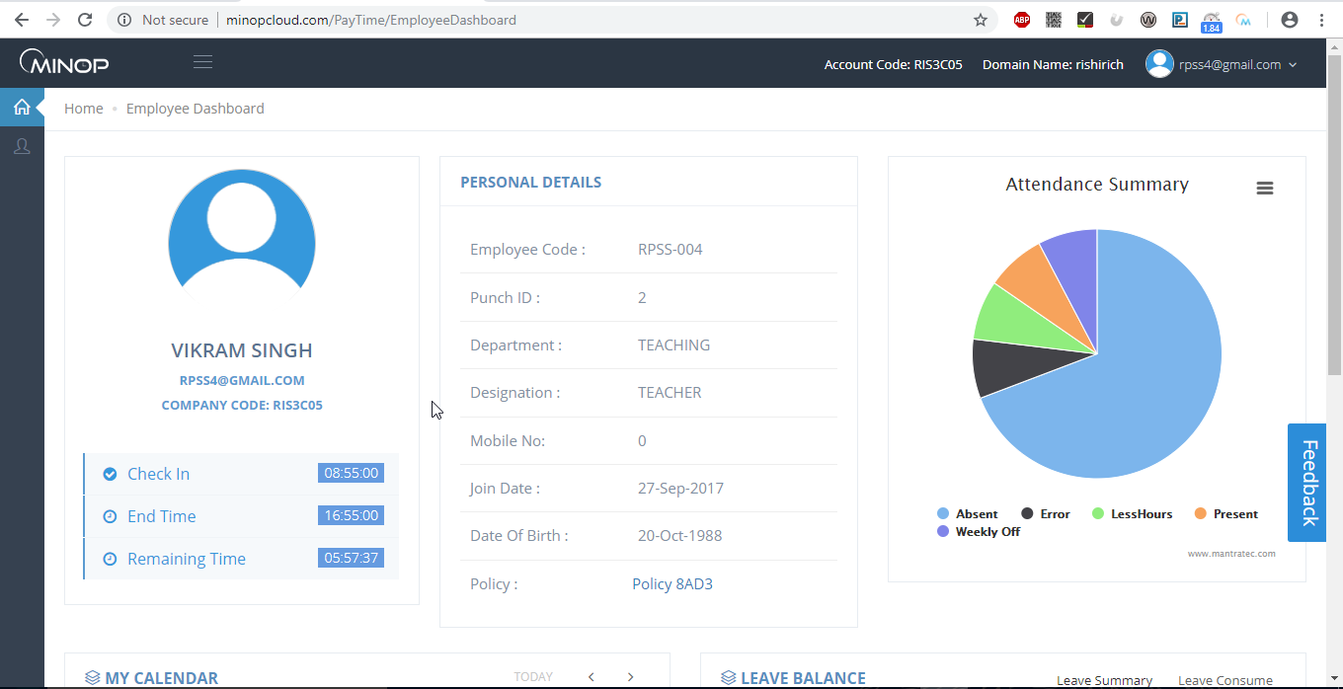

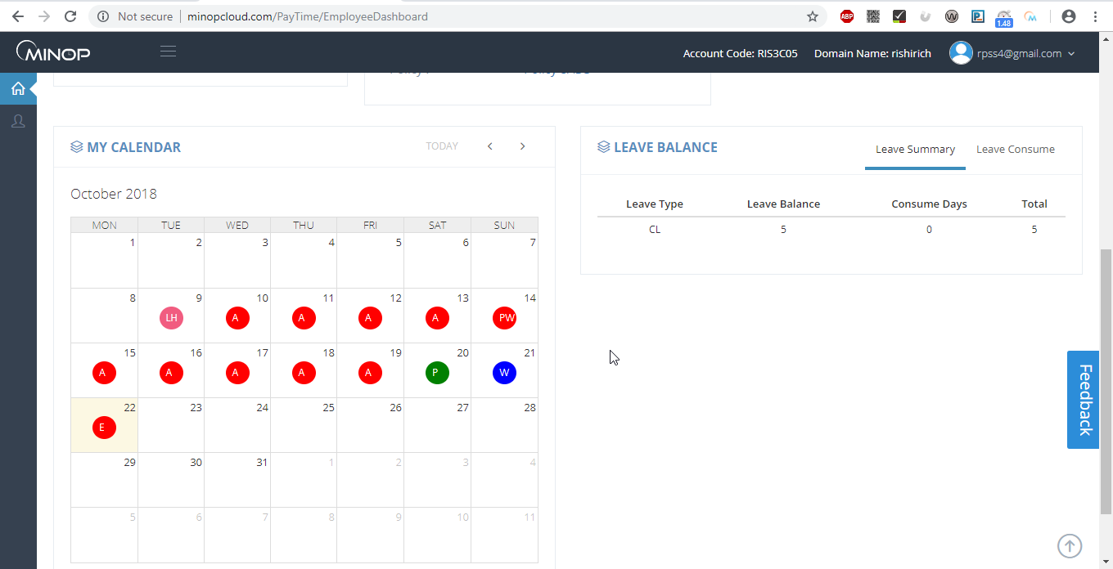

  - Web Punch

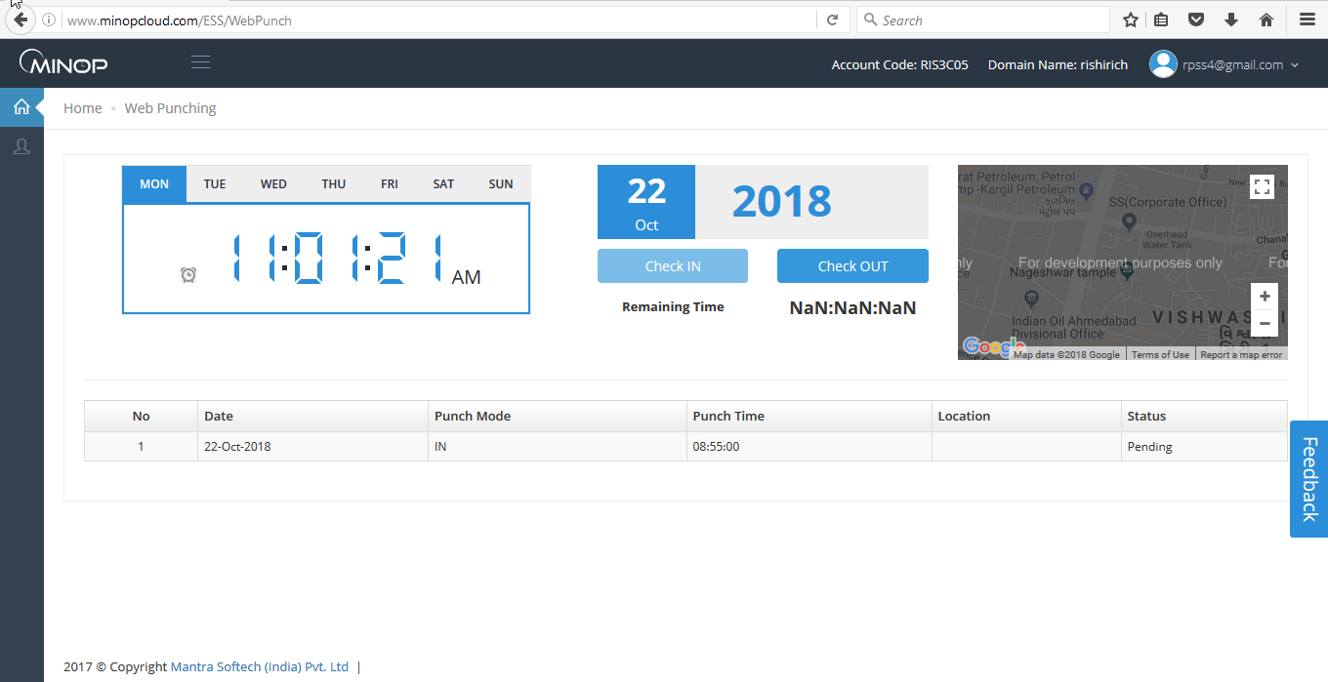

User will be asked to share Location after opening the page.

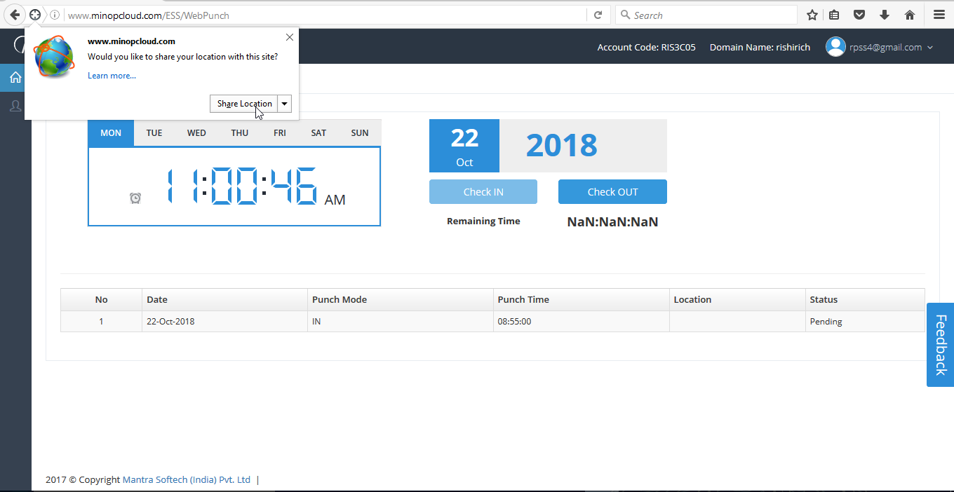

- User is able to do Check In/Check Out from this page.
- After click on check in/out Status of WebPunch will display as pending until Admin/Reporting person approve/reject it.
- After Admin/Reporting person approve/reject it the status will be Approved/Rejected

  - Analytics Dashboard

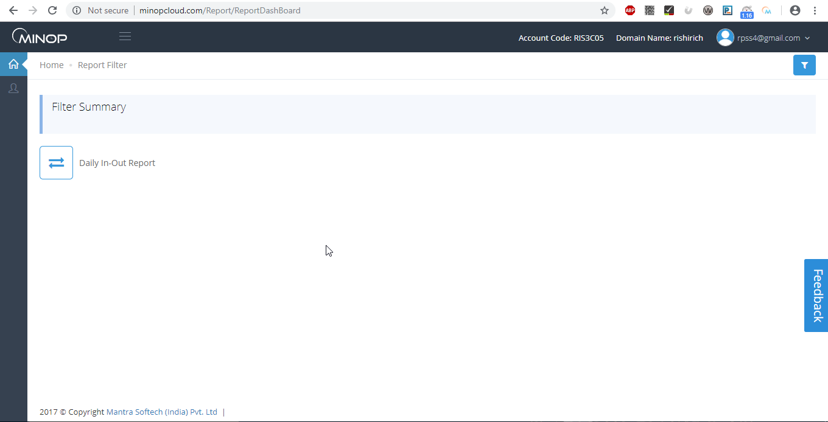

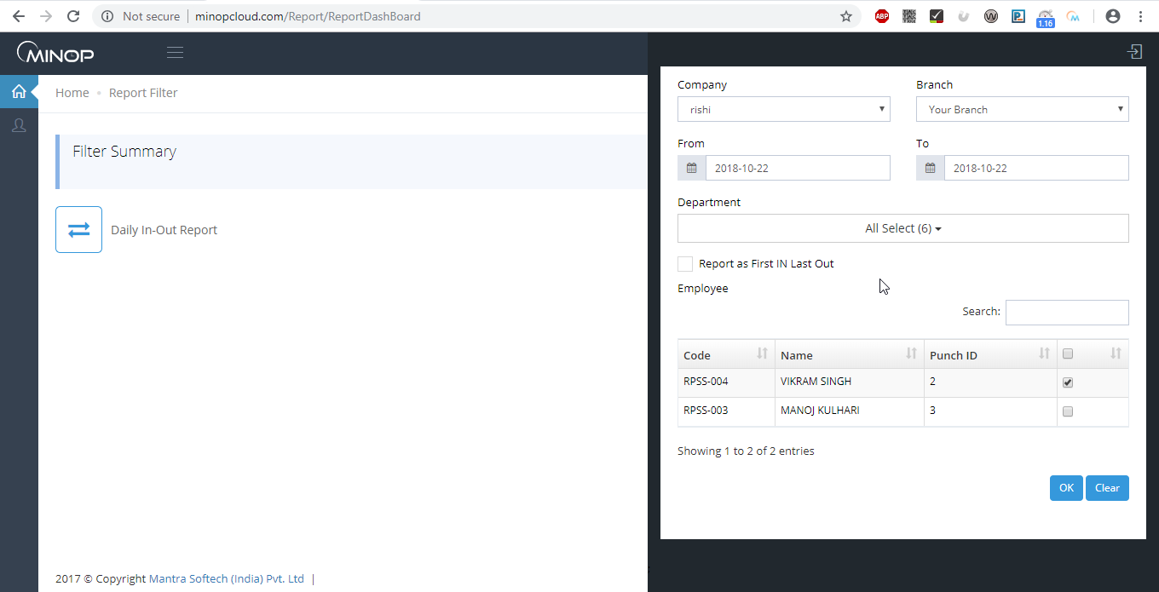

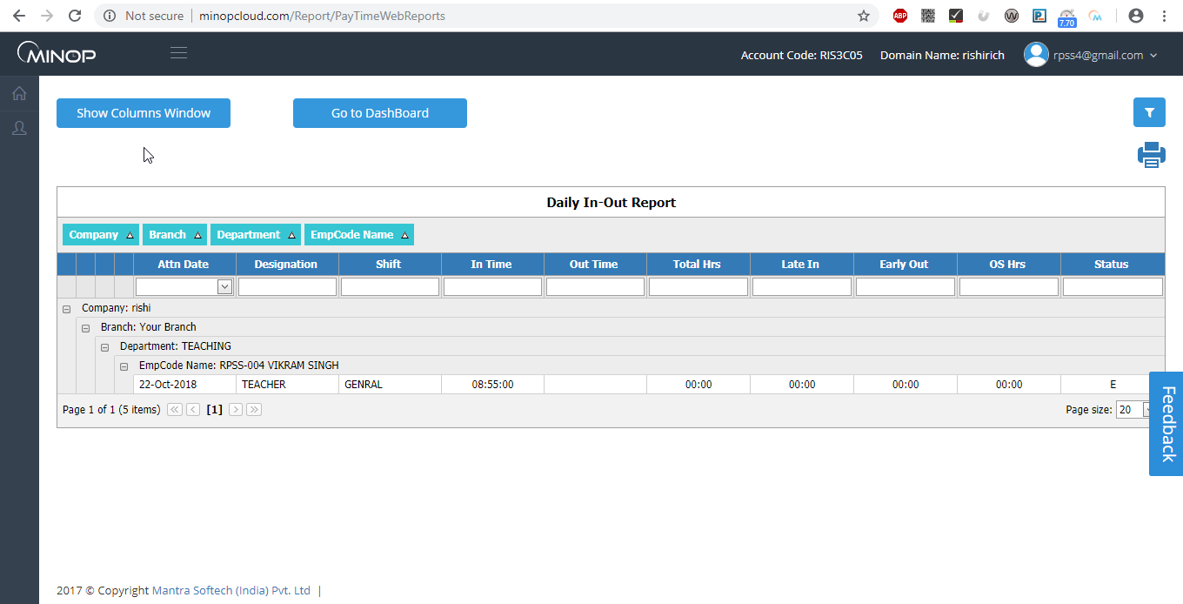

- Employee can see his/her Daily In-Out report by filling all the details in filter and then click on Daily In-Out report.

  - ESS

Employee Self Service has following modules

    - Leave Request
    - Approve Leave
    - Attendance
    - Approve Attendance
    - Holidays
    - Approve Webpunch

    - Leave Request

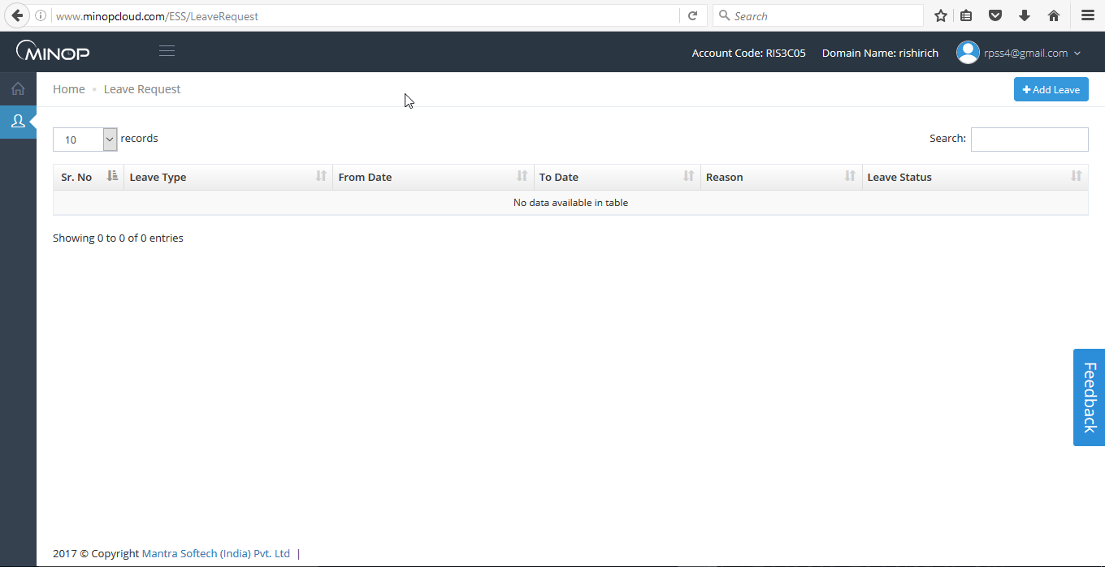

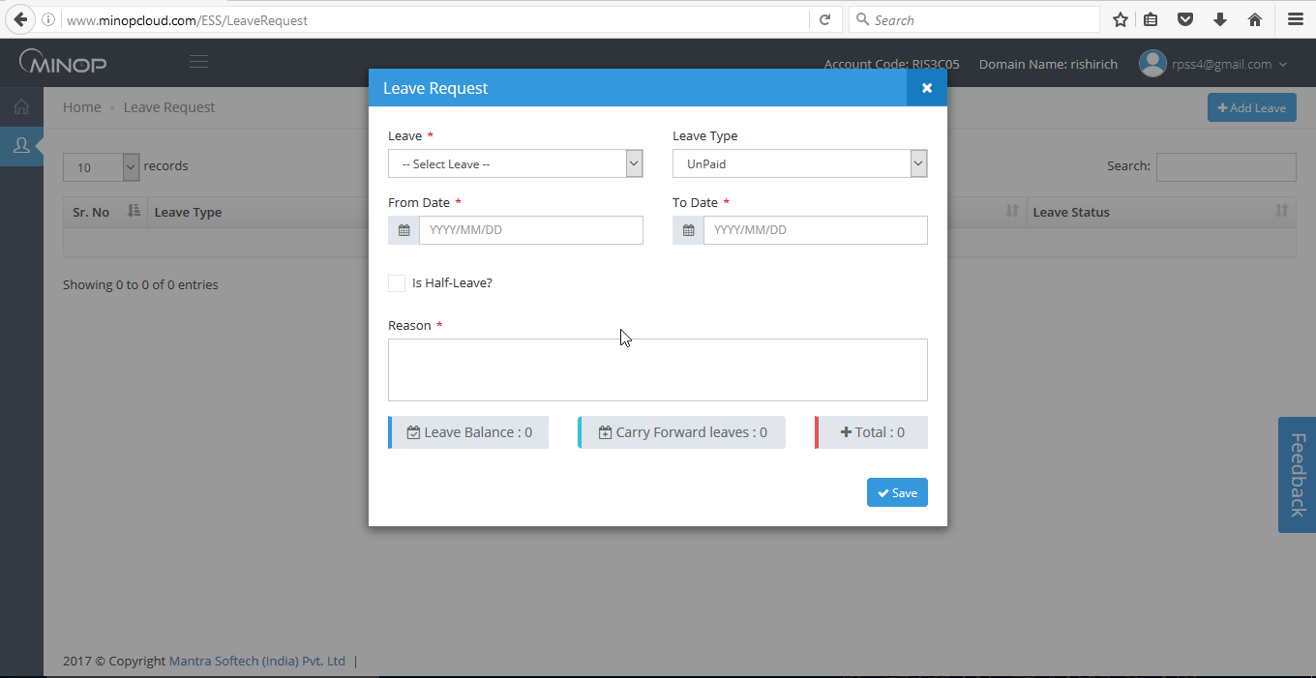

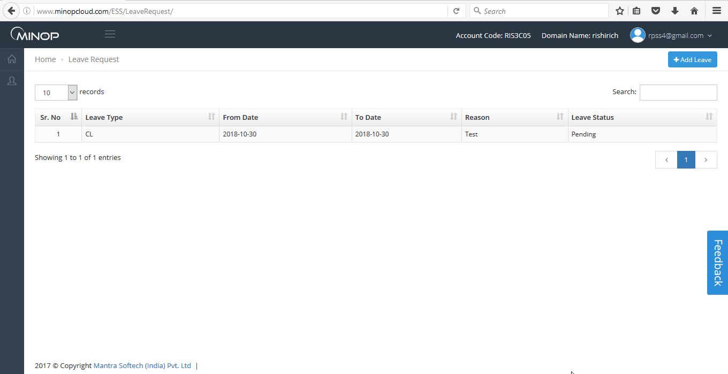

- User can request for leave from here.
- After applying for leave Status of leave will display as pending until Admin/Reporting person approve/reject it.
- After Admin/Reporting person approve/reject it the status will be Approved/Rejected
- After submitting for leave the data will display in the Grid.

2.3.2 Approve Leave

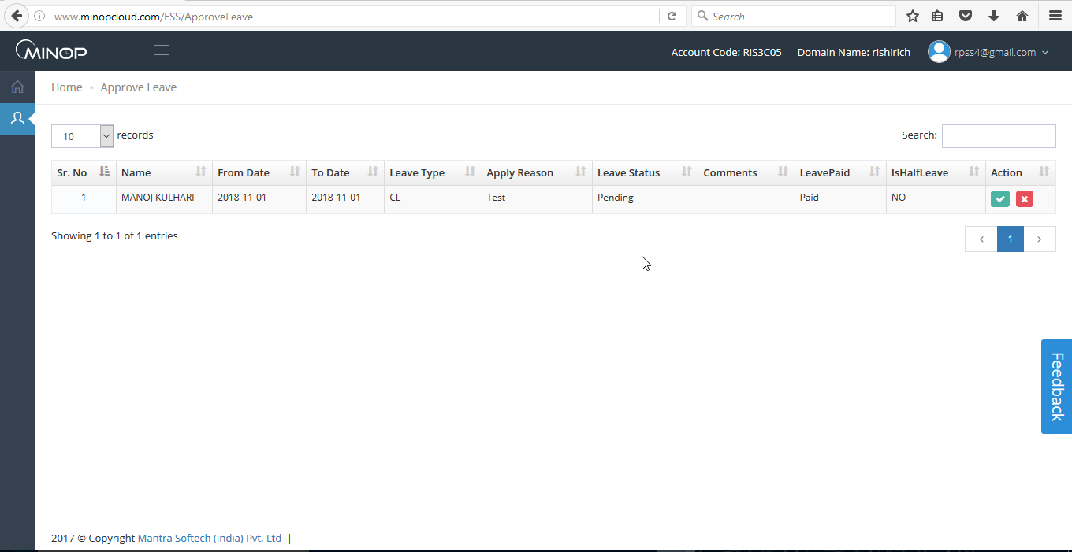

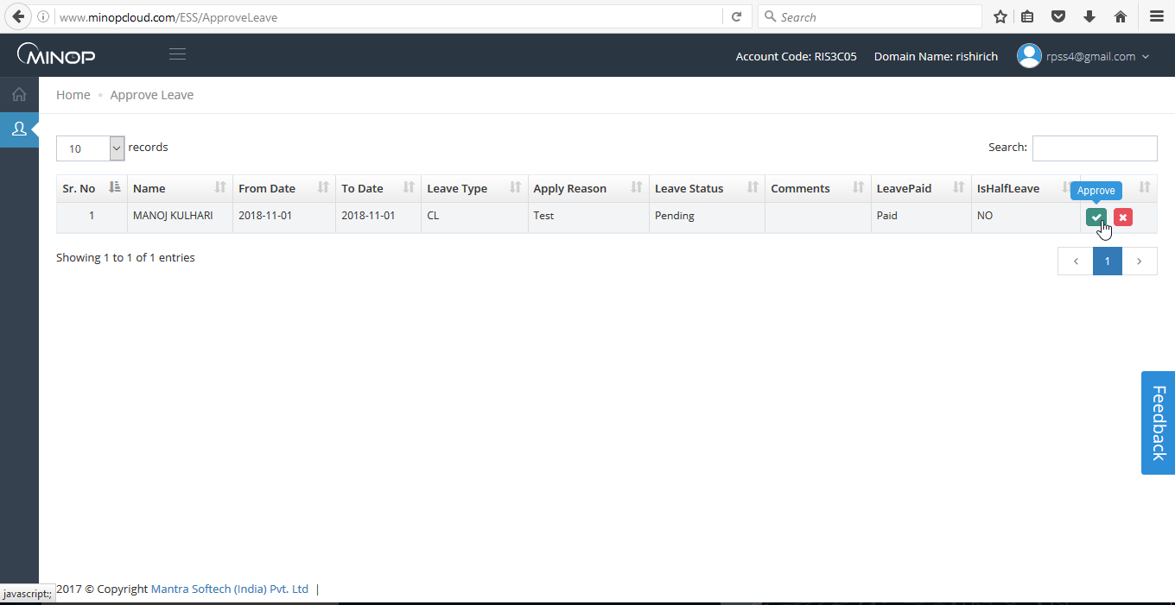

- On this page Reporting Person can see the leave applied by employee who is under his/her authority.
- Only Employee who is Reporting person can Approve/reject the Leave, If Employee is not Reporting person then Blank page will display to him/her.

    - Attendance

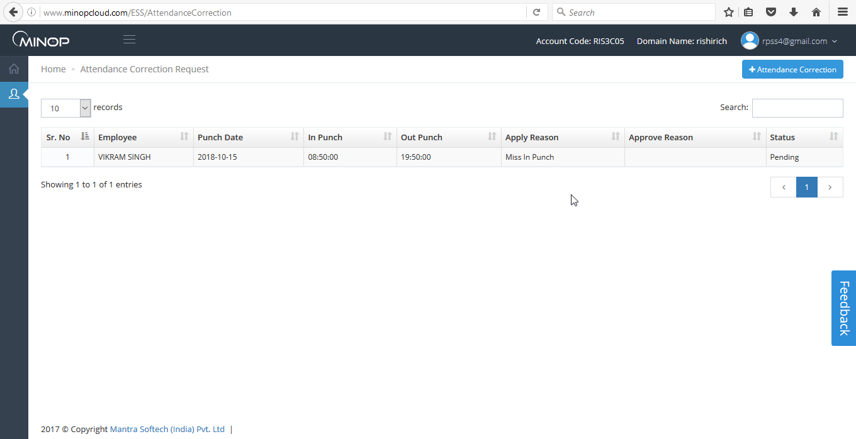

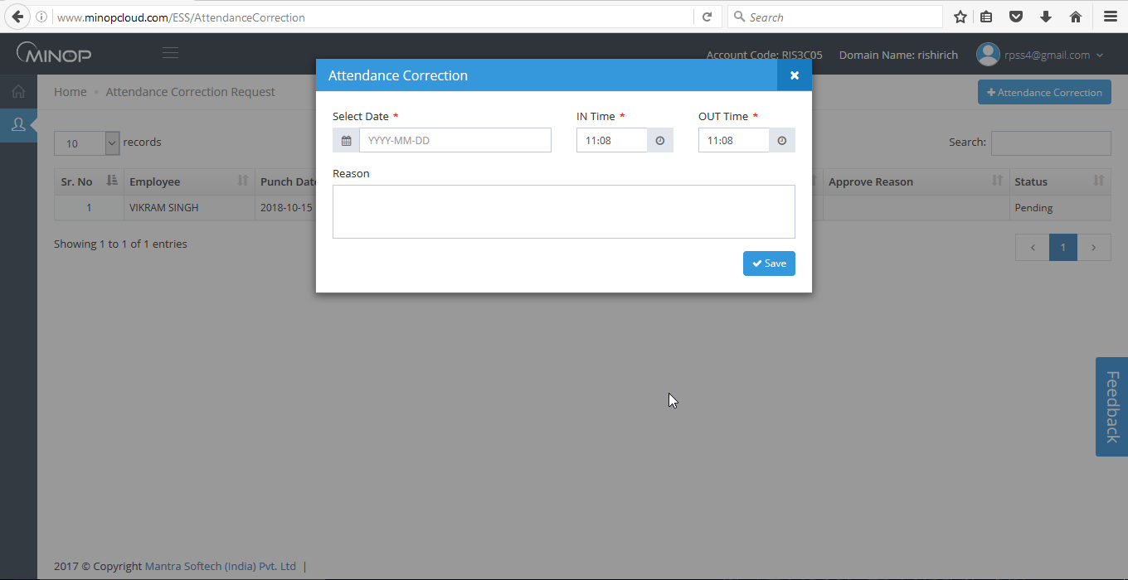

- User can request for Attendance correction from here.
- After applying for Attendance correction the Status of Attendance will display as pending until Admin/Reporting person approve/reject it.
- After Admin/Reporting person approve/reject it the status will be Approved/Rejected.
- After submitting for Attendance the data will display in the Grid.

2.3.7 Attendance Approval

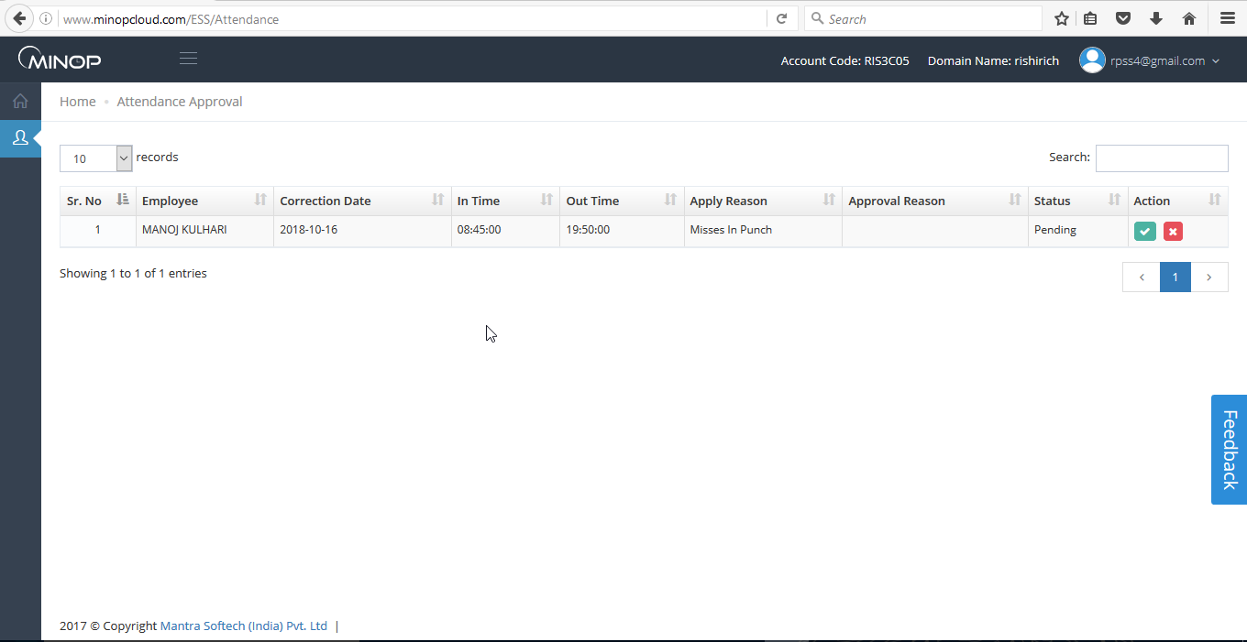
- On this page reporting person can see the Attendance Correction applied by employee who is under his/her authority.
- Only Employee who is Reporting person can Approve/reject the Attendance, If Employee is not Reporting person then Blank page will display to him/her.

2.3.5 Holidays

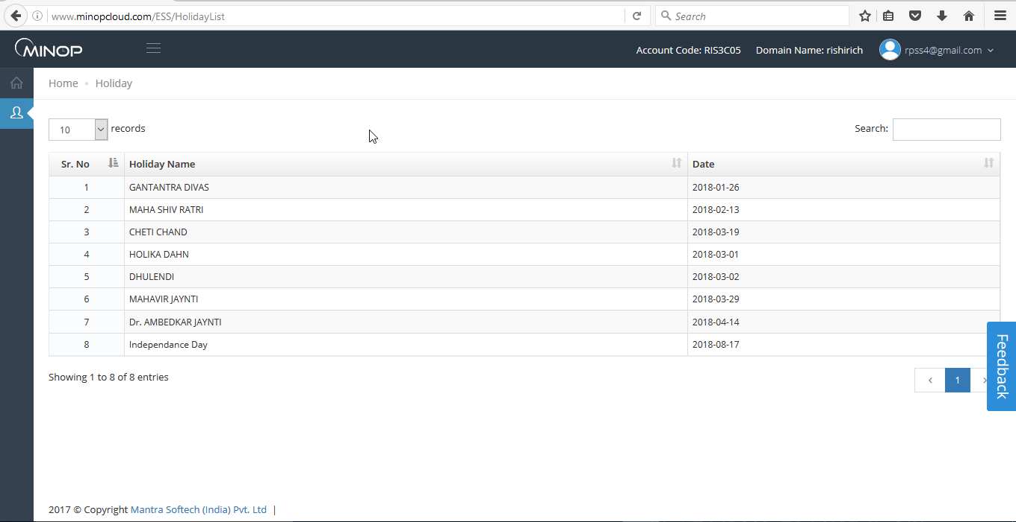

- Employee can see the Holidays declared/Added by Admin.

2.3.6 Approve Web Punch

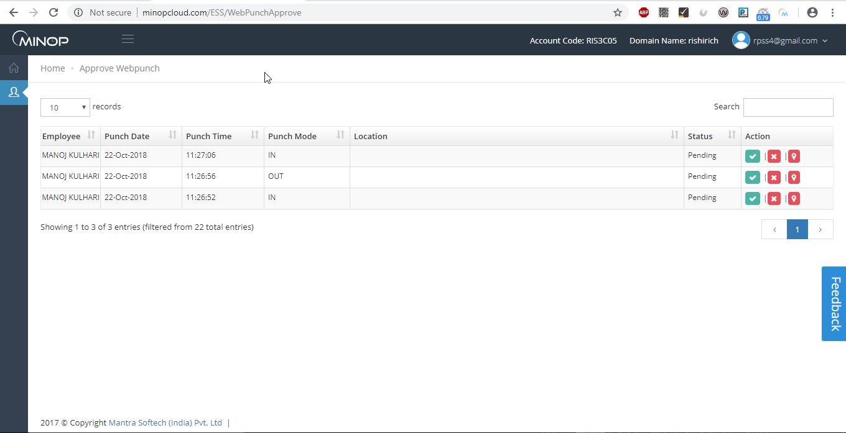

- On this page reporting person can see the Web Punch applied by employee who is under his/her authority.
- Only Employee who is Reporting person can Approve/reject the Web Punch, If Employee is not Reporting person then Blank page will display to him/her.

2.7 Employee Profile Account

- Employee User can add personal information and change the password from here.

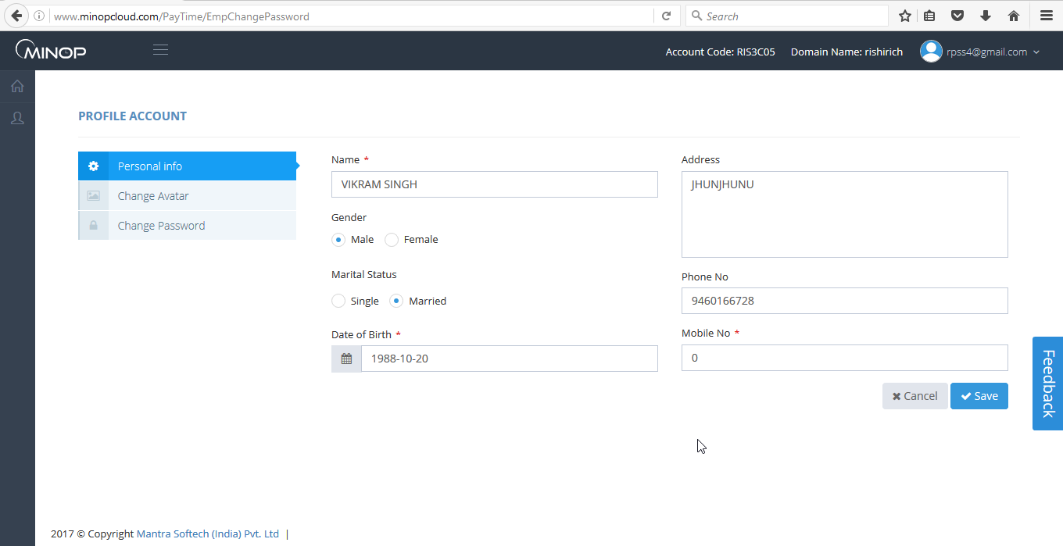

- If Employee want to add avatar then he/she can add from Change Avatar page.

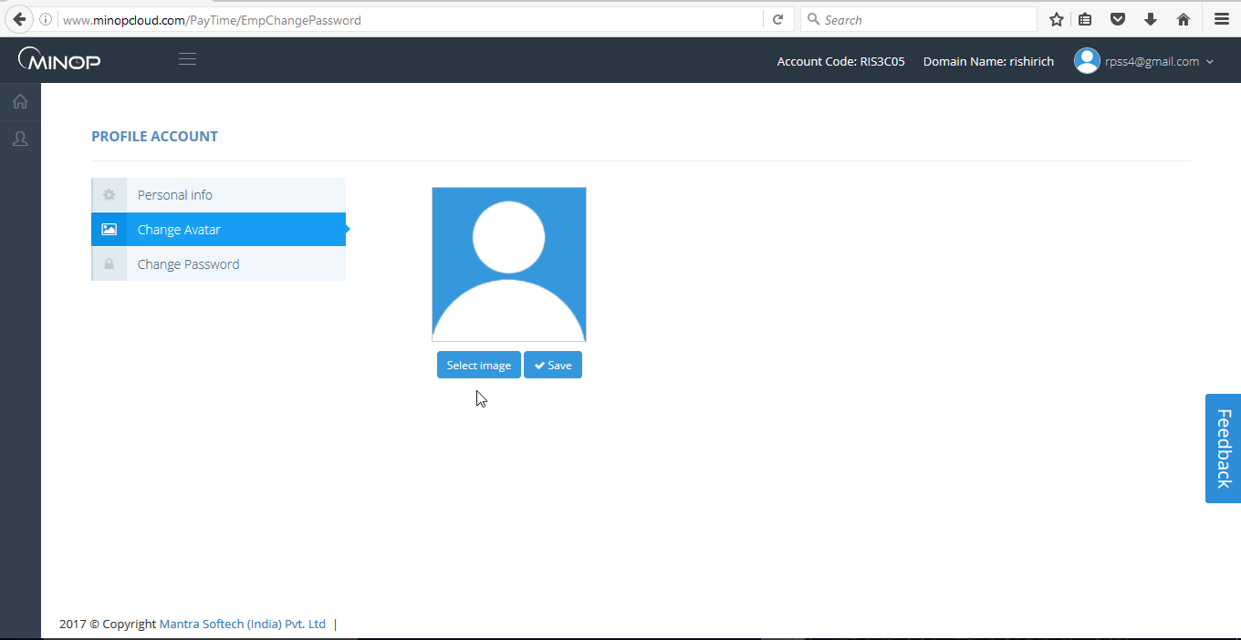

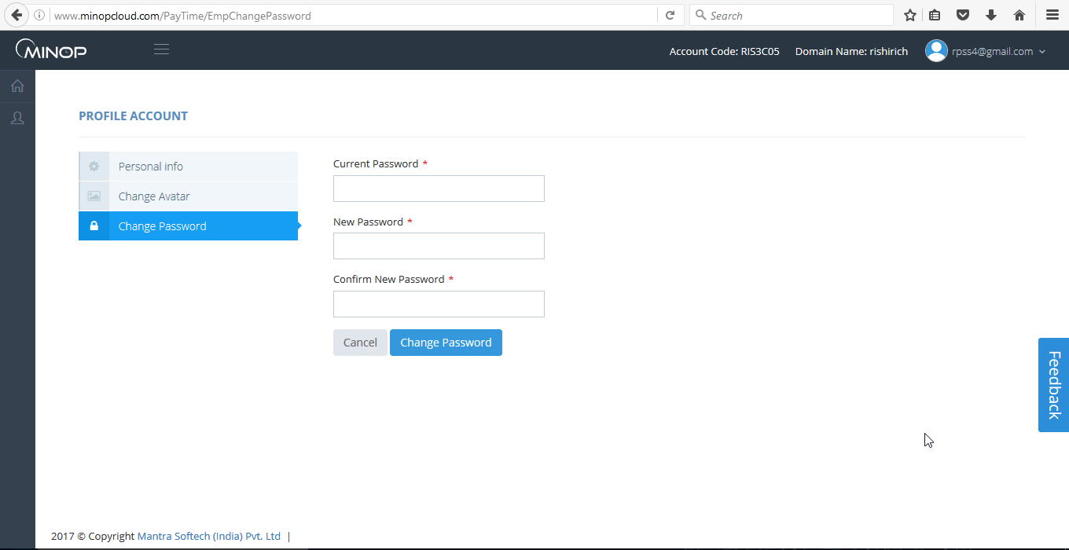

- User can change the password from Change Password page.

- Developer Login

- To do Developer Login following steps are required.

- Navigate to http://minopcloud.com/.
- Navigate to http://minopcloud.com/PayTime/DevelopersAccount to do Developer Login.

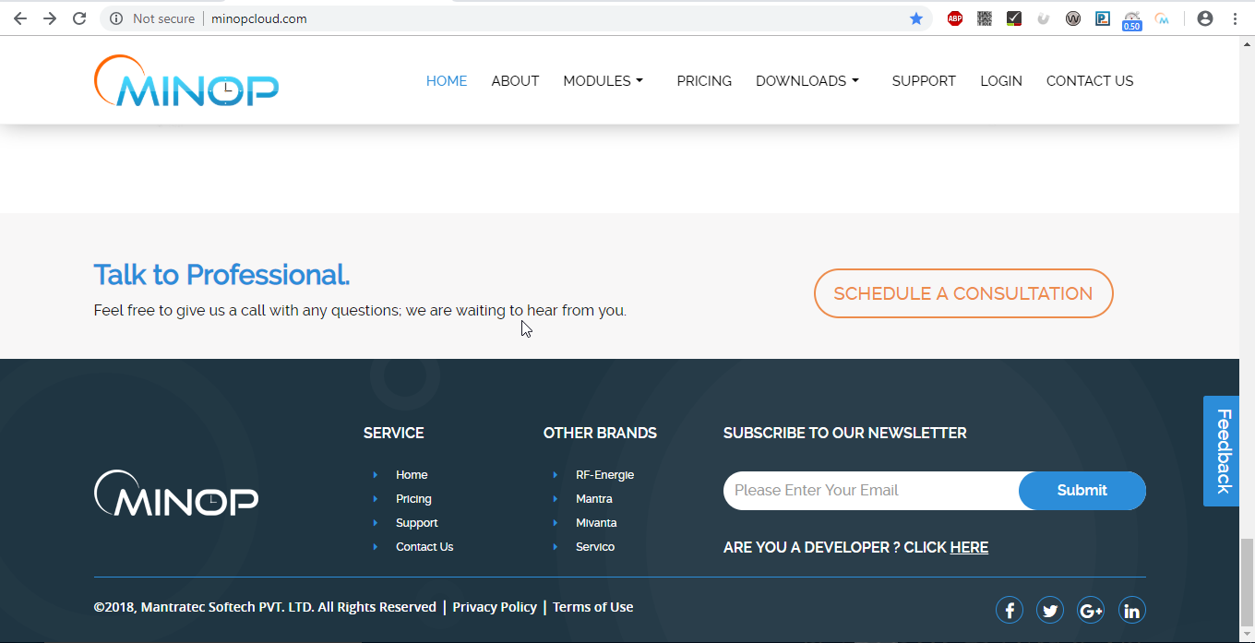

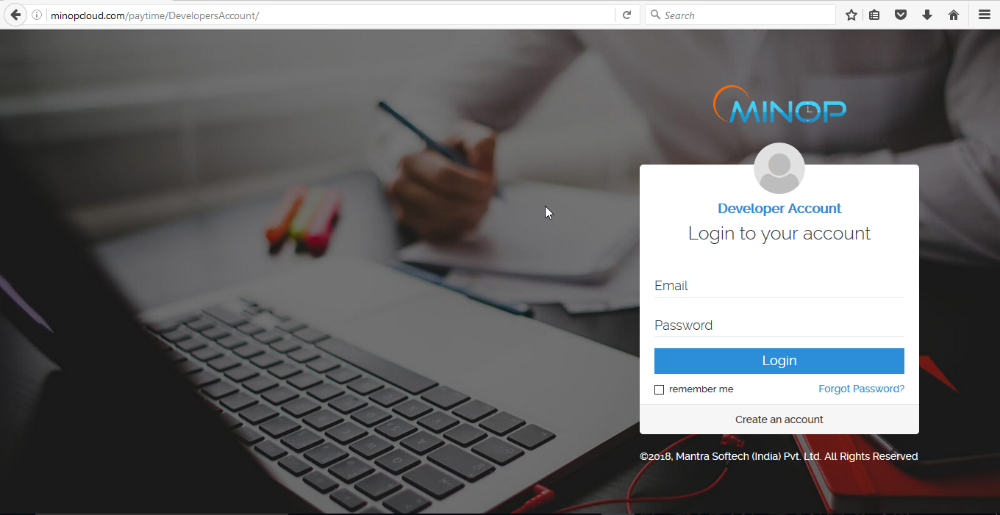

After Doing Login with Valid Credentials user will redirected to the Developer Dashboard.

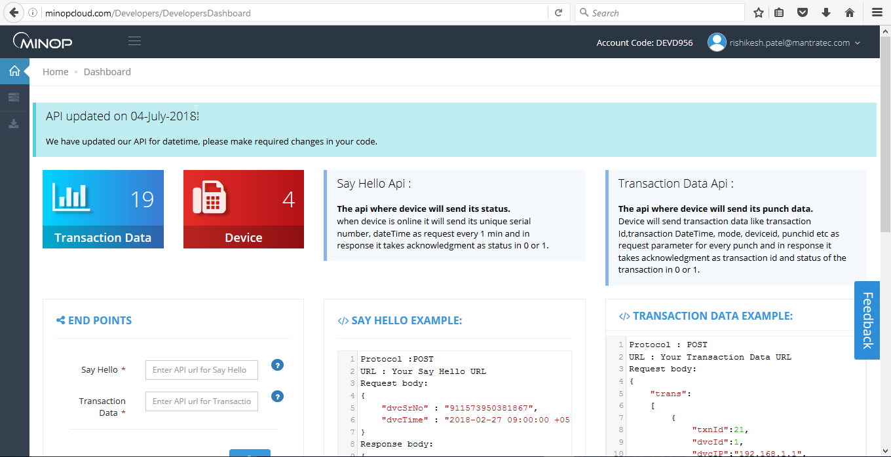

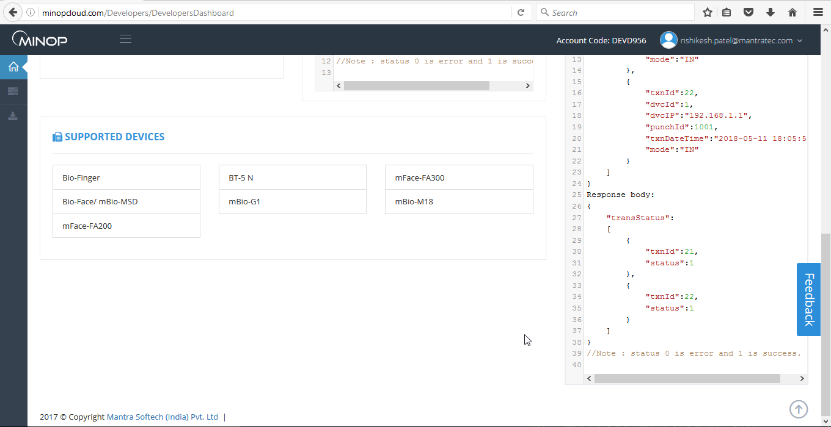

- Device Management

  - Device

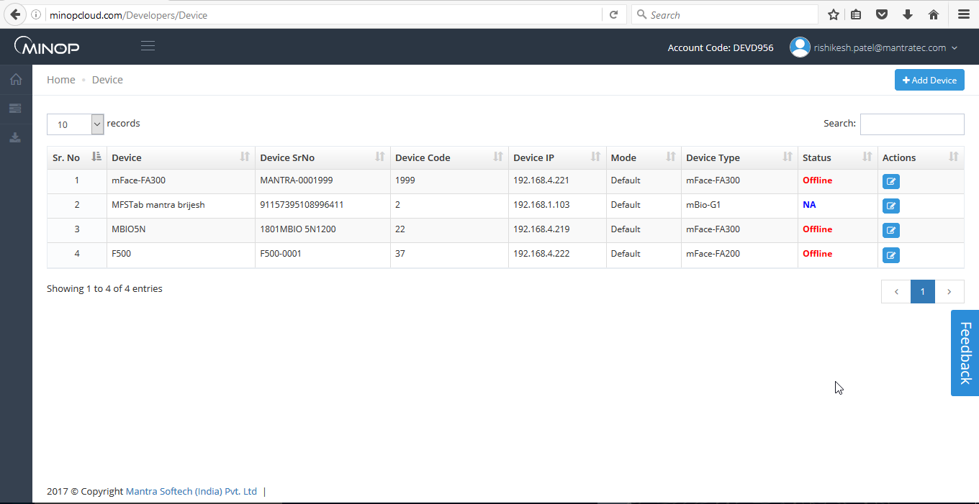

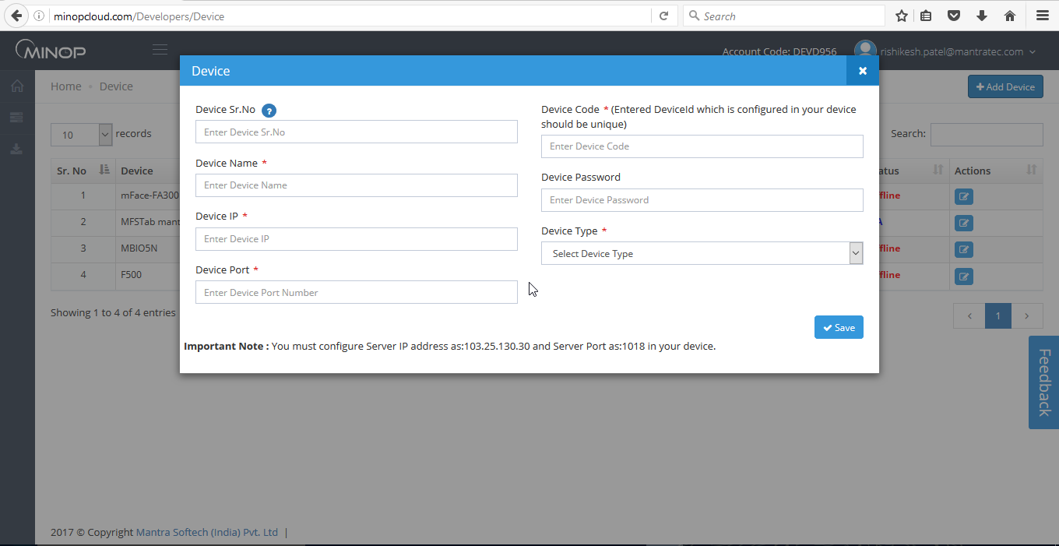

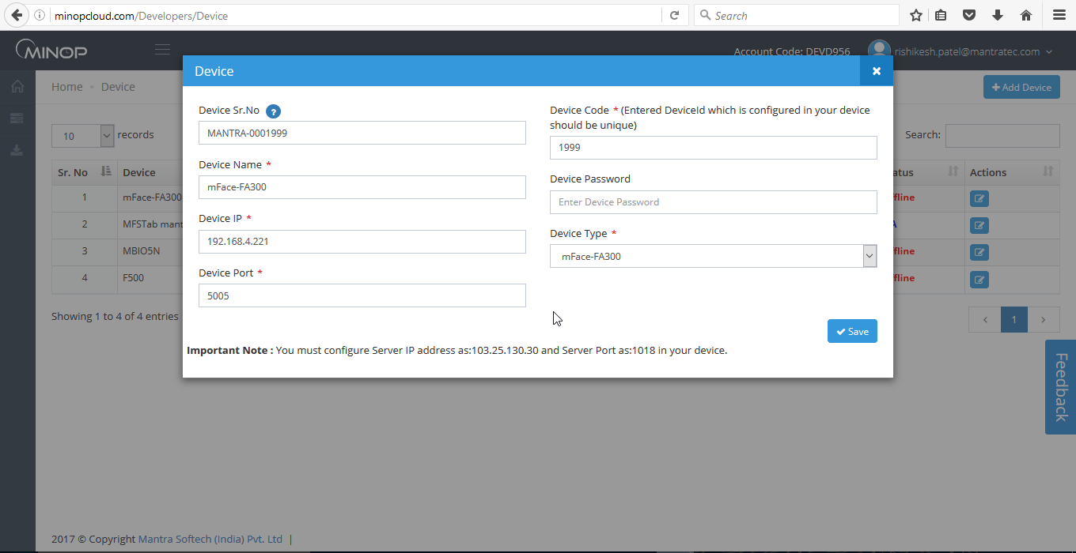

Configuration of All Devices is needed to save in Device Master.
Device ID, Device IP, Port Number, Device Password Details will be got from your Device Menu.
Push Data Configuration:-
Server Port – On this Port, Device will sent Data to Server, show this port will be accessible from Device & enter same Port in “Server Port” in Device Menu.
Server IP/Host IP (At Device Level) – This value need to set in Device Menu and it should be IP address of Server where Minop Push Data Service is running.

3.2 Transaction Data

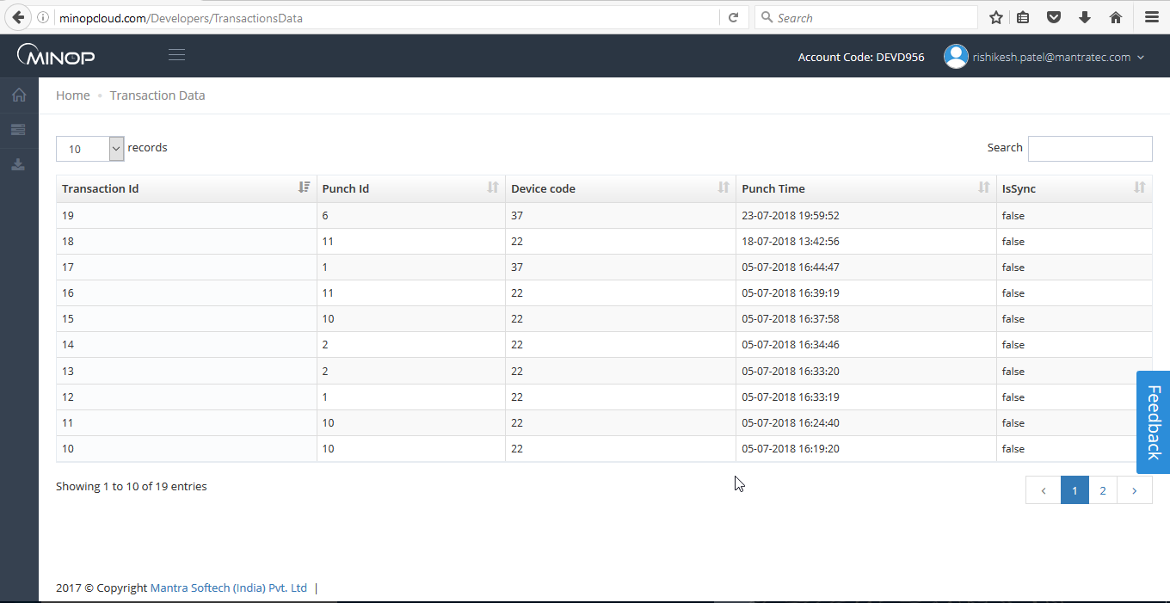

- Transaction Data will be displayed in Transaction Monitor as User do punches from Device.
- Device will send transaction data like transaction Id,transaction DateTime, mode, deviceid, punchid etc as request parameter for every punch and in response it takes acknowledgment as transaction id and status of the transaction in 0(False) or 1(True).

3.3 Download Sample

Sample API Code is available for download in Microsoft .net and for Slim PHP. User can download it from this page by clicking on it.

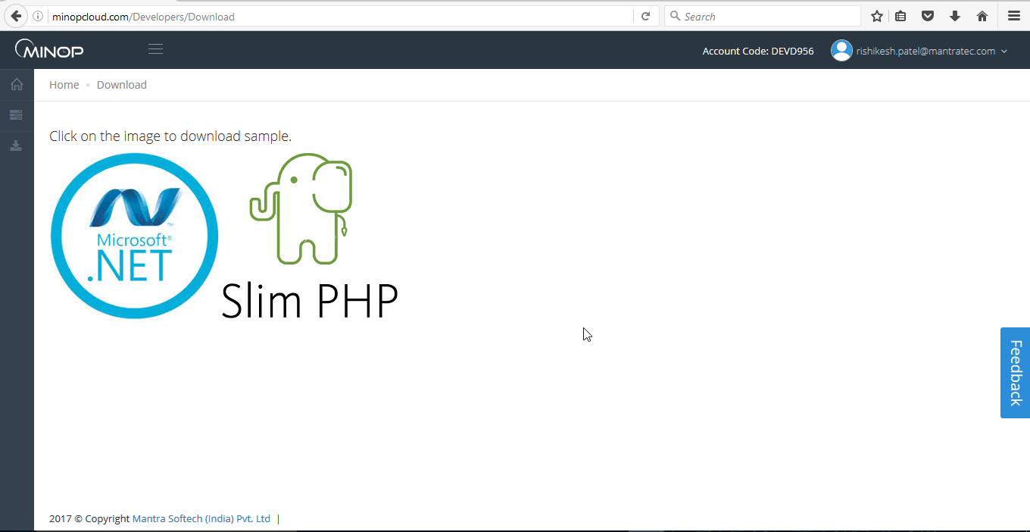

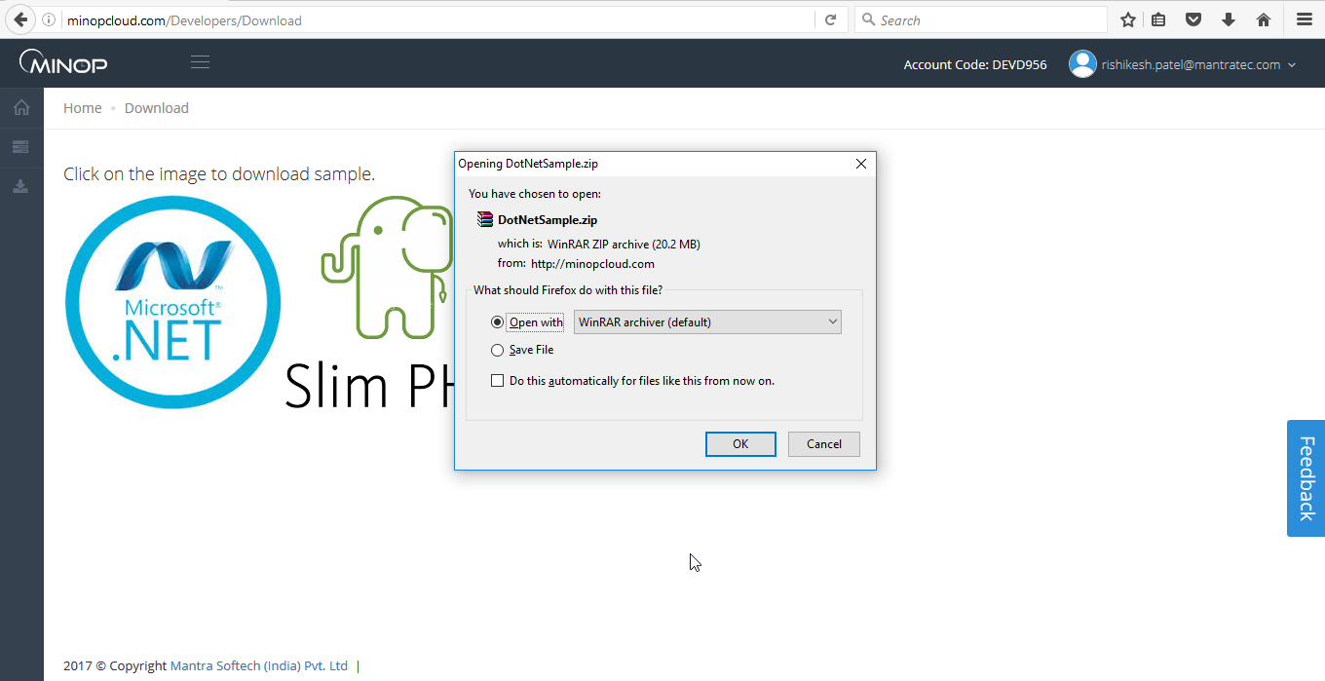

THE END

